The Caissons Go Rolling Along (Edmund L. Gruber 1908)
The Field Artillery Song (John Philip Sousa 1917)




C
F
G7
C
Over hill, over dale, as we hit the dusty trail,
G7 C
And the caissons go rolling a-long.
C
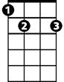
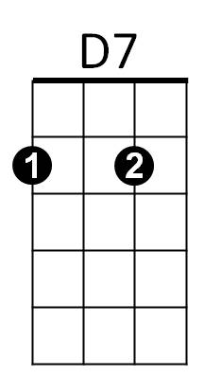
In and out, hear them shout,
E7
Counter-march and right about,
G7 C
And the caissons go rolling a-long.

C F C
Then it's hi! hi! hee! In the Field Ar-til-ler-y,
D7 G7
Shout out your numbers loud and strong,
C E7 F C
For where e'er you go, you will always know,
G7 C
That the caissons go rolling along.
(Keep them rolling!)
G7 C
Yes, those caissons go rolling along!

The Army Goes Rolling Along (1956)

C F
March along, sing our song,
C G7 C
With the Army of the free.
C F
Count the brave, count the true,
E7 B7 E7
who have fought to victo -ry.
Dm Am
We’re the Army and proud of our name!
E7 G7
We’re the Army and proudly proclaim:

C
First to fight for the right,
And to build the Nation’s might,
G7 C
And the Army Goes Rolling Along.
C
C
Proud of all we have done,
Fighting till the battle’s won,
G7 C
And the Army Goes Rolling Along.

Refrain:
C F C
Then it’s hi! hi! hey! The Army’s on its way.
D7 G7
Count off the cadence loud and strong;
C E7 F C
For where’er we go, You will always know




G7 C
G7
B7
Am
C
F
Dm
That the Army Goes Rolling Along.
BARITONE

C
Valley Forge, Custer’s ranks,
San Juan Hill and Patton;s tanks
G7 C
D7
And the Army went Rolling Along.
C
Minute Men, from the start,
always fighting from the heart,
G7 C
And the Army Goes Rolling Along.
(Refrain)

C
Men in rags, men who froze,
still that Army met its foes,
G7 C
And the Army went Rolling Along.
C
Faith in God, then we’re right,
and we’ll fight with all our might,
G7 C
And the Army Goes Rolling Along.

(Refrain)

(Keep them rolling!)
G7 C
That the Army Goes Rolling Along.

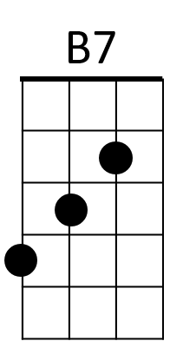
E7
G7
F
Am
Dm

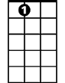
E7

