Calendar Girl (Howard Greenfield / Neil Sedaka)

C Am
I love, I love, I love my calendar girl
C Am
Yeah, sweet calendar girl
C Am
I love, I love, I love my calendar girl
F G C G7
Each and every day of the year

C
January - You start the year off fine
Am
February - You're my little valentine
C
March - I'm gonna march you down the aisle
Am
April - You're the Easter Bunny when you smile


Chorus:
C
F F7
Yeah, yeah, my heart's in a whirl
C Cmaj7 Am7 Cmaj7 A7
I love, I love, I love my little calendar girl
D7
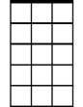
Every day (every day),
Am7
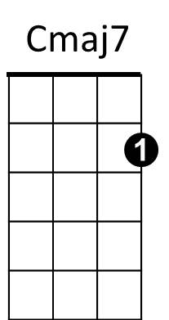
G7 C
Every day (every day) of the year
F C G7
Every day of the year

C
May - Maybe if I ask your Dad and Mom
Am
June - They'll let me take you to the Junior Prom
BARITONE


C
Am
F

July - Like a firecracker all aglow
C
G
Am
August - When you're on the beach you steal the show

(Chorus)

G7

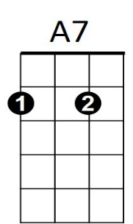
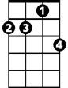
(Instrumental verse chords)
D7
Am7
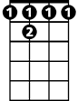
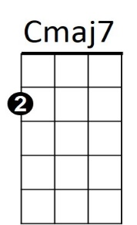
F 7

C
September - Light the candles at your Sweet 16
Am
October - Romeo and Juliet on Halloween
C
November - I'll give thanks that you belong to me
Am
December - You're the present 'neath my Christmas tree

(Chorus)

(repeat to fade):

C Am
I love, I love, I love my calendar girl
C Am
Yeah, sweet calendar girl
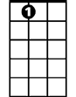
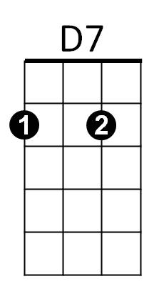
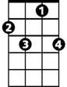


G7
A7
F7
Am
F
G

