California Dreaming (John Phillips / Michelle Phillips) Key A
Intro: A Dm / C Bb / C A7

A7 Dm C Bb
All the leaves are brown (all the leaves are brown)
C A
And the sky is gray (and the sky is gray)
Bb F A Dm
I’ve been for a walk (I’ve been for a walk)
A A7
On a winter’s day (on a winter’s day)

Dm C Bb
I’d be safe and warm (I’d be safe and warm)
C A
If I was in L.A. (If I was in L.A.)
Dm C Bb
California dreaming (California dreaming)
C A7
On such a winter’s day

Dm C Bb
Stopped into a church
C A
I passed along the way
Bb F A Dm
Well I got down on my knees (Got down on my knees)
Bb A7
And I pretend to pray (I pretend to pray)

Dm
You know the preacher liked the cold,
C Bb
(Preacher liked the cold)
C A
He knows I’m gonna stay (Knows I’m gonna stay)
Dm C Bb
California dreaming (California dreaming)
C A7
On such a winter’s day

Interlude…Dm Gm Dm Gm / F A Dm Bb A
Dm Gm Dm Gm A / Dm Gm Dm Gm A7

A7 Dm C Bb
All the leaves are brown (all the leaves are brown)
C A
And the sky is gray (and the sky is gray)
Bb F A Dm
I’ve been for a walk (I’ve been for a walk)
A
On a winter’s day (on a winter’s day)
Dm C Bb
If I didn’t tell her (If I didn’t tell her)
C A A7
I could leave today (I could leave today)
Dm C Bb
California dreaming (California dreaming)
C Dm C Bb
On such a winter’s day (California dreaming)
C Dm C Bb
On such a winter’s day (California dreaming)
C Bbmaj7 Dm
On such a winter’s da --- ay

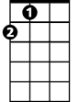





A
Bb
C
Dm
F
Gm

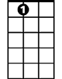
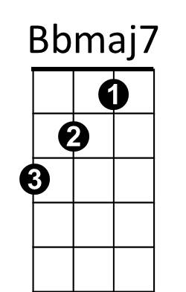
A7

BARITONE


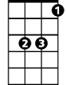
A
Bb
C
Dm

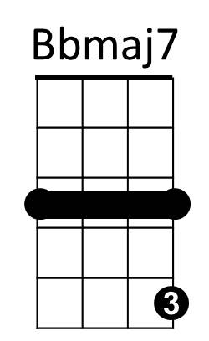
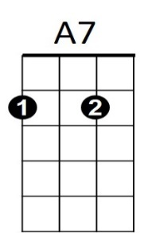
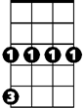
Gm
F

California Dreaming (John Phillips / Michelle Phillips) Key D
Intro: D Gm / F Eb / F D7

D7 Gm F Eb
All the leaves are brown (all the leaves are brown)
F D
And the sky is gray (and the sky is gray)
Eb Bb D Gm
I’ve been for a walk (I’ve been for a walk)
D D7
On a winter’s day (on a winter’s day)

Gm F Eb
I’d be safe and warm (I’d be safe and warm)
F D
If I was in L.A. (If I was in L.A.)
Gm F Eb
California dreaming (California dreaming)
F D7
On such a winter’s day

Gm F Eb
Stopped into a church
F D
I passed along the way
Eb Bb D Gm
Well I got down on my knees (Got down on my knees)
Eb D7
And I pretend to pray (I pretend to pray)

Gm
You know the preacher liked the cold,
F Eb
(Preacher liked the cold)
F D
He knows I’m gonna stay (Knows I’m gonna stay)
Gm F Eb
California dreaming (California dreaming)
F D7
On such a winter’s day

Interlude…Gm Cm Gm Cm / Bb D Gm Eb D
Gm Cm Gm Cm D / Gm Cm Gm Cm D7

D7 Gm F Eb
All the leaves are brown (all the leaves are brown)
F D
And the sky is gray (and the sky is gray)
Eb Bb D Gm
I’ve been for a walk (I’ve been for a walk)
D
On a winter’s day (on a winter’s day)
Gm F Eb
If I didn’t tell her (If I didn’t tell her)
F D D7
I could leave today (I could leave today)
Gm F Eb
California dreaming (California dreaming)
F Gm F Eb
On such a winter’s day (California dreaming)
F Gm F Eb
On such a winter’s day (California dreaming)
F Ebmaj7 Gm
On such a winter’s da --- ay

Gm
D
F
Eb

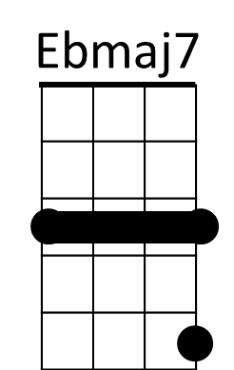
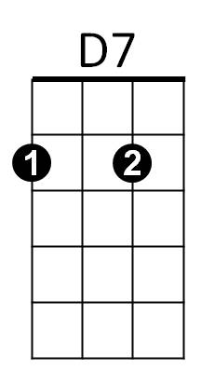
Bb
Cm

BARITONE
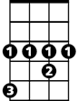

Eb
F
D
Gm

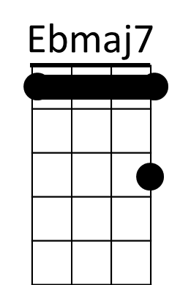
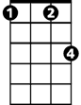

Cm
D7
Bb

California Dreaming (John Phillips / Michelle Phillips) Key G
Intro: G Cm / Bb Ab / Bb G7

G7 Cm Bb Ab
All the leaves are brown (all the leaves are brown)
Bb G
And the s ky is gray (and the sky is gray)
Ab Eb G Cm
I’ve been for a walk (I’ve been for a walk)
G G7
On a winter’s day (on a winter’s day)

Cm Bb Ab
I’d be be safe and warm (I’d be safe and warm)
Bb G
If I wa s in L.A. (If I was in L.A.)
Cm Bb Ab
California dreaming (California dreaming)
Bb G7
On such a winter’s day

Cm Bb Ab
Stopped into a church
Bb G
I passed along the way
Ab Eb G Cm
Well I got down on my knees (Got down on my knees)
Ab G7
And I pretend to pray (I pretend to pray)

Cm
You know the preacher liked the cold,
Bb Ab
(Preacher liked the cold)
Bb G
He knows I’m gonna stay (Knows I’m gonna stay)
Cm Bb Ab
California dreaming (California dreaming)
Bb G7
On such a winter’s day

Interlude…Cm Fm Cm Fm / Eb G Cm Ab G
Cm Fm Cm Fm G / Cm Fm Cm Fm G7

G7 Cm Bb Ab
All the leaves are brown (all the leaves are brown)
Bb G
And the sky is gray (and the sky is gray)
Ab Eb G Cm
I’ve been for a walk (I’ve been for a walk)
G
On a winter’s day (on a winter’s day)
Cm Bb Ab
If I didn’t tell her (If I didn’t tell her)
Bb G G7
I could leave today (I could leave today)
Cm Bb Ab
California dreaming (California dreaming)
Bb Cm Bb Ab
On such a winter’s day (California dreaming)
Bb Cm Bb Ab
On such a winter’s day (California dreaming)
Bb Abmaj7 Cm
On such a winter’s da --- ay
G
Ab
Bb
Cm

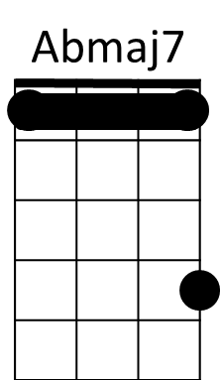
G7
Fm
Eb

BARITONE
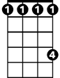
Ab
Bb
Cm
G

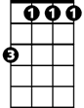

Fm
G7
Eb
