Candle In The Wind (Elton John / Bernie Taupin) Key C

C

Goodbye Norma Jean
C
F
Though I never knew you at all
C
You had the grace to hold yourself
F

While those around you crawled
F
C
They crawled out of the woodwork
F
And they whispered into your brain
C
They set you on the treadmill

F
G
And they made you change your name

Chorus:
G G7
And it seems to me you lived your life

C F
G7
Like a candle in the wind
C F
Never knowing who to cling to
G
When the rain set in
F

And I would have liked to have known you
Am
Am
But I was just a kid
G
Your candle burned out long before
F
Your legend ever did

F//// C / F/ C// G7

BARITONE

F
C
G


Am
G7

C
Loneliness was tough
F
The toughest role you ever played
C
Hollywood created a superstar
F
And pain was the price you paid
C
Even when you died
F
Oh the press still hounded you
C
All the papers had to say
F
Was that Marilyn was found in the nude

(Chorus) F//// C / F/ C// G7

C
Goodbye Norma Jean
F
Though I never knew you at all
C
You had the grace to hold yourself
F
While those around you crawled
C
Goodbye Norma Jean
F
From the young man in the 22nd row
Who sees you as something more than
C
sexual
F
More than just our Marilyn Monroe

(Chorus) F//// C / Gm/ C/
G
Your candle burned out long before
F F//// C / F/ C/
Your legend ever did

Candle In The Wind (Elton John / Bernie Taupin) Key G
G
Goodbye Norma Jean
G
C
Though I never knew you at all
G
You had the grace to hold yourself
C
While those around you crawled
G
C
They crawled out of the woodwork
C
And they whispered into your brain
G
They set you on the treadmill

C
D
And they made you change your name

Chorus:
D D7
And it seems to me you lived your life
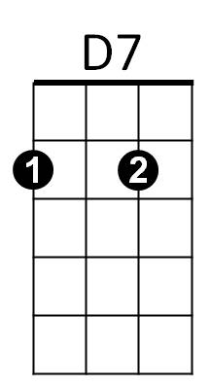
G C
Like a candle in the wind
G C
Never knowing who to cling to
D
When the rain set in
C
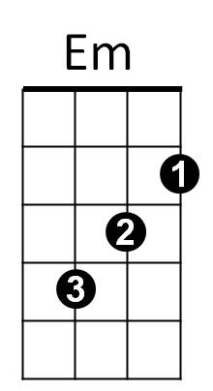
And I would have liked to have known you
Em
But I was just a kid
D
Your candle burned out long before
C
Your legend ever did

C//// G / C/ G// D7

BARITONE

D7
D
C
G
Em

G
Loneliness was tough
C
The toughest role you ever played
G
Hollywood created a superstar
C
And pain was the price you paid
G
Even when you died
C
Oh the press still hounded you
G
All the papers had to say
C
Was that Marilyn was found in the nude

(Chorus) C//// G / C/ G// D7

G
Goodbye Norma Jean
C
Though I never knew you at all
G
You had the grace to hold yourself
C
While those around you crawled
G
Goodbye Norma Jean
C
From the young man in the 22nd row
Who sees you as something more than
G
sexual
C
More than just our Marilyn Monroe

(Chorus) C//// G / C/ G/
D
Your candle burned out long before
C C//// G / C/ G/
Your legend ever did

