Can’t Fight This Feeling (Kevin Cronin)
Intro: Chords for first line

C G Am
I can't fight this feeling any longer,
F C G
And yet I'm still afraid to let it flow
C G
What started out as friendship
A
Has grown stronger
Dm F G
I only wish I had the strength to let it show

C G Am
I tell myself that I can't hold out forever,
F C G
I said there is no reason for my fear
C G A
'Cause I feel so secure when we're together
Dm C
You give my life direction,
F G
You make everything so clear

Bridge:
F
And even as I wander,
C
I'm keeping you in sight
F
You're a candle in the window
C G
On a cold, dark winter's night
F
And I'm getting closer
Am G F G
Than I ever thought I might
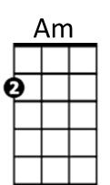
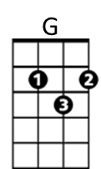
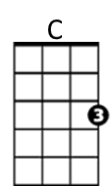


Dm
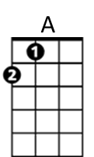
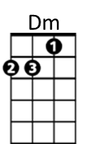
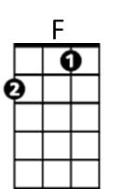

F

Chorus:
F C Dm F
And I can't fight this feeling anymore
C Dm F
I've forgotten what I started fighting for
C Dm F
It's time to bring this ship into the shore
F G F G
And throw away the oars, forever
F C Dm F
'Cause I can't fight this feeling anymore
C Dm F
I've forgotten what I started fighting for
C Dm
And if I have to crawl upon the floor
F Dm
Come crashing through your door
F G C F G
Baby, I can't fight this feeling anymore

C G Am
My life has been such a whirlwind since I saw you,
F C G
I've been running round in circles in my mind
C G A
And it always seems that I'm fol~lowing you, girl
Dm C
'Cause you take me to the places
F G
That alone I'd never find

(Bridge and Chorus) (Repeat chorus to finish)
BARITONE
A
C
Am
G

