Car Wash Blues (Jim Croce)

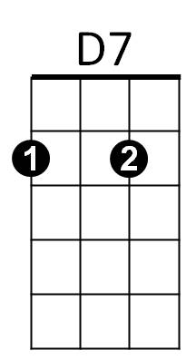

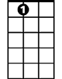
Key G
G
C
A7

G
Well, I just got out from the county prison,
D7
Doin' ninety days for non-support.
Tried to find me an executive position,
G
But no matter how smooth I talked
They wouldn't listen to
G7
The fact that I was a genius,
C A7
The man say, 'We got all that we can use...'

CHORUS:

A7 G B7
Now I got them steadily depressin',
Em G7
Low down mind messin',
C D7 G
Workin' at the car wash blues.

G
Well, I should be sittin' in an air conditioned
D7
Office In a swivel chair.
Talkin' some trash to the secretaries,
G
Sayin', 'Hey, now mama, come on over here.'
Instead, I'm stuck here rubbin' these fenders with
G7
a rag
C A7
And walkin' home in soggy old shoes...

(CHORUS)

G C
You know a man of my ability,
G
He should be smokin' on a big cigar.
C
But till I get myself straight
I guess I'll just have to wait
A7 D7
In my rubber suit rubbin' these cars.

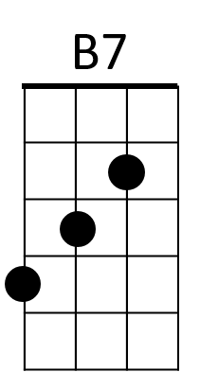
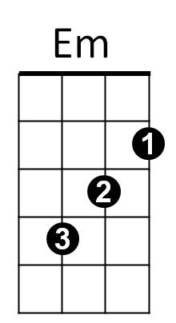

G7

G
Well, all I can do is a shake my head,
D7
You might not believe that it's true.
For workin' at this end of Niagara Falls
G
Is an undiscovered Howard Hughes.
So baby, don't expect to see me,
G7
With no double martini
C A7
In any high-brow society news.

(Chorus)

G B7
Cause I got them steadily depressin',
Em G7
Low down mind messin',
C D7 G
Workin' at the car wash blues

BARITONE


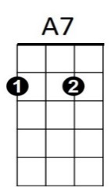

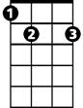
Em
G
D7
C
G7
B7

Car Wash Blues (Jim Croce)
F
G7
C
Key C

C
Well, I just got out from the county prison,
G7
Doin' ninety days for non-support.
Tried to find me an executive position,
C
But no matter how smooth I talked
They wouldn't listen to the fact
C7
That I was a genius,
F D7
The man say, 'We got all that we can use...'

CHORUS:

D7 C E7
Now I got them steadily depressin',
Am C7
Low down mind messin',
F G7 C
Workin' at the car wash blues.

C
Well, I should be sittin' in an air conditioned
G7
Office In a swivel chair.
Talkin' some trash to the secretaries,
C
Sayin', 'Hey, now mama, come on over here.'
Instead, I'm stuck here rubbin' these fenders
C7
with a rag
F D7
And walkin' home in soggy old shoes...

(CHORUS)

C F
You know a man of my ability,
C
He should be smokin' on a big cigar.
F
But till I get myself straight
I guess I'll just have to wait
D7 G7
In my rubber suit rubbin' these cars.

C7
Am
E7

C
Well, all I can do is a shake my head,
G7
You might not believe that it's true.
For workin' at this end of Niagara Falls
C
Is an undiscovered Howard Hughes.
So baby, don't expect to see me,
C7
With no double martini
F D7
In any high-brow society news.

(Chorus)

C E7
Cause I got them steadily depressin',
Am C7
Low down mind messin',
F G7 C


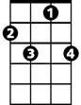
Workin' at the car wash blues
E7
F

C
BARITONE
G7
D7
Am
C7

