Cat's in the Cradle (Sandy Chapin / Harry Chapin)

A C
A child arrived just the other day
D A
He came to the world in the usual way
A C
But there were planes to catch and bills to pay
D A
He learned to walk while I was away
G
And he was ta lkin’ 'fore I knew it
And as he grew he'd say
C G A
I'm gonna be like you, dad
C Cmaj7 A
You know I'm gonna be like you
Chorus:
A G
And the cat’s in the cradle and the silver spoon
C D
Little boy blue and the man in the moon
A G
When you coming home Dad, I don't know when
C A
But we'll get together then
C A
You know we'll have a good time then.
A C
My son turned ten just the other day
D A
He said “Thanks for the ball. dad, c'mon let's play
A C
Can you teach me to throw, I said "not today;
D A
I got a lot to do", he said "that's okay"
G
And, he walked away
But his smile never dimmed, he said
C G A
"I'm gonna be like him, yeah
C Cmaj7 A
You know I'm gonna be like him"
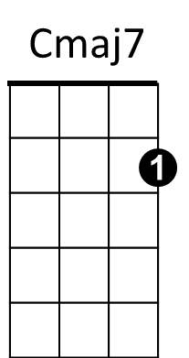



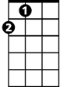
(Chorus)
C
D
G
A

A C
Well, he came home college just the other day
D A
So much like a man, I just had to say
A C
"Son I'm proud of you, can you sit for a while?"
D A
He shook his head and he said with a smile
G
"What I'd really like Dad is to borrow the car keys.
C G A
See you later, can I have them please?"
(Chorus)
C Cmaj7 G A C G D A
A C
I've long since retired, my son's moved away
D A
I called him up just the other day
C
I said "I'd like to see you if you don't mind"
D A
He said "I'd love to dad if I could find the time"
G
You see, my new job's a hassle
And the kids have the flu
C G A
But it's sure nice talkin' to you dad
C Cmaj7 A
It's been sure nice talkin' to you
G
And as I hung up the phone it occurred to me
C G A
He'd grown up just like me
C Cmaj7 A
My boy was just like me
(Chorus) (extend last line)
BARITONE

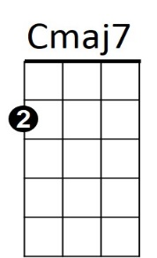
G
D
A
C

Cat's in the Cradle (Sandy Chapin / Harry Chapin)

C Eb
A child arrived just the other day
F C
He came to the world in the usual way
Eb
But there were planes to catch and bills to pay
F C
He learned to walk while I was away
Bb
And he was talkin’ 'fore I knew it
And as he grew, he'd say
Eb Bb C
I'm gonna be like you, dad
Eb Ebmaj7 C
You know I'm gonna be like you
Chorus:
C Bb
And the cat’s in the cradle and the silver spoon
Eb F
Little boy blue and the man in the moon
C Bb
When you coming home Dad, I don't know when
Eb C
But we'll get together then
Eb C
You know we'll have a good time then.
C Eb
My son turned ten just the other day
F C
He said “Thanks for the ball. dad, c'mon let's play
C Eb
Can you teach me to throw, I said "not today;
F C
I got a lot to do", he said "that's okay"
Bb
And, he walked away

But his smile never dimmed, he said
Eb Bb C
"I'm gonna be like him, yeah
Eb Ebmaj7 C
You know I'm gonna be like him"
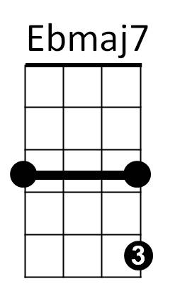

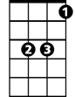
(Chorus)
Bb
F
Eb
C

C Eb
Well, he came home from college just the other day
F C
So much like a man, I just had to say
C Eb
"Son I'm proud of you, can you sit for a while?"
F C
He shook his head and he said with a smile
Bb
"What I'd really like Dad is to borrow the car keys.
Eb Bb C
See you later, can I have them please?"
(Chorus)
Eb Ebmaj7 Bb C Eb Bb F C
C Eb
I've long since retired, my son's moved away
F C
I called him up just the other day
Eb
I said "I'd like to see you if you don't mind"
F C
He said "I'd love to dad if I could find the time"
Bb
You see, my new job's a hassle
And the kids have the flu
Eb Bb C
But it's sure nice talkin' to you dad
Eb Ebmaj7 C
It's been sure nice talkin' to you
Bb
And as I hung up the phone it occurred to me
Eb Bb C
He'd grown up just like me
Eb Ebmaj7 C
My boy was just like me
(Chorus) (extend last line)
BARITONE
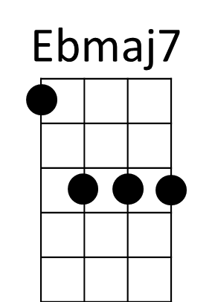
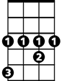
C
Eb
F
Bb

Cat's in the Cradle (Sandy Chapin / Harry Chapin)

G Bb
A child arrived just the other day
C G
He came to the world in the usual way
G Bb
But there were planes to catch and bills to pay
C G
He learned to walk while I was away
F
And he was talki n’ 'fore I knew it
And as he grew he'd say
Bb F G
I'm gonna be like you, dad
Bb Bbmaj7 G
You know I'm gonna be like you
Chorus:
G F
And the cat’s in the cradle and the silver spoon
Bb C
Little boy blue and the man in the moon
G F
When you coming home Dad, I don't know when
Bb G
But we'll get together then
Bb G
You know we'll have a good time then.
G Bb
My son turned ten just the other day
C G
He said “Thanks for the ball. dad, c'mon let's play
G Bb
Can you teach me to throw, I said "not today;
C G
I got a lot to do", he said "that's okay"
F
And he, he walked away
But his smile never dimmed, he said
Bb F G
"I'm gonna be like him, yeah
Bb Bbmaj7 G
You know I'm gonna be like him"
(Chorus)
Bb
G
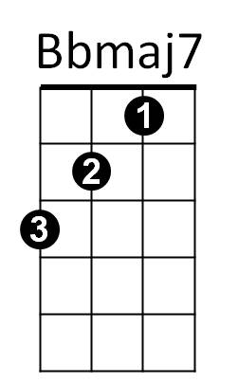
F
C

G Bb
Well, he came home college just the other day
C G
So much like a man, I just had to say
G Bb
"Son I'm proud of you, can you sit for a while?"
C G
He shook his head and he said with a smile
F
"What I'd really like Dad is to borrow the car keys.
Bb F G
See you later, can I have them please?"
(Chorus)
Bb Bbmaj7 F G Bb F C G
G Bb
I've long since retired, my son's moved away
C G
I called him up just the other day
Bb
I said "I'd like to see you if you don't mind"
C G
He said "I'd love to dad if I could find the time"
F
You see, my new job's a hassle
And the kids have the flu
Bb F G
But it's sure nice talkin' to you dad
Bb Bbmaj7 G
It's been sure nice talkin' to you
F
And as I hung up the phone it occurred to me
Bb F G
He'd grown up just like me
Bb Bbmaj7 G
My boy was just like me
(Chorus) (extend last line)
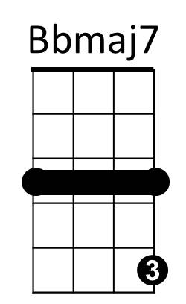
BARITONE
G
Bb
F
C

