Centerfield (John Fogerty)

Intro: F G / C F / (3x) F Em Dm G C C C C C

C F C
Well, beat the drum and hold the phone - the sun came out today!
Am G
We’re born again, there’s new grass on the field.
C F C
A-roundin’ third, and headed for home, it’s a brown-eyed handsome man;

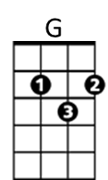
F G C
F
Anyone can understand the way I feel.

Chorus:
C F C
Oh, put me in, coach - I’m ready to play - today;
F Em
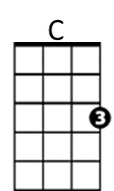
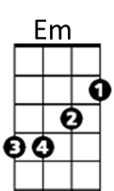
Put me in, coach - I’m ready to play - today;
Dm G C
Look at me, I can be centerfield.

C F C
Well I spent some time in the Mudville nine watchin’ it from the bench;


Am G
Am
Dm
You know I took some lumps when the Mighty Case struck out.
C F C
So say hey, Willie, tell Ty Cobb - and Joe DiMaggi-o;
F G C
Don’t say "it ain’t so", you know the time is now.

(Chorus)

C F C
BARITONE
Got a beat-up glove, a homemade bat, and brand-new pair of shoes;


Am G
G
F
You know I think it’s time to give this game a ride.
C F C
Just to hit the ball and touch ’em all - a moment in the sun;
F G C
(pop) It’s gone and you can tell that one goodbye!
Am
Em
C

Chorus x2
Dm

