Cheers Theme (Gary Portnoy / Judy Hart Angelo) Key C
Intro: C G 2x

C G
Making your way in the world today
C G
Takes everything you've got
C G
Taking a break from all your worries
C G
Sure would help a lot
Gm A7 Dm G
Wouldn't you like to get away?

C G
All those nights when you got no lights,
C G
The ch eck is in the mail
C G
And your little angel
C G
Hung the cat up by its' tail
Gm A7 Dm
And your third fiance didn't show
G F C
Somet imes you wanna go

C Bb F G
Where everybody knows your name
C Bb F G
And they're always glad you came
Em F
You wanna be where you can see
Em F
Our troubles are all the same
Em
You wanna go where
F G C
Everybody knows your name

C G / C G

BARITONE
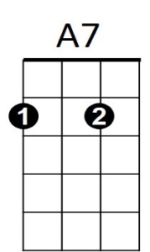
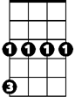


Gm
G
C

C G
You roll out of bed, Mr. Coffee's dead,
C G
The morning's looking bright
C G
And your shrink ran off to Europe,
C G
And didn't even write
Gm A7 Dm
And your husband wants to be a girl
G F C
Be glad there's one place in the world

C Bb F G
Where everybody knows your name
C Bb F G
And they're always glad you came
Em F
You wanna be where people know
Em F
People are all the same
Em
You wanna go where
F G C
Everybody knows your name

C G / C G / C
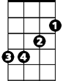
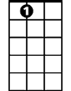



Em
F
A7
G
Dm
C
Gm


Bb


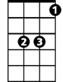
F
Em
Bb
Dm

Cheers Theme (Gary Portnoy / Judy Hart Angelo) Key F

Intro: F C 2X

F C
Making your way in the world today
F C
takes everything you've got
F C
Taking a break from all your worries
F C
Sure would help a lot
Cm D7 Gm C
Wouldn't you like to get away?

F C
All those nights when you got no lights,
F C
The check is in the mail
F C
And your little angel
F C
Hung the cat up by its' tail
Cm D7 Gm
And your third fiance didn't show
C Bb F
Sometimes you wanna go

F Eb Bb C
F
Where everybody knows your name
F Eb Bb C
And they're always glad you came
Am Bb
You wanna be where you can see
Am Bb
Our troubles are all the same
Gm
Am
You wanna go where
Bb C F
Everybody knows your name

F C / F C

BARITONE

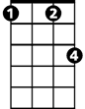
D7
Cm
F
C

F C
You roll out of bed, Mr. Coffee's dead,
F C
The morning's looking bright
F C
And your shrink ran off to Europe,
F C
And didn't even write
Cm D7 Gm
And your husband wants to be a girl
C Bb F
Be glad there's one place in the world

F Eb Bb C
Where everybody knows your name
F Eb Bb C
And they're always glad you came
Am Bb
You wanna be where people know
Am Bb
People are all the same
Am
You wanna go where
Bb C F
Everybody knows your name

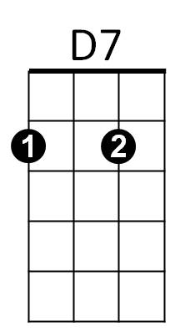
F C / F C / C
Cm
C

Am
Eb
Bb

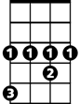
Eb
Am
Gm
Bb

Cheers Theme (Gary Portnoy / Judy Hart Angelo) Key G

Intro: G D 2X

G D
Making your way in the world today
G D
takes everything you've got
G D
Taking a break from all your worries
G D
Sure would help a lot
Dm E7 Am D
Wouldn't you like to get away?

G D
All those nights when you got no lights,
G D
The check is in the mail
G D
And your little angel
G D
Hung the cat up by its' tail
Dm E7 Am
And your third fiance didn't show
D C G
Sometimes you wanna go

G F C D
Where everybody knows your name
G F C D
And they're always glad you came
Bm C
You wanna be where you can see
Bm C
Our troubles are all the same
Bm
You wanna go where
C D G
Everybody knows your name

G D / G D

BARITONE
E7
Dm
G
D

G D
You roll out of bed, Mr. Coffee's dead,
G D
The morning's looking bright
G D
And your shrink ran off to Europe,
G D
And didn't even write
Dm E7 Am
And your husband wants to be a girl
D C G
Be glad there's one place in the world

G F C D
Where everybody knows your name
G F C D
And they're always glad you came
Bm C
You wanna be where people know
Bm C
People are all the same
Bm
You wanna go where
C D G
Everybody knows your name

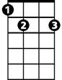
G D / G D / G
E7
G

Dm
D

Am
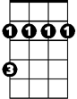
Bm
C
F

Am
Bm
F
C

