Christmas All Over Again (Tom Petty)
Key F

Intro: F Dm Gm C x2

F Dm Gm C
Well it’s Christmas time again.
F Dm Gm C
Decorations are all hung by the fire
Gm C Gm A7
Everybody's singing, all the bells are ringing out
F Dm F Dm Gm C
And it's Christmas all o - ver again yea again

F Dm Gm C
Long distance rel - a - tives
F Dm Gm C
Haven't seen 'em in a long, long time
Gm C Gm A7
Yeah, I kind of missed 'em, I just don't wanna kiss 'em, no
F Dm F Dm Gm C
And it's Christmas all o - ver again yea again

Gm C Gm C
And all over town, Little kids gon’ get down.
Bb
And Christmas is a rocking time, put your body next to mine,
G C
Underneath the mistletoe we go, we go

(First two lines of verse melody)
BARITONE
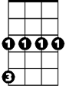Gm C Gm A7
Gm
Dm
F
Everybody's singing, all the bells are ringing out
F Dm F Dm Gm C
And it's Christmas all o - ver again yea again

Gm C Gm C
And right down our block, little kids start to rock.
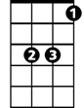Bb
G
C
Bb
And Christmas is a rocking time, put your body next to mine,
G C
Underneath the mistletoe we go, we go

F Dm Gm C
Merry Christmas time come and find you
F Dm Gm C
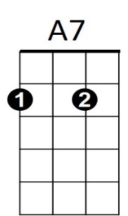
Happy and there by your fire,
Gm C Gm A7
I hope you have a good one, I hope momma gets her shoppin' done

F Dm F Dm Gm C
And it's Christmas all o - ver again
F Dm F Dm Gm C
Baby it's Christmas all o – ver again yea again
F Dm F Dm Gm C F
And it's Christmas all o - ver again yea again

