Christmas Carols
in the
Keys of G & C

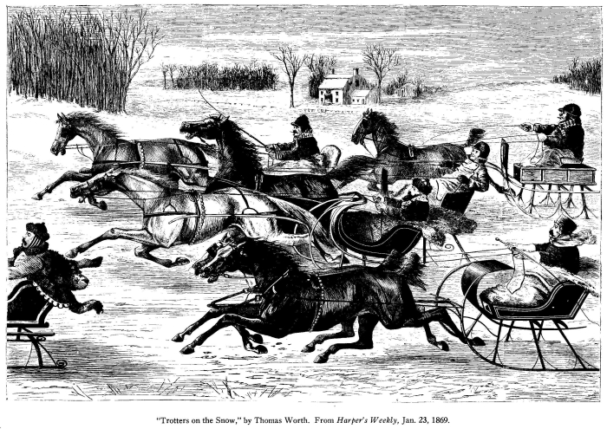

2018
Christmas Carols in the Keys of G & C
Together With Their Minor Keys
Plus Ukulele Tablature
Popular Selections from the 19th Century
Suggested from the contents of leading hymnals and carol collections of the Era
First Edition – January 2018
Douglas D. Anderson, Editor.
Released To The Public Domain.
Get updates, and additional carols, hymns and poems at
The Hymns and Carols of Christmas
www.hymnsandcarolsofchristmas.com
All songs in this book are in the public domain.
Only public domain arrangements have been used in the compilation of this collection.
Sources included:
Davies Gilbert, Some Ancient Christmas Carols. Second Edition.
London: John Nichols And Son, 1823
William Sandys, Christmas Carols Ancient and Modern
London: Richard Beckley, 1833
Joshua Sylvester, A Garland of Christmas Carols, Ancient and Modern
London: John Camden Hotten, 1861
William Henry Husk, Songs of the Nativity
London: John Camden Hotten, 1868
Rev. Henry Ramsden Bramley and Sir John Stainer, Christmas Carols New and Old
First, Second and Third Series
London: Novello, Ewer & Co., ca 1860s and 1870s
Rev. Richard R. Chope, Carols For Use In Church
London: William Clowes & Sons, The Complete Edition, 1894
Martin Shaw and Rev. Percy Dearmer, The English Carol Book
London: Mowbray & Co., Ltd.
First Series, 1913; Second Series, 1919
Rev. Charles L. Hutchins, Carols Old And Carols New
Boston: The Parish Choir, 1916

Ukulele Chord graphics were created by Hans Boldt.
“The Ukulele Chord Box Collection by Hans Boldt is licensed under a Creative Commons Attribution - ShareAlike 2.5 Canada License. They were obtained from Boldts.net, http://www.boldts.net/ukulele/uke-chords/ Accessed January 27, 2018.”

Table of Contents

Angels From The Realms of Glory 4
Angels We Have Heard On High 6
As With Gladness Men of Old 8
Away In A Manger 10
Christ Was Born On Christmas Day 12
Deck The Halls 14
God Rest You Merry, Gentlemen 16
Good Christian Men, Rejoice 18
Good King Wenceslas 20
Hark! The Herald Angels Sing 22
I Saw Three Ships 24
It Came Upon The Midnight Clear 26
Jingle Bells 28
Jolly Old St. Nicholas 30
Joy To The World 32
O Christmas Tree 34
O Come, All Ye Faithful 36
O Come, Little Children 38
O Come, O Come, Emmanuel 40
O Holy Night 42
O Little Town of Bethlehem 44
Once In Royal David's City 46
Silent Night, Holy Night 48
The Coventry Carol - Work 50
The First Nowell 52
The Holly And The Ivy - Work 54
The Wassail Song - Work 56
Up On The Housetop - Work 58
We Three Kings Of Orient Are - Work 60
What Child Is This? - Work 62

Note that a companion volume with carols in the keys of C and G is contemplated.
It will be of use to those who have a lower register than is generally called for in this volume.

Angels From The Realms of Glory
Alternate Title: Westminster Carol
Words: James Montgomery, 1816
Music: "Regent Square," Henry Thomas Smart, 1867
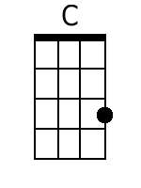  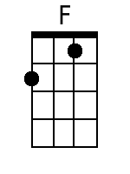  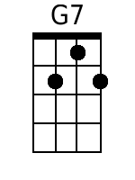  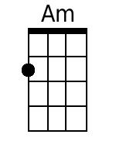  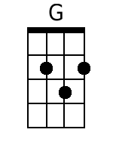  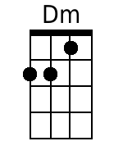 | 1. [C] Angels from the realms of glory,  [F] Wing your [C] flight over [G7] all the [C] earth;  [C] Ye who sang creation's story  [Am] Now proclaim the Mes - [G] siah's birth.  Chorus  [G] Come and [G7] worship, [C] come and [F] worship  [Dm] Worship Christ, the [G7] newborn [C] King.  2. [C] Shepherds, in the field abiding,  [F] Watching [C] over your [G7] flocks by [C] night,  [C] God with us is now residing;  [Am] Yonder shines the [G] infant light: Chorus  3. [C] Sages, leave your contemplations,  [F] Brighter [C] visions [G7] beam a - [C]far;  [C] Seek the great Desire of nations;  [Am] Ye have seen His [G] natal star. Chorus  4. [C] Saints, before the altar bending,  [F] Watching [C] long in [G7] hope and [C] fear;  [C] Suddenly the Lord, descending,  [Am] In His temple [G] shall appear. Chorus  5. [C] Sinners, wrung with true repentance,  [F] Doomed for [C] guilt to [G7] endless [C] pains,  [C] Justice now re - [G7] vokes the [C] sentence,  [Am] Mercy calls you, [G] break your chains. Chorus  6. [C] Though an infant now we view Him,  [F] He shall [C] fill His [G7] Father's [C] throne,  [C] Gather all the nations to Him;  [Am] Every knee shall [G] then bow down: Chorus
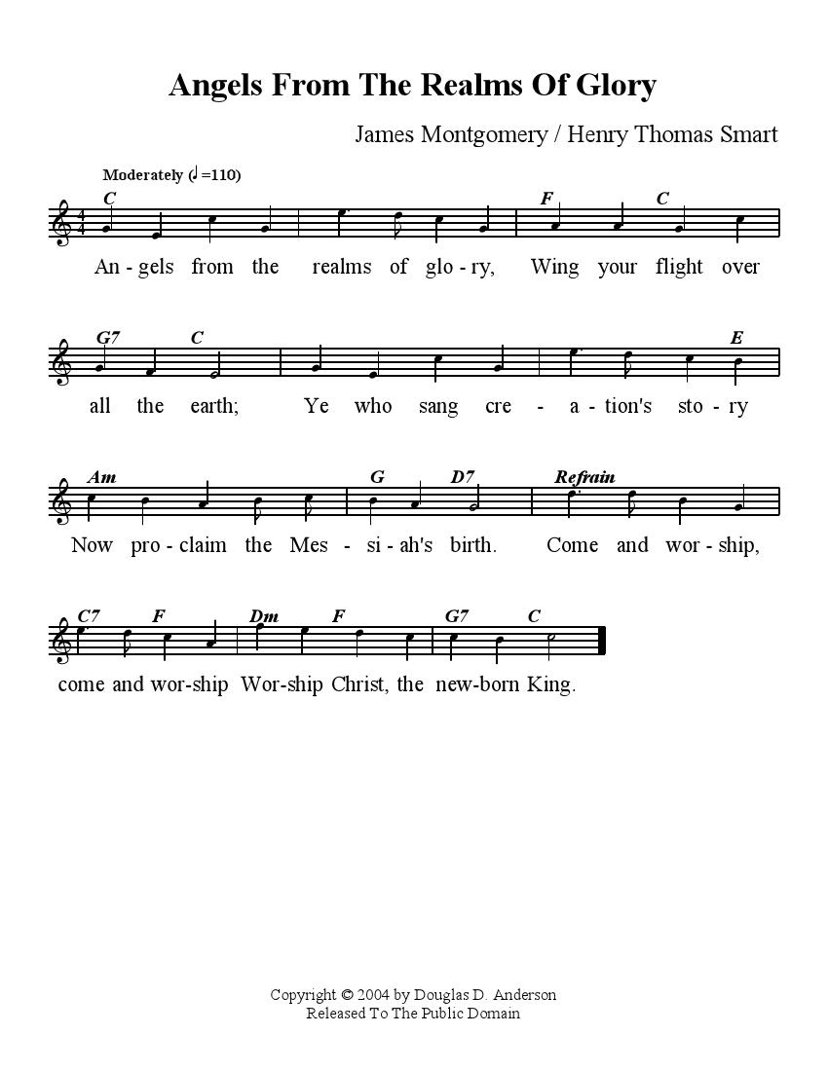

Angels We Have Heard On High
Alternate Title: The Westminster Carol
Words: Traditional French carol, "Les Anges dans nos Campagnes."
Translated from French to English by James Chadwick (1813-1882)
Music: "Gloria (Barnes)," an adaptation of the French carol melody
"Les Anges dans nos Campagnes," arranged by Edward Shippen Barnes.
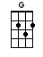  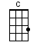  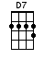  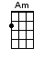  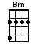  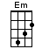  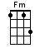 | 1. [G] Angels we have [D7] heard on [G] high  [G] Sweetly singing [D7] o'er the [G] plains,  [G] And the mountains [D7] in re- [G] ply  [G] Echoing their [D7] joyous [G] strains.  Refrain  [G] Glo - [D7] [G] [D7] ria, [G] in excelsis [D7] Deo!  [G] Glo - [D7] [G] [D7] ria, [G] in excelsis [D7] Deo!  2. [G] Shepherds, why this [D7] jubi- [G] lee?  [G] Why your joyous [D7] strains pro- [G] long?  [G] What the gladsome [D7] tidings [G] be  [G] Which inspire your [D7] heavenly [G] song? Refrain  3. [G] Come to Bethle- [D7] hem and [G] see  [G] Him whose birth the [D7] angels [G] sing;  [G] Come, adore on [D7] bended [G] knee,  [G] Christ the Lord, the [D7] newborn [G] King. Refrain  4. [G] See Him in a [D7] manger [G] laid,  [G] Whom the choirs of [D7] angels [G] praise;  [G] Mary, Joseph, [D7] lend your [G] aid,  [G] While our hearts in [D7] love we [G] raise. Refrain

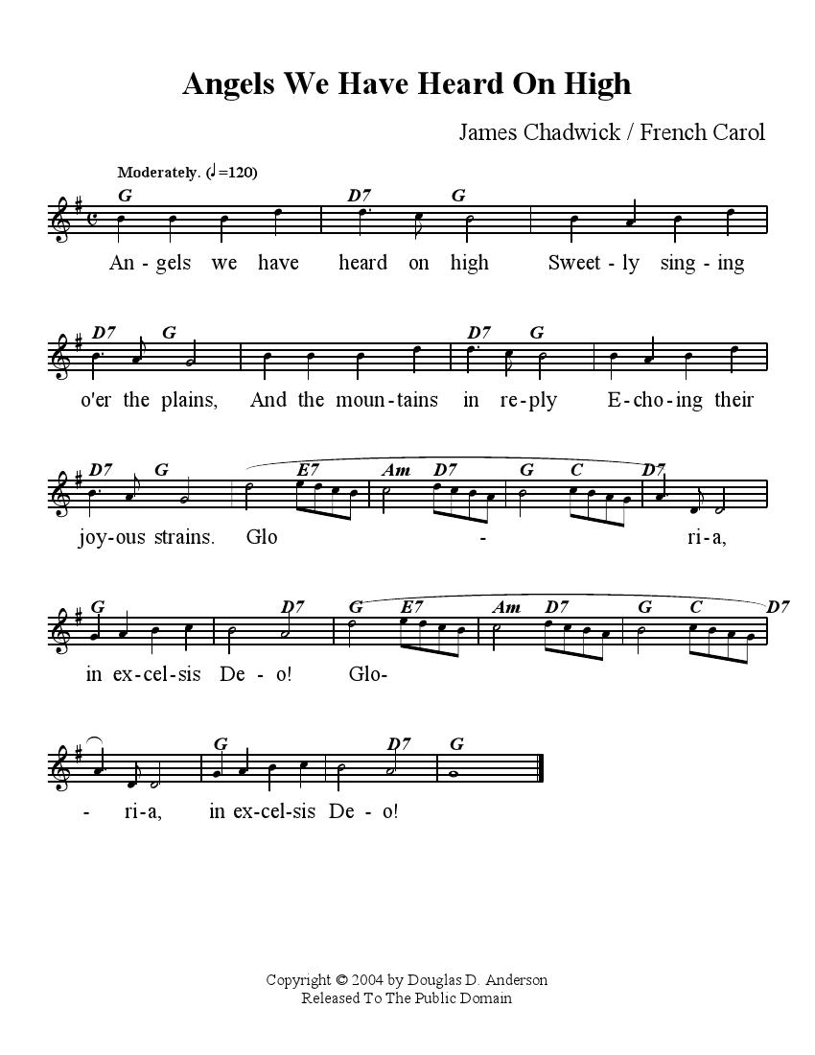

As With Gladness Men of Old
Words: William Chatterton Dix, 1860.
Music: "Dix," adapted by William Henry Monk from the original "Treuer Heiland, Wir Sind Heir" by Conrad Kocher, Stimmen aus dem Reiche Gottes, 1838.
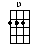  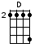 | 1. [G] As with gladness, [C] men of [G] old  [C] Did the [G] guiding [D] star be - [G] hold  [G] As with joy they [C] hailed its [G] light  [C] Leading onward, [D] beaming bright  [G] So, most glorious [D] Lord, may [G] we  [C] Evermore be [G] led [D] to [G] Thee.  2. [G] As with joyful [C] steps they [G] sped  [C] To that [G] lowly [D] manger [G] bed  [G] There to bend the [C] knee be- [G] fore  [C] Him Whom heaven and [D] earth adore;  [G] So may we with [D] willing [G] feet  [C] Ever seek Thy [G] mer- [D] cy [G] seat.  3. [G] As they offered [C] gifts most [G] rare  [C] At that [G] manger [D] rude and [G] bare;  [G] So may we with [C] holy [G] joy,  [C] Pure and free from [D] sin's alloy,  [G] All our costliest [D] treasures [G] bring,  [C] Christ, to Thee, our [G] heav'n- [D] ly [G] King.  4. [G] Holy Jesus, [C] every [G] day  [C] Keep us [G] in the [D] narrow [G] way;  [G] And, when earthly [C] things are [G] past,  [C] Bring our ransomed [D] souls at last  [G] Where they need no [D] star to [G] guide,  [C] Where no clouds Thy [G] glo- [D] ry [G] hide.  5. [G] In the heavenly [C] country [G] bright,  [C] Need they [G] no creat- [D] ed [G] light;  [G] Thou its light, its [C] joy, its [G] crown,  [C] Thou its sun which [D] goes not down;  [G] There forever [D] may we [G] sing  [C] Alleluias [G] to [D] our [G] King!

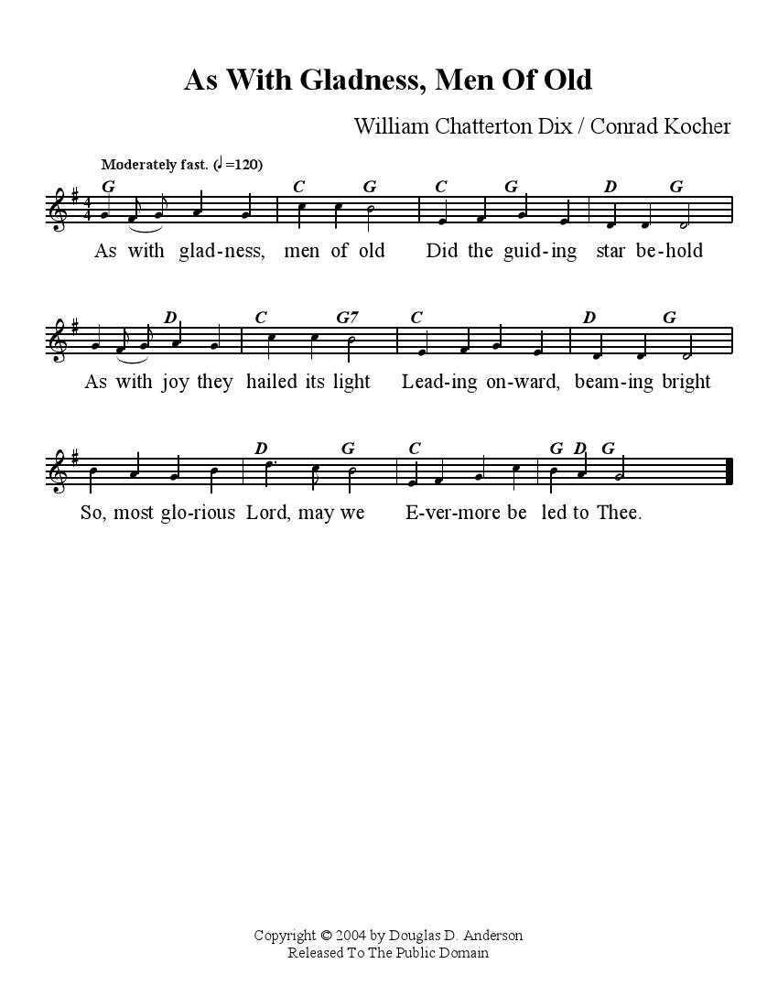

Away In A Manger
Words: Unknown, 1885 (verses 1 & 2)
Verse 3: Attributed to John Thomas McFarland, 1887 (1851-1913)
Attribution by James R. Murray to Martin Luther is incorrect.
Music: "Mueller" by James Ramsey Murray
And over 40 other musical settings.
1. A - [G] way in a manger, no [C] crib for His [G] bed,
The [D7] little Lord Jesus laid [G] down His sweet head;
The [G] stars in the sky looked [C] down where He [G] lay,
The [D7] little Lord [G] Jesus, a -[C] sleep in [D7] the [G] hay.

2. The [G] cattle are lowing, the [C] poor Baby [G] wakes.
But [D7] little Lord Jesus, no [G] crying He makes.
I [G] love thee, Lord Jesus, [C] look down from the [G] sky.
And [D7] stay by the [G] cradle till [C] morning [D7] is [G] nigh.

3. Be [G] near me, Lord Jesus, I [C] ask Thee to [G] stay,
Close [D7] by me forever, and [G] love me, I pray!
Bless [G] all the dear children in [C] Thy tender [G] care
And [D7] take us to [G] heaven, to [C] Live with [D7] Thee [G] there.

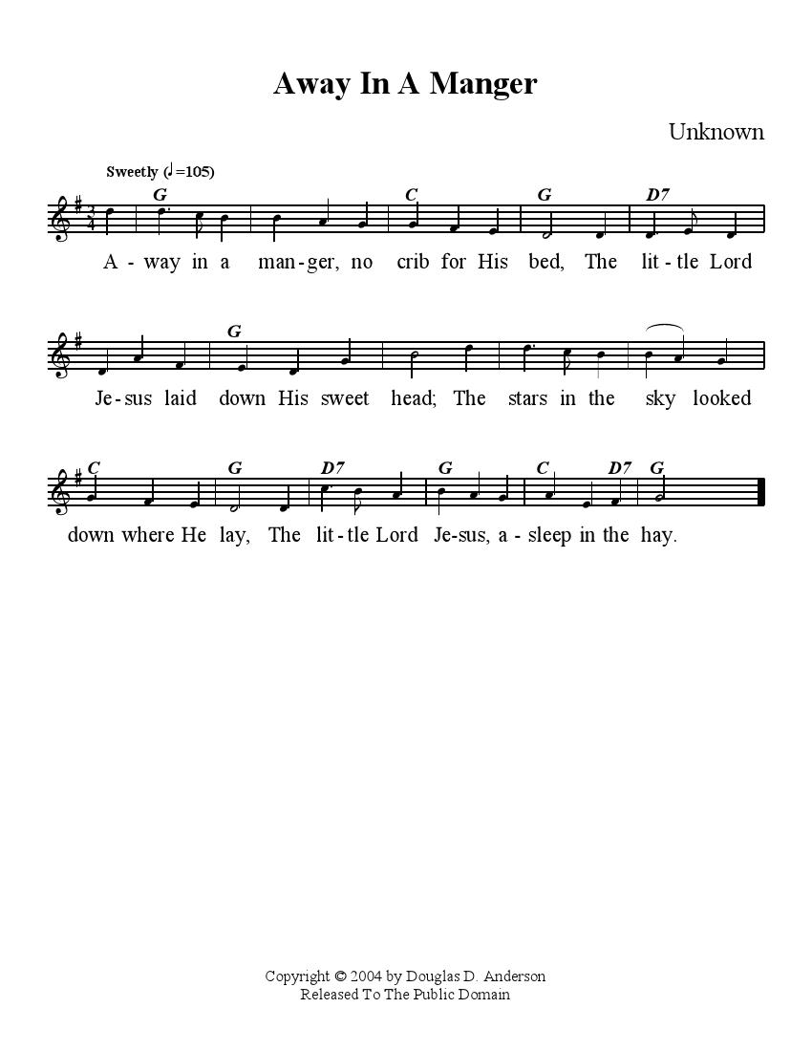

Christ Was Born On Christmas Day
Words: Resonet In Laudibus, freely translated by John Mason Neale, 1853
Music: Resonet In Laudibus, the Finnish title of the German tune, Fourteenth Century, adapted by Thomas Helmore
1. [G] Christ was born on Christmas Day
Wreathe the holly, twine the bay;
[Am] Christus natus [G] ho-di- [D] e;
The [G] Babe, The [C] Son, the [G] Holy [D7] One of [G] Mary.
2. [G] He is born to set us free,
He is born our Lord to be,
[Am] Ex Maria [G] Vir- gi- [D] ne,
The [G] God, the [C] Lord, by [G] all a- [D7] dor’d for- [G] ever.
3. [G] Let the bright red berries glow,
Ev’ry where in goodly show,
[Am] Christus natus [G] ho-di- [D] e;
The [G] Babe, The [C] Son, the [G] Holy [D7] One of [G] Mary.
4. [G] Christian men, rejoice and sing,
‘Tis the birthday of a King
[Am] Ex Maria [G] Vir- gi- [D] ne,
The [G] God, the [C] Lord, by [G] all a- [D7] dor’d for- [G] ever.

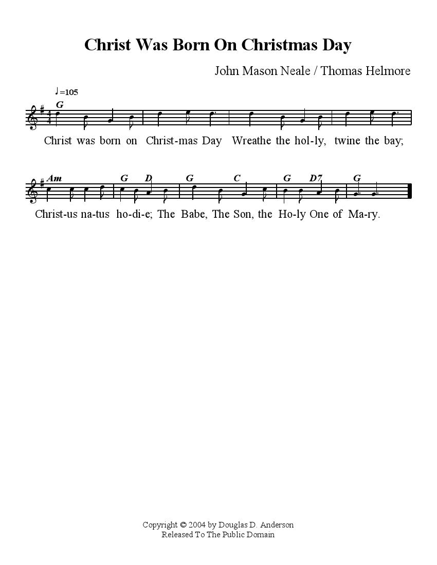

Deck The Halls
Words: Traditional
Music: Old Welsh Air
Mozart used this air for a violin-piano duet in the 1700s.
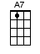 | 1. [G] Deck the halls with boughs of holly, [D7] Fa la la la [G] la, la la [D7] la [G] la.  [G] Tis the season to be jolly, [D7] Fa la la la [G] la, la la [D7] la [G] la.  [D7] Don we now our [G] gay apparel, [G] Fa la la, [Em] la la la, [D] la [A7] la [D7] la.  [G] Troll the ancient Yuletide carol, [C] Fa la la la [G] la, la la [D7] la [G] la.  2. [G] See the blazing Yule before us. [D7] Fa la la la [G] la, la la [D7] la [G] la.  [G] Strike the harp and join the chorus. [D7] Fa la la la [G] la, la la [D7] la [G] la.  [D7] Follow me in [G] merry measure. G] Fa la la, [Em] la la la, [D] la [A7] la [D7] la.  [G] While I tell of Yuletide treasure. [C] Fa la la la [G] la, la la [D7] la [G] la.  3. [G] Fast away the old year passes. [D7] Fa la la la [G] la, la la [D7] la [G] la.  [G] Hail the new ye lads and lasses. [D7] Fa la la la [G] la, la la [D7] la [G] la.  [D7] Sing we joyous [G] all together. G] Fa la la, [Em] la la la, [D] la [A7] la [D7] la.  [G] Heedless of the wind and weather. [C] Fa la la la [G] la, la la [D7] la [G] la.

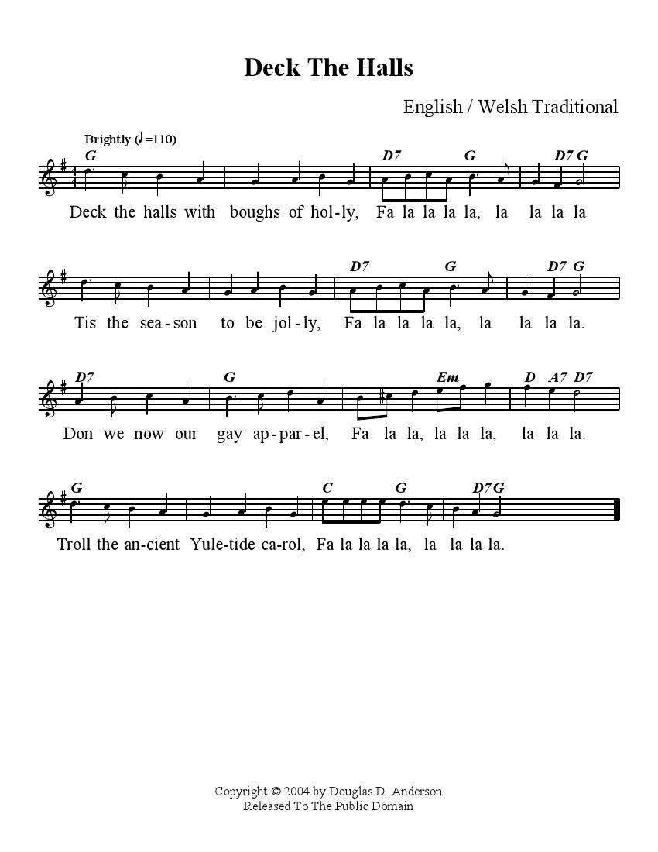

God Rest You Merry, Gentlemen
Words: Traditional English, 18th Century
Music: English Carol, 18th Century
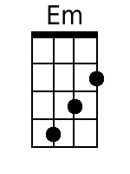  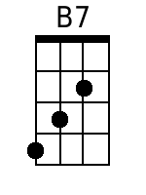  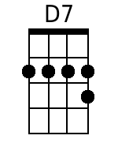  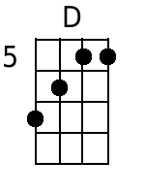 | 1. God [Em] rest you merry, gentlemen,  Let [C] nothing you dismay.  For [Em] Jesus Christ our Savior,  Was [C] born on Christmas [B7] Day;  To [Am] save us all from [G] Satan’s power,  When [Em] we were gone a - [D7] stray.  Chorus  O [G] tidings of [Am] comfort and [Em] joy,  Comfort and [D] joy  O [G] tidings of [Am] com - [B7] fort  and [Em] joy.  2. In [Em] Bethlehem, in Jury,  This [C] blessed Babe was born,  And [Em] laid within a manger,  Up- [C] on this blessed [B7] morn;  The [Am] which His mother [G] Mary  Did [Em] nothing take in [D7] scorn. Chorus  3. From [Em] God our heavenly Father,  A [C] blessed angel came.  And [Em] unto certain shepherds,  Brought [C] tidings of the [B7] same,  How [Am] that in Bethle- [G] hem was born,  The [Em] Son of God by [D7] name: Chorus  4. Fear [Em] not, then said the Angel,  Let [C] nothing you affright,  This [Em] day is born a Savior,  Of [C] virtue, power, and [B7] might;  So [Am] frequently to [G] vanquish all,  The [Em] friends of Satan [D7] quite; Chorus  5. The [Em] shepherds at those tidings,  Re- [C] joiced much in mind,  And [Em] left their flocks a feeding,  In [C] tempest, storm, and [B7] wind,  And [Am] went to Bethle- [G] hem straightway,  This [Em] blessed babe to [D7] find: Chorus  6. But [Em] when to Bethlehem they came,  Where- [C] as this infant lay  They [Em] found him in a manger,  Where [C] oxen feed on [B7] hay;  His [Am] mother Mary [G] kneeling,  Un- [Em] to the Lord did [D7] pray: Chorus  7. Now [Em] to the Lord sing praises,  All [C] you within this place,  And [Em] with true love and brotherhood,  Each [C] other now em- [B7] brace;  This [Am] holy tide of [G] Christmas,  Doth [Em] bring redeeming [D7] grace. Chorus

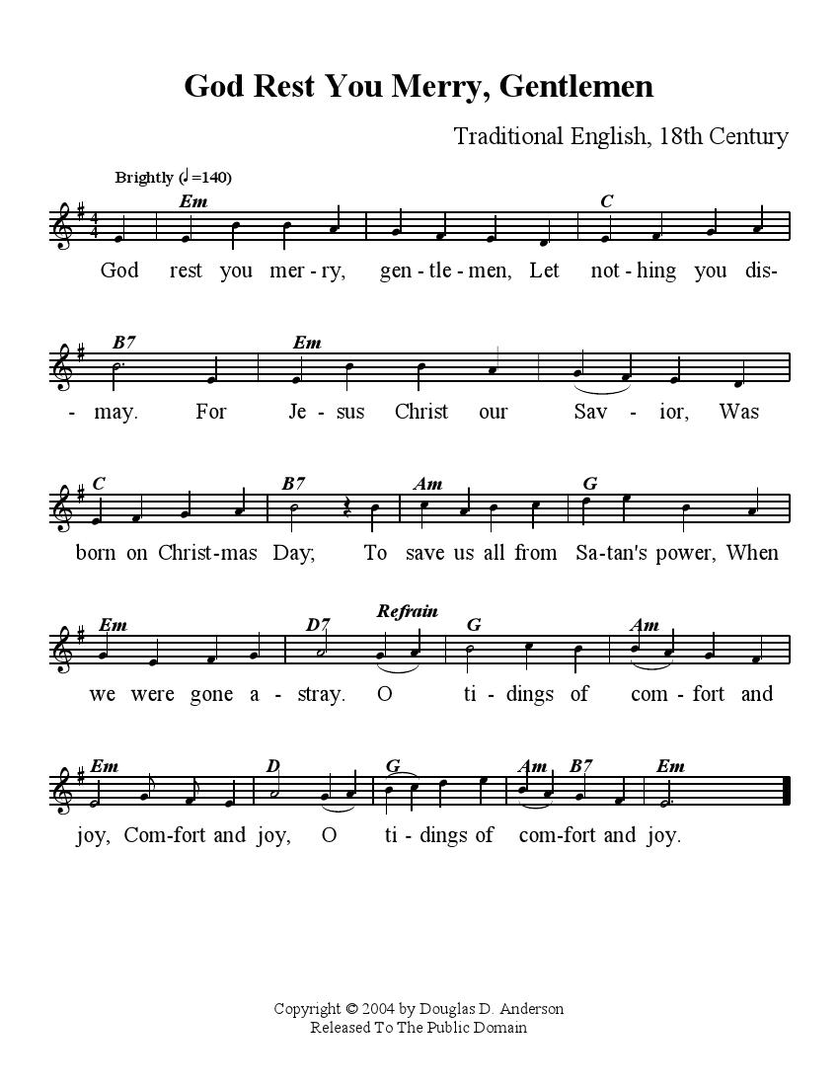

Good Christian Men, Rejoice
Words: Attributed to Heinrich Suso (ca. 1295-1366), Nun singet und seid froh; found in Piae Cantiones and freely translated from Latin to English by John Mason Neale in Carols for Christmastide (London: 1853)
Music: "In Dulci Jubilo," 14th Century German melody
1. Good [G] Christian men, rejoice
With heart and soul and voice,
Give ye [D] heed to [G] what we say:
[Am] Jesus [D7] Christ was [Em] Born [G] today!
[G] Ox and [D] ass be - [G] fore Him [Em] bow,
And [C] He is [D] in the [Em] manger [G] now;
[C] Christ is [D] born to- [Em - D] day!
[G] Christ is [D] born to - [G] day.

2. Good [G] Christian men, rejoice
With heart and soul and voice;
Now ye [D] hear of [G] endless bliss;
[Am] Jesus [D7] Christ was [Em] Born [G] this!
[G] He hath [D] ope'd the [G] heav'nly [Em] door
And [C] man is [D] blessed [Em] ever- [G] more.
[C] Christ was [D] born [Em] for [D] this!
[G] Christ was [D] born for [G] this!

3. Good [G] Christian men, rejoice
With heart and soul and voice;
Now ye [D] need not [G] fear the grave;
[Am] Jesus [D7] Christ was [Em] born to [G] save!
[G] Calls you [D] one and [G] calls you [Em] all
To [C] gain his [D] ever- [Em] lasting G] hall.
[C] Christ was [D] born [Em] to [D] save!
G] Christ was [D] born to [G] save!

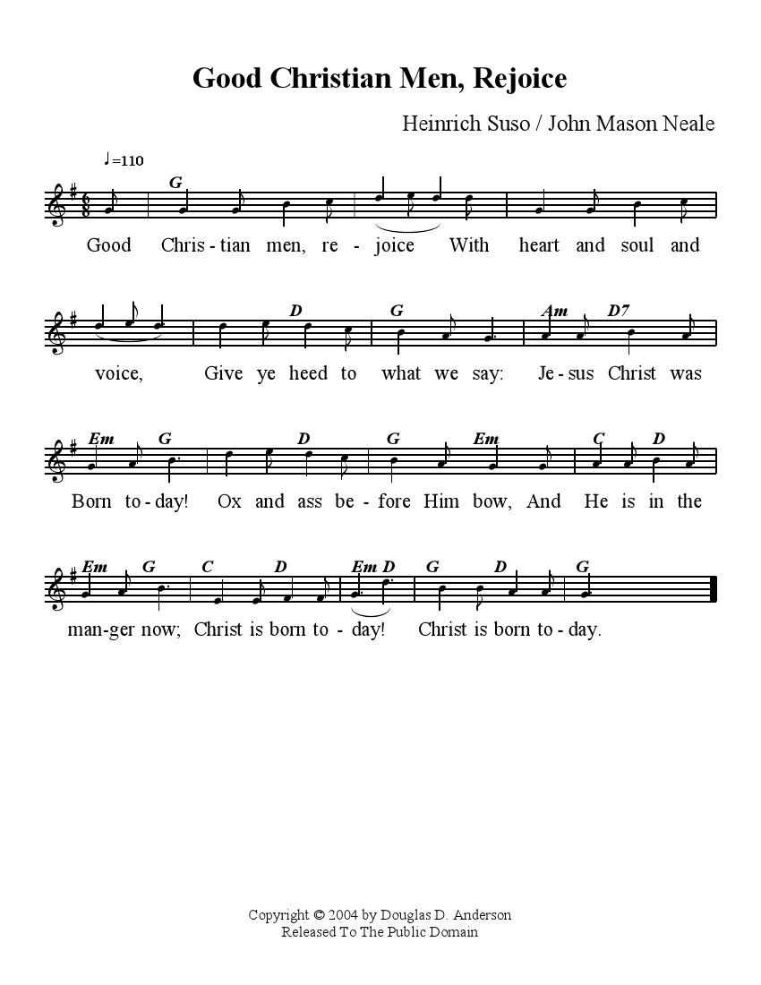

Good King Wenceslas
Words: John Mason Neale (1818-1866); first appeared in Carols for Christmas-Tide, 1853, by Neale and Thomas Helmore. Music: "Tempus Adest Floridum" ("Spring has unwrapped her flowers"), a 13th Century spring carol, first published in the Swedish Piae Cantiones, 1582.
1. [G] Good King Wenceslas looked out,
[C] On the feast of [G] Stephen,
When the snow lay round about,
[C] Deep and crisp [D7] and [G] even:
Brightly shone the moon that night,
[C] Though the frost was [G] cruel,
When a poor man came in [D7] sight,
[G] Gathering winter [Em – C] fu - [G] el.

2. [G] "Hither page and stand by me,
[C] If thou know'st it, [G] telling,
Yonder peasant, who is he,
[C] Where and what [D7] his [G] dwelling?"
"Sire, he lives a good league hence,
[C] Underneath the moun- [G] tain,
Right against the forest [D7] fence,
[G] By Saint Agnes' [Em – C] foun- [G] tain."

3. [G] "Bring me flesh and bring me wine,
[C] Bring me pine logs [G] hither:
Thou and I will see him dine,
[C] When we bear [D7] them [G] thither."
Page and monarch forth they went,
[C] Forth they went to- [G] gether;
Though the rude winds wild la- [D7] ment,
[G] And the bitter [Em – C] wea- [G] ther.

4. [G] "Sire, the night is darker now,
[C] And the wind blows [G] stronger;
Fails my heart, I know now how,
[C] I can go [D7] no [G] longer."
"Mark my footsteps, my good page;
[C] Tread thou in them [G] boldly;
Thou shalt find the winter's [D7] rage
[G] Freeze thy blood less [Em – C] cold- [G] ly."

5. [G] In his master's steps he trod,
[C] Where the snow lay [G] dinted;
Heat was in the very sod
[C] Which the saint [D7] had [G] printed.
Therefore, Christian men, be sure,
[C] Wealth or rank possess- [G] ing,
Ye who now will bless the [D7] poor,
[G] Shall yourselves find [Em – C] bless- [G] ing.

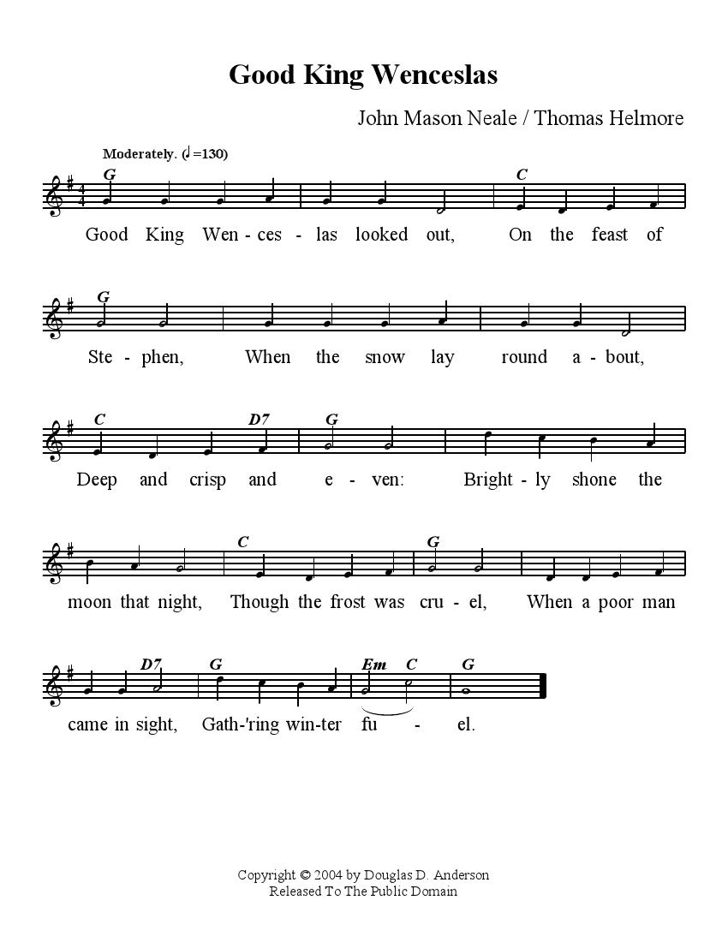

Hark! The Herald Angels Sing
"Hymn For Christmas Day"
Words: Hark How All The Welkin Rings, Charles Wesley (1707-1788), Hymns and Sacred Poems, 1739
Music: "Mendelssohn," ("Gott ist Licht"), Felix Mendelssohn, 1840,
Arranged by William Hayman Cummings; first presented Christmas Day, 1855
1. [G] Hark! The herald angels [D7] sing,
[G] "Glory to the new-born King;
Peace on earth, and mercy [A7] mild,
[D] God and sinners reconciled!"
[G] Joyful, all ye nations, rise.[D7]
[G] Join the triumph [D7] of the skies.
[C] With angelic hosts pro - [Am] claim,
[D7] "Christ is [G] born in Bethlehem!"
[C] Hark! the herald an - [D7] gels [Am] sing,
[D7] "Glory [G] to the
new - [D7] born [G] King."

2. [G] Christ, by highest heaven a- [D7] dored,
[G] Christ the everlasting lord
Late in time behold him [A7] come,
[D] Off-spring of the virgin's womb
[G] Veiled in flesh the Godhead see,[D7]
[G] Hail th' incarnate [D7] deity
[C] Pleased as Man with men to [Am] dwell,
[D7] Jesus our [G] Emmanuel.
[C] Hark! the herald an - [D7] gels [Am] sing,
[D7] "Glory [G] to the
new - [D7] born [G] King."

3. [G] Hail the heav'n-born Prince of [D7] Peace,
[G] Hail, the Son of Righteousness
Light and life to all He [A7] brings,
[D] Ris'n with healing in His wings.
[G] Mild He lays His throne on high,[D7]
[G] Born that man no [D7] more may die
[C] Born to raise the sons of [Am] earth,
[D7] Born to [G] give them second birth.
[C] Hark! the herald an - [D7] gels [Am] sing,
[D7] "Glory [G] to the
new - [D7] born [G] King."

4. [G] Come, Desire of nations [D7] come,
[G] Fix in us Thy humble home;
Oh, to all Thyself im- [A7] part,
[D] Formed in each believing heart!
[G] Hark! the herald angels sing,[D7]
[G] "Glory to the new-born [D7] king;
[C] Peace on earth and mercy [Am] mild,
[D7] God and sinners [G] reconciled!"
[C] Hark! the herald an - [D7] gels [Am] sing,
[D7] "Glory [G] to the
new - [D7] born [G] King."

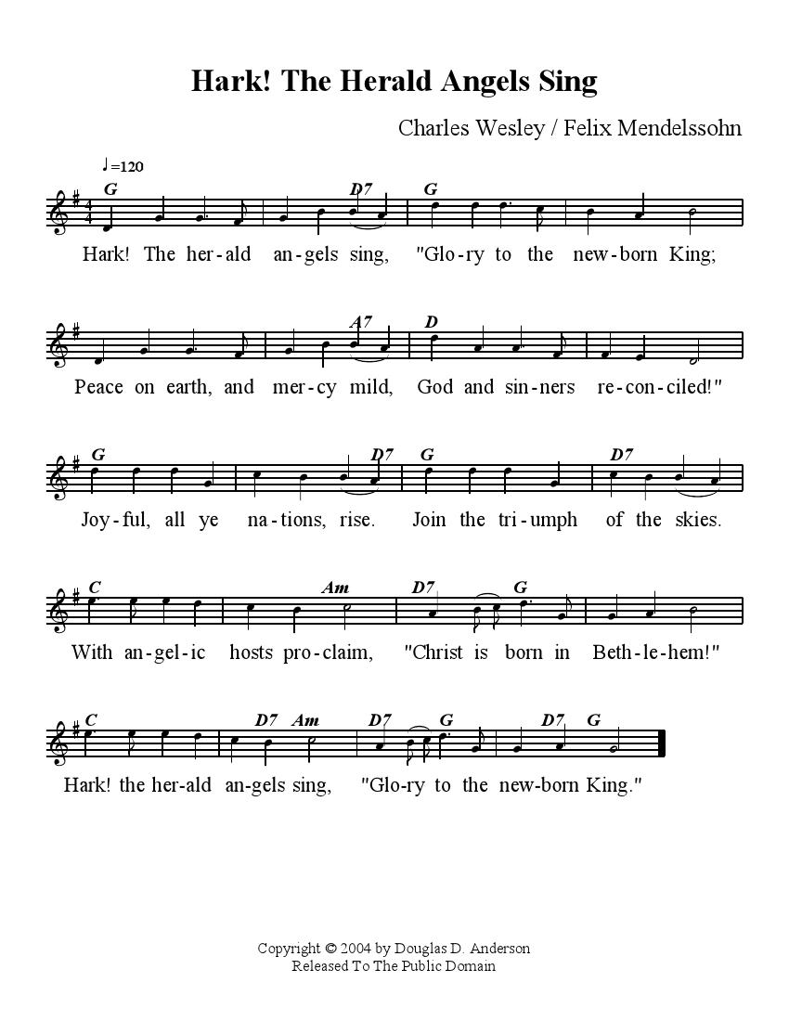

I Saw Three Ships
Alternate Title: On Christmas Day In The Morning
Words: Traditional;
First Publication Date: John Forbes' Cantus, 2nd. ed. (1666)
Music: Traditional English
1. I [G] saw three ships come sailing [D7] in,
On [G] Christmas day, on [D7] Christmas day,
I [G] saw three ships come sailing [D7] in,
On [G] Christmas day in the [D7] morn- [G] ing.

2. And [G] what was in those ships all [D7] three?
On [G] Christmas day, on [D7] Christmas day,
And [G] what was in those ships all [D7] three?
On [G] Christmas day in the [D7] morn- [G] ing.

3. Our [G] Saviour Christ and his la- [D7] dy
On [G] Christmas day, on [D7] Christmas day,
Our [G] Saviour Christ and his la- [D7] dy
On [G] Christmas day in the [D7] morn- [G] ing.

4. Pray [G] whither sailed those ships all [D7] three?
On [G] Christmas day, on [D7] Christmas day,
Pray [G] whither sailed those ships all [D7] three?
On [G] Christmas day in the [D7] morn- [G] ing.

5. Oh, they sailed into Bethlehem,
On [G] Christmas day, on [D7] Christmas day,
Oh, they sailed into Bethlehem,
On [G] Christmas day in the [D7] morn- [G] ing.

6. And all the bells on earth shall ring,
On [G] Christmas day, on [D7] Christmas day,
And all the bells on earth shall ring,
On [G] Christmas day in the [D7] morn- [G] ing.

7. And all the Angels in Heaven shall sing,
On [G] Christmas day, on [D7] Christmas day,
And all the Angels in Heaven shall sing,
On [G] Christmas day in the [D7] morn- [G] ing.

8. And all the souls on earth shall sing,
On [G] Christmas day, on [D7] Christmas day,
And all the souls on earth shall sing,
On [G] Christmas day in the [D7] morn- [G] ing.

9. Then let us all rejoice, amain,
On [G] Christmas day, on [D7] Christmas day,
Then let us all rejoice, amain,
On [G] Christmas day in the [D7] morn- [G] ing.

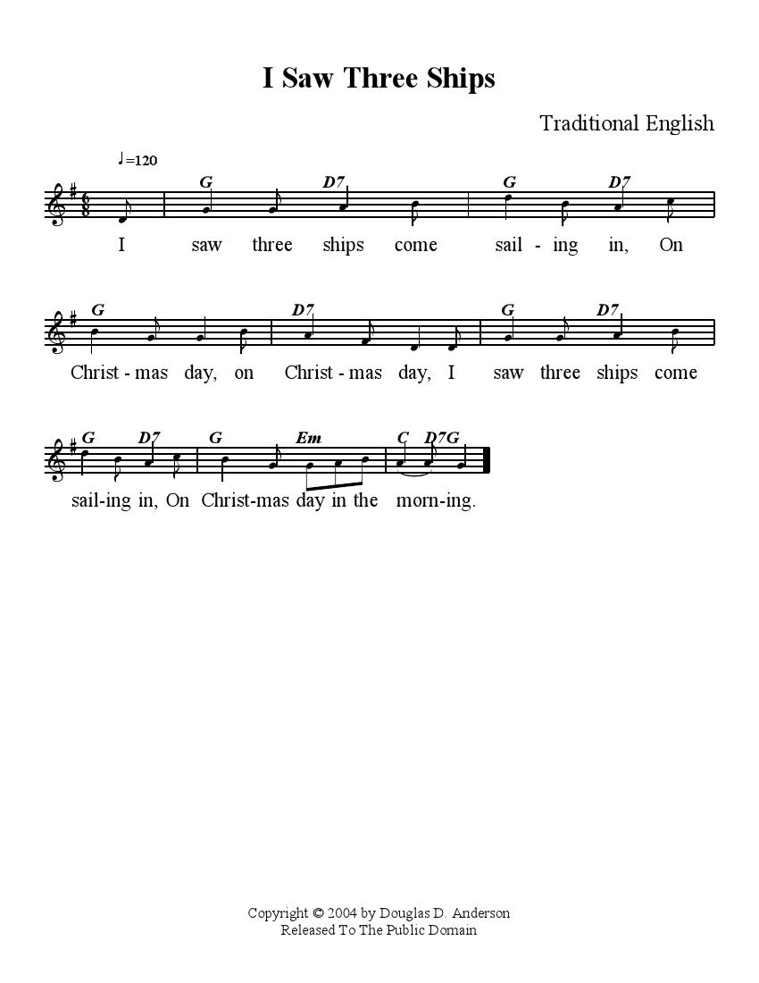

It Came Upon The Midnight Clear
Words: Edmund Hamilton Sears, 1849; first appeared in the Christian Register, 1849.
Music: "Carol," Richard Storrs Willis, 1850
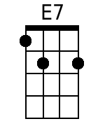 | 1. It [C] came upon the midnight clear,  That [F] glorious song of [G7] old,  From [C] angels bending near the earth,  To [F] touch their harps of [C] gold;  "Peace [E7] on the earth, good [Am] will to men,  From [G] heaven’s all [D7] gracious [G] King."  The [C] world in [F] solemn [C] stillness lay,  To [F] hear the[G7] angels [C] sing.  2. Still [C] through the cloven skies they come,  With [F] peaceful wings un- [G7] furl  And [C] still their heavenly music floats,  O'er [F] all the weary [C] world.  A- [E7] bove its sad and [Am] lowly plains,  They [G] bend on [D7] hovering [G] wing  And [C] ever [F] o'er its [C] Babel sounds,  The [F] blessed [G7] angels [C] sing.  3. Yet [C] with the woes of sin and strife,  The [F] world has suffered [G7] long;  Be- [C] neath the angel-strain have rolled,  Two [F] thousand years of [C] wrong;  And [E7] man, at war with [Am] man, hears not,  The [G] love song which they bring:  O [C] hush the [F] noise, ye [C] men of strife,  And [F] hear the [G7] angels [C] sing.  4. And [C] ye, beneath life's crushing load,  Whose [F] forms are bending [G7] low  Who [C] toil along the climbing way  With [F] painful steps and [C] slow  Look [E7] now! for glad and [Am] golden hours  Come [G] swiftly [D7] on the [G] wing  O [C] rest be- [F] side the [C] weary road  And [F] hear the [G7] angels [C] sing.  5. For [C] lo! the days are hastening on,  By [F] prophet bards fore- [G7] told,  When, [C] with the ever-circling years,  Shall [F] come the Age of [C] Gold;  When [E7] peace shall over [Am] all the earth,  Its [G] ancient [D7] splendors [G] fling,  And [C] all the [F] world give [C] back the song,  Which [F] now the [G7] angels [C] sing.

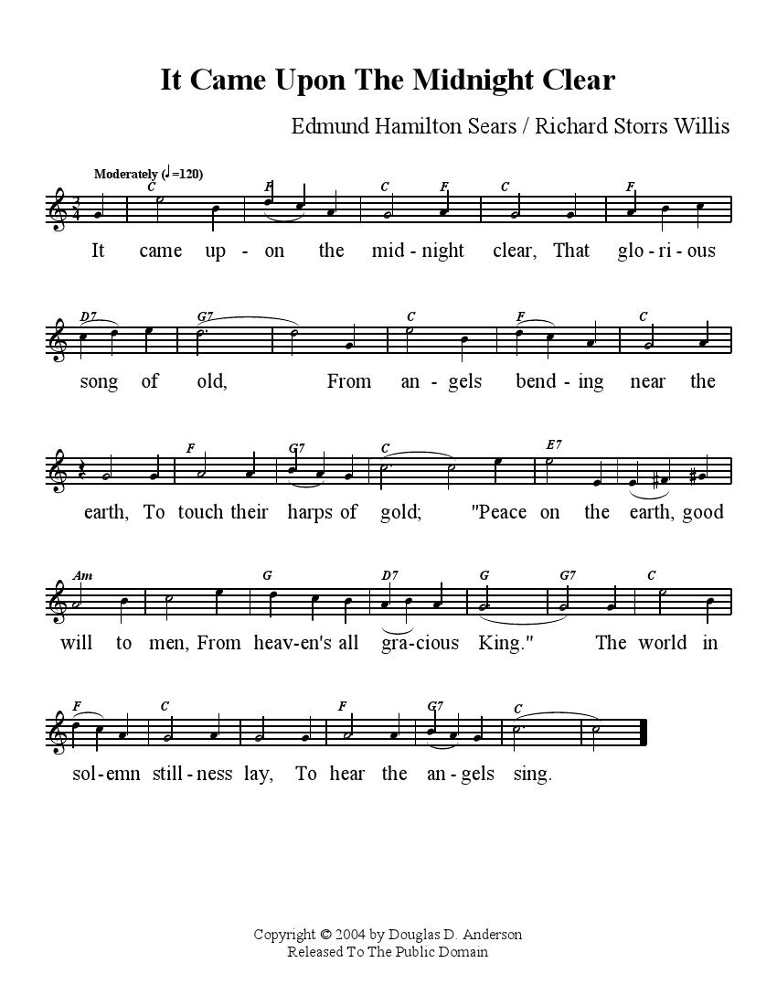

Jingle Bells
Original Title: "One-Horse Open Sleigh"
Words & Music: James Lord Pierpont (1822-1893), copyright 1857
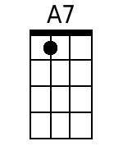 | 1. [G] Dashing through the snow  In a one-horse open [C] sleigh  [Am] Through the fields we [D7] go  [D7] Laughing all the [G] way.  [G] Bells on bob-tail ring  [G] Making spirits [C] bright  What [Am] joy it is to [D7] ride and sing  A [D7] sleighing song to – [G] night. [D7] O!  Chorus:  [G] Jingle bells, jingle bells, jingle all the way,  [C] Oh what fun it [G] is to ride  In a [A7] one-horse open [D] sleigh, [D7] O!  [G] Jingle bells, jingle bells, jingle all the way,  [C] Oh what fun it [G] is to ride  In a [D7] one-horse open [G] sleigh.  2. [G] A day or two ago  I thought I'd take a [C] ride  And [Am] soon Miss Fanny [D7] Bright  Was [D7] seated by my [G] side;  The [G] horse was lean and lank  Mis- [G] fortune seemed his [C] lot,  We [Am] ran into a [D7] drifted bank  And [D7] there we got up- [G] sot. [D7] O! Chorus  3. A [G] day or two ago  The story I must [C] tell  I [Am] went out on the [D7] snow  And [D7] on my back I [G] fell;  A [G] gent was riding by  In a [G] one-horse open [C] sleigh  He [Am] laughed at me as I there  [D7] sprawling laid  But [D7] quickly drove a- [G] way. [D7] O! Chorus  4. [G] Now the ground is white,  Go it while you're [C] young,  [Am] Take the girls a- [D7] long  And [D7] sing this sleighing [G] song.  Just [G] bet a bob-tailed bay,  Two- [G] forty as his [C] speed,  [Am] Hitch him to an [D7] open sleigh  And [D7]crack! You'll take the [G] lead.  [D7] O!Chorus

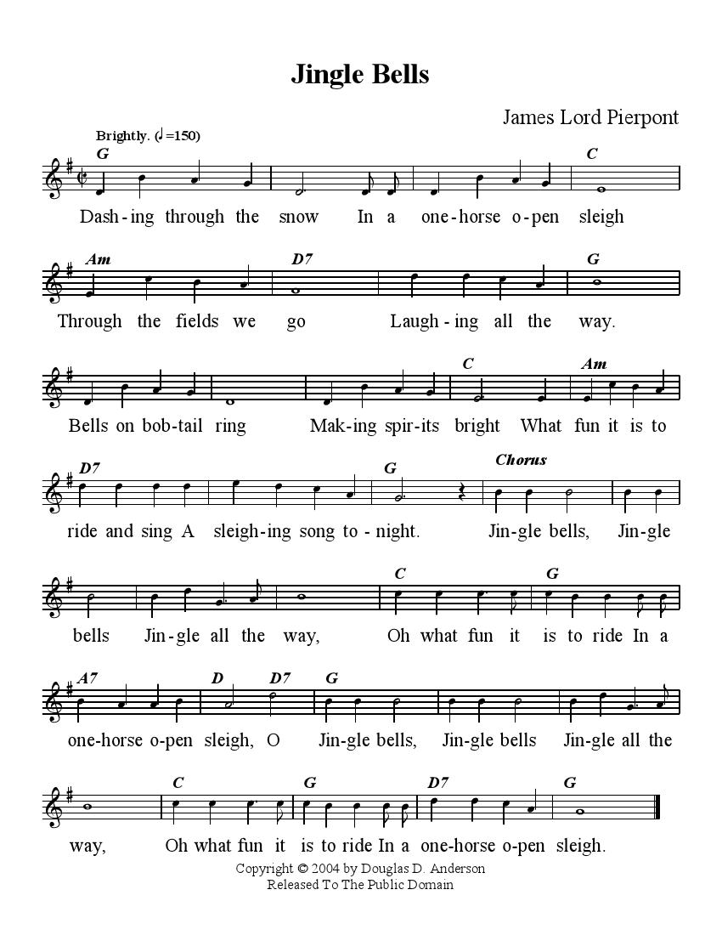

Jolly Old St. Nicholas
Words: Emily Huntington Miller, printed in "The Little Corporal Magazine," December, 1865.
Music published by S. Brainard's Sons before 1881.
Source: Mrs. Alfred Gatty, ed., Aunt Judy's May-Day Volume For Young People.
Volume 6. No. XXXVI. March, 1869 (London: Bell and Daldy, 1869), p. 316,
citing "The Little Corporal Magazine," December, 1865.
"Lilly's Secret"
1. [C] Jolly old St. [G7] Nicholas,
[Am] Lean your ear this [Em] way!
[F] Don't you tell a [C] single soul
[G] What I'm going to [G7] say.
[C] Christmas Eve is [G7] coming soon!
[Am] Now, you dear old [Em] man.
[F] Whisper what you'll [C] bring to me;
[G7] Tell me if you [C] can.

2. [C] When the clock is [G7] striking twelve.
[Am] When I'm fast a- [Em] sleep,
[F] Down the chimney [C] broad and black,
[G] With your pack you'll [G7] creep.
[C] All the stockings [G7] you will see1
[Am] Hanging In a [Em] row;
[F] Mine will be the [C] shortest one —,
[G7] You'll be sure to [C] know.

3. [C] Johnny wants a [G7] pair of skates.
[Am] Susy wants a [Em] dolly,
[F] Nelly wants a [C] story book—
[G] She thinks dolls a [G7] folly.
[C] As for me, my [G7] little brain
[Am] Never was the [Em] wisest.
[F] Choose for me, old [C] Santa Clans,
[G7] What you think is [C] nicest.

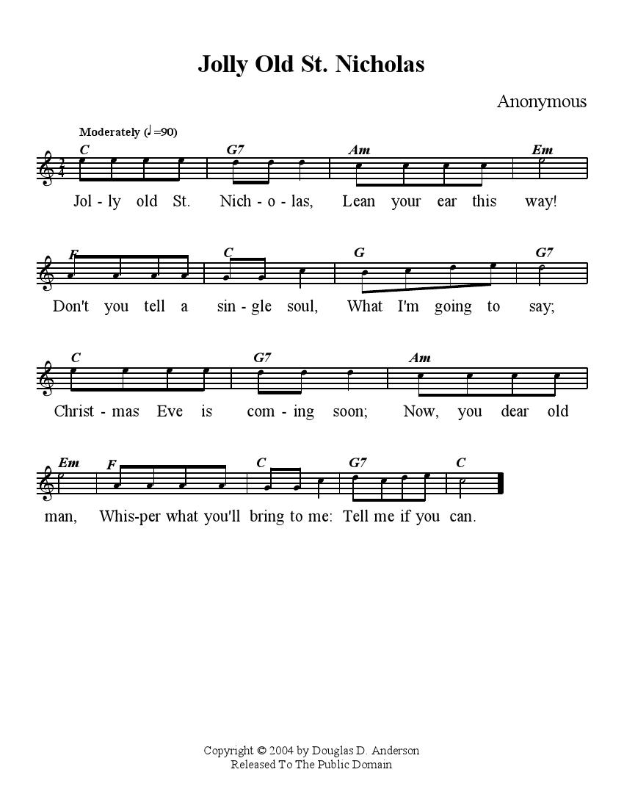

Joy To The World
Words: Isaac Watts, The Psalms of David, Psalm 98, 1719.
Music: "Antioch," Lowell Mason, 1848
1. [C] Joy to the world! The [G7] Lord is [C] come.
Let [F] earth re- [G7] ceive her [C] King;
Let [C] every heart prepare Him room;
And [C] heav’n and nature sing,
And [G7] heav’n and nature sing.
And [C] heav’n and heav’n and na- [G7] ture sing.

2. [C] Joy to the world, the [G7] Savior [C] reigns
Let [F] men their [G7] songs em- [C] ploy.
While [C] fields and floods, Rocks, hills, and plains
Repeat the sounding joy,
[G7] Repeat the sounding joy
Re- [C] peat the sounding [G7] joy

3. [C] No more let sin and [G7] sorrows [C] grow,
Nor [F] thorns [G7] infest the [C] ground;
He [C] comes to make His blessings flow
Far as the curse is found,
[G7] Far as the curse is found,
Far [C] as, far as the curse is [G7] found.

4. [C] He rules the world with [G7] truth and [C] grace,
And [F] makes the [G7] nations [C] prove
The [C] glories of His righteousness.
And wonders of His love,
[G7] And wonders of His love,
And [C] wonders, wonders of His [G7] love.

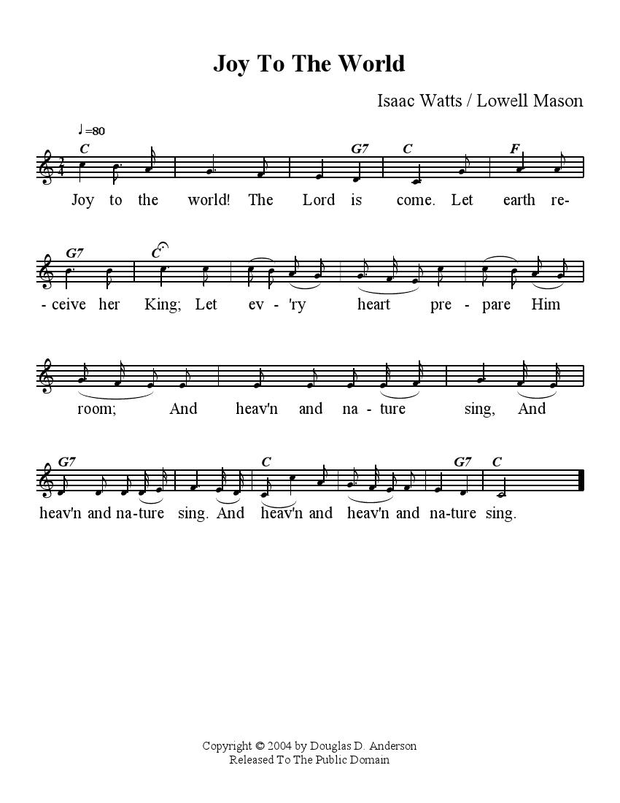

O Christmas Tree
Words: O Tannenbaum. First verse is traditional German; second and third verses by Ernst Gebhard Anschutz, 1824. Translator unknown.
Music: O Tannenbaum, German Folk Song
1. O [G] Christmas Tree, O Christmas tree,
Thy [D7] leaves are green for- [G] ever.
O Christmas Tree, O Christmas tree,
Thy [D7] beauty leaves thee [G] never.
Thy [G] leaves are [C] green in [D7] summer’s prime,
Thy leaves are green at [G] Christmas time.
O Christmas tree, O Christmas tree,
Thy [D7] leaves are green for- [G] ever.

2. O [G] Christmas tree, O Christmas tree,
Much [D7] pleasure doth thou [G] bring me!
O Christmas tree, O Christmas tree,
Much[D7] pleasure doth thou [G] bring me!
For [G] every year [C] the [D7] Christmas tree,
Brings to us all both [G] joy and glee.
O Christmas tree, O Christmas tree,
Much [D7] pleasure doth thou bring [G] me!

3. O [G] Christmas tree, O Christmas tree,
Thy [D7] candles shine out [G] brightly!
O [G] Christmas tree, O Christmas tree,
Thy [D7] candles shine out [G] brightly!
Each [G] bough doth [C] hold its [D7] tiny light,
That makes each toy to sparkle bright.
O [G] Christmas tree, O Christmas tree,
Thy [D7] candles shine out [G] brightly!

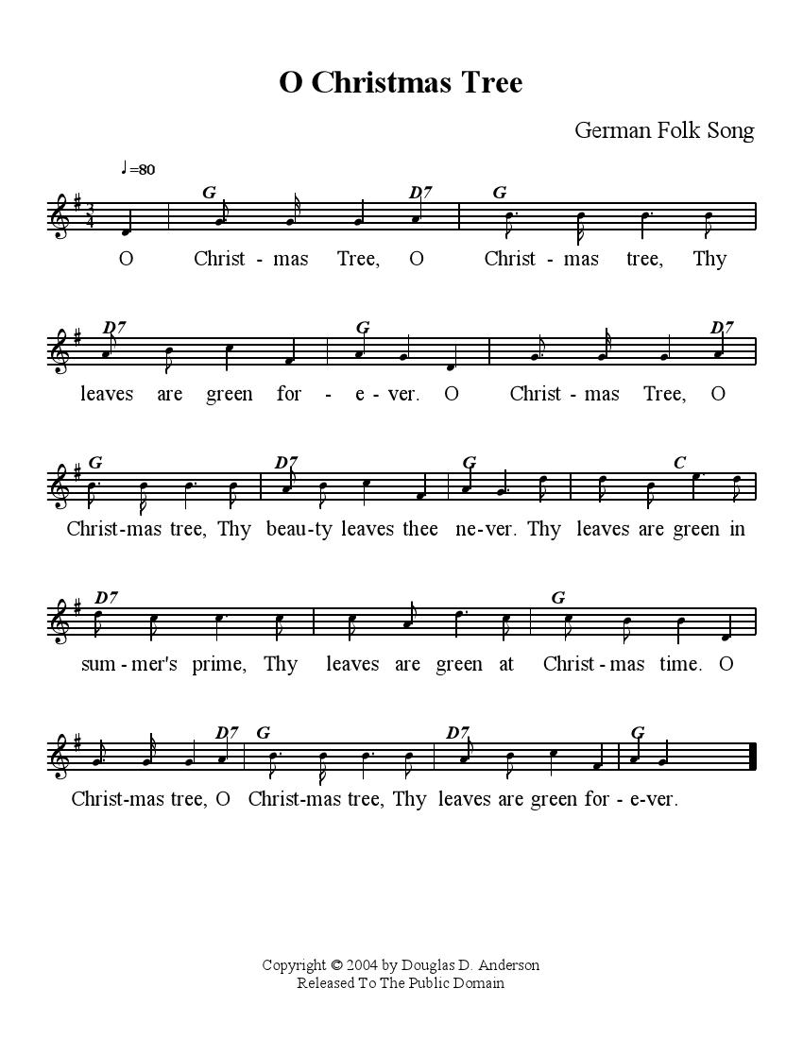

O Come, All Ye Faithful
Hymn on the Prose for Christmas Day
Also known as the Portuguese Hymn
Words: "Adeste Fideles," Verses 1-4, John Francis Wade (c. 1711-1786), circa 1743 / 4
Translated by Frederick Oakeley (1802-1880), 1841
Verses 5-6: Abbé Étienne Jean François Borderies (1764-1832), 1822
Translated by William Thomas Brooke (1848-1917)
Music: "Adeste Fideles," John Francis Wade (c. 1711-1786), circa 1743 (or 1744).
Meter: Irregular
[C]  [Am]  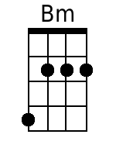  [Bm] | 1. O [G] come, all ye [D] faithful, [G] Joyful and triumphant,  O [Em] Come ye, O [D] come ye, to Bethlehem.  [G] Come and be- [D] hold [G] Him, [D] Born the King of angels;  Refrain  O [G] come, let us adore Him,  O come, let us adore [D] Him,  O [D7] come, let us adore Him,  [G] Christ [D7] the [G] Lord.  2. God of God, Light of Light,  Lo! he abhors not the Virgin’s womb;  Very God, Begotten not created. Chorus  3. Sing, choirs of angels, Sing in exultation;  Sing, all ye citizens of heaven above!  Glory to God, In the highest; Chorus  4. Yea, Lord, we greet Thee, Born this happy morning;  Jesu, to Thee be glory given;  Word of the Father, Now in flesh appearing Chorus  5. See how the shepherds, Summoned to His cradle,  Leaving their flocks, draw nigh to gaze;  We too will thither Bend our hearts' oblations Chorus  6. Child, for us sinners Poor and in the manger,  We would embrace Thee, with love and awe;  Who would not love Thee, Loving us so dearly? Chorus

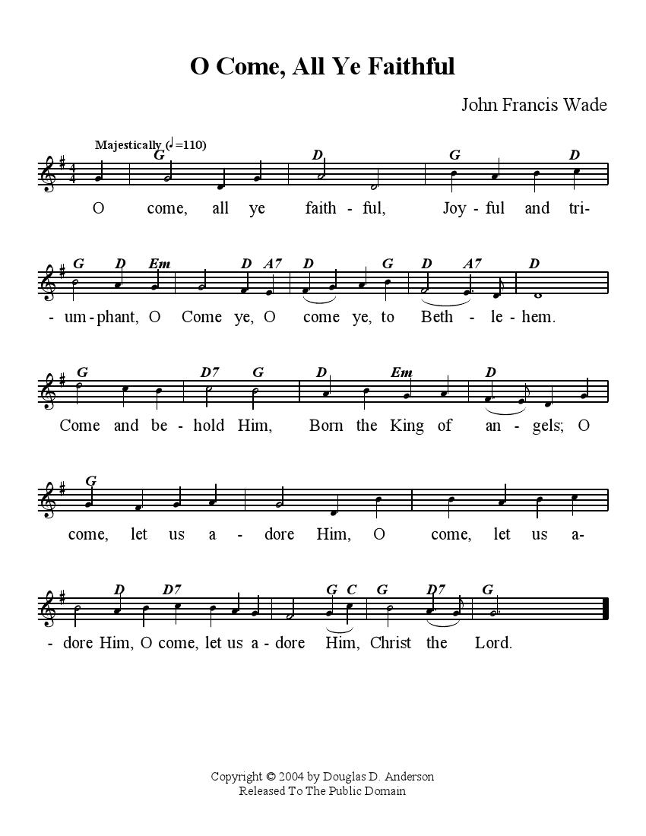

O Come, Little Children
Words: Ihr Kindelein, kommet, Christoph Von Schmid (1840)
Translation: Unknown
Music: Ihr Kinderlein, Kommet, Johann Abraham Peter Schulz (1840)
1. [G] O come, little children, O [C] come, [D7] one and [G] all.
To [G] Bethlehem haste, to the [C] manger [D7] so [G] small.
God’s [D] Son for a [D7] gift has been [G] sent you this [C] day.
To [G] be your redeemer, your[D] joy [D7] and de- [G] light.
2. The hay is His pillow, the manger His bed
The beasts stand in wonder to gaze on His head
Yet there where He lieth, so weak and so poor
Come shepherds and wise men to kneel at His door
3. He’s born in a stable for you and for me,
Draw near by the bright gleaming starlight to see,
In swaddling clothes lying so meek and so mild,
And purer than angels the heavenly child.
4. See Mary and Joseph with love beaming eyes
Are gazing upon the rude bed where He lies,
The shepherds are kneeling, with hearts full of love,
While angels sing loud hallelujahs above.
5. Kneel down and adore Him with shepherds today,
Lift up little hands now and praise Him as they;
Rejoice that a Savior from sin you can boast,
And join in the song of the heavenly host.
6. Now "Glory to God!" sing the angels on high.
And "Peace upon Earth!" heavenly voices reply.
Then come little children, and join in the day
That gladdened the world on that first Christmas Day

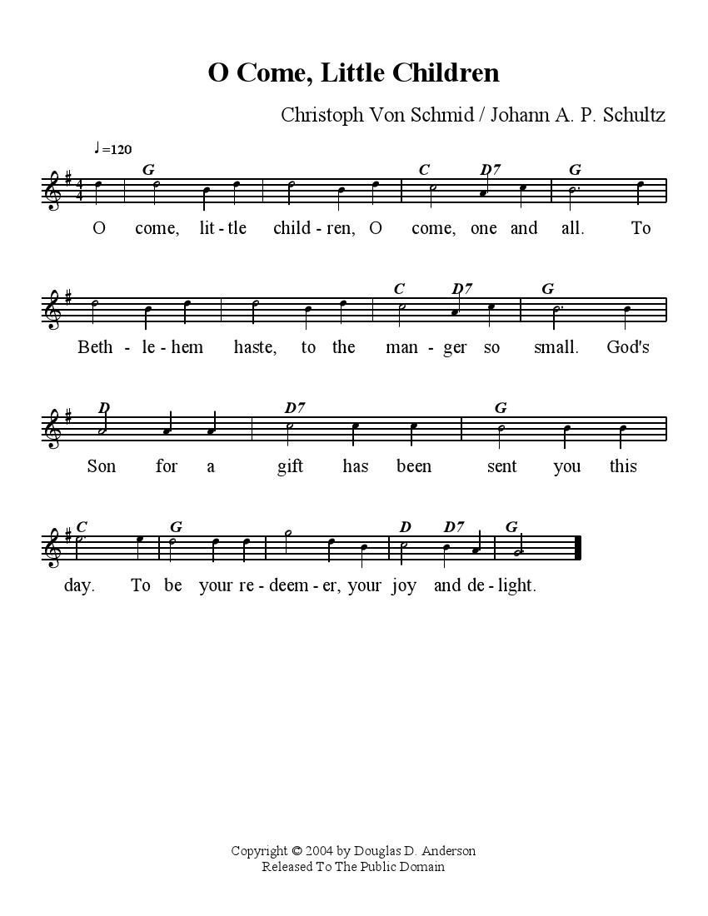

O Come, O Come, Emmanuel
Words: Veni, Veni, Emanuel (the "O" Antiphons), Authorship Unknown, 8th Century Latin; Translated from Latin to English by John Mason Neale
in Mediaeval Hymns and Sequences, 1851.
Music: "Veni Emmanuel," 15th Century French Plain Song Processional,
Arranged and harmonized by Thomas Helmore in Hymnal Noted, Part II (London: 1854).
1. O [Em] come, O come, E- [C] mmanu- [G] el,
And [G] ransom [C] captive [Am] Isra- [Em] el,
That [Am] mourns in lonely [Em] exile [D] here
Un- [D] til the [G] Son of [C] God ap- [G] pear.
Refrain
Re- [D] joice! Re- [Bm] joice! Em- [C] manu- [Em] el
Shall [G] come to [C] thee, O [Am] Isra- [Em] el.
2. O [Em] come, Thou [C] Rod of Jesse, [G] free
Thine own from Satan's tyranny;
From depths of hell Thy people save,
And give them victory over the grave. Refrain

3. O [Em] come, Thou Day-spring, [C] come and [G] cheer
Our spirits by Thine advent here;
And drive away the shades of night
And pierce the clouds and bring us light! Refrain

4. O [Em] come, Thou Key of [C] David, [G] come,
And open wide our heavenly home;
Make safe the way that leads on high,
And close the path to misery. Refrain

5. O [Em] come, O come, Thou [C] Lord of [G] might,
Who to Thy tribes on Sinai's height
In ancient times once gave the law
In cloud, and majesty, and awe. Refrain

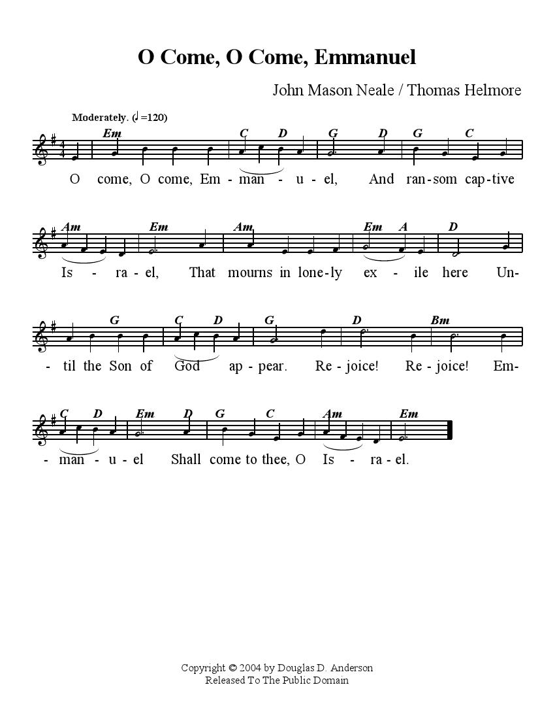

O Holy Night
Minuit Chrétiens or Cantique de Noel
Words: Placide Clappeau, 1847; English Translation by John Sullivan Dwight (1812-1893).
Music: Adolphe-Charles Adam (1803-1856), best known for his ballet Giselle (1841).
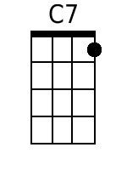 | 1. O holy [C] night, the [F] stars are brightly [C] shining,  It is the [C] night of the [G7] dear Savior’s [C] birth;  Long lay the world in [F] sin and error [C] pining,  Till He ap- [Em] peared and the [B7] soul felt it’s [Em] worth.  A [G7] thrill of hope the [C] weary soul rejoices,  For [G7] yonder breaks a [C] new and glorious morn;  Chorus  [Am] Fall on your [Em] knees, Oh [Dm] hear the angel [Am] voices!  O [C-G7] night di- [C] vine, [F] O [C-G7] night when Christ was [C] born!  O [G7] night [C] divine, O [C] night, [G7] O night di- [C] vine.  2. Led by the light of Faith serenely beaming  With glowing hearts by His cradle we stand  So led by light of a star sweetly gleaming  Here come the wise men from Orient land  The King of Kings lay thus in lowly manger  In all our trials born to be our friend. Chorus  3. Truly He taught us to love one another  His law is love and His gospel is peace  Chains shall He break for the slave is our brother  And in His name all oppression shall cease  Sweet hymns of joy in grateful chorus raise we,  Let all within us praise His holy name. Chorus

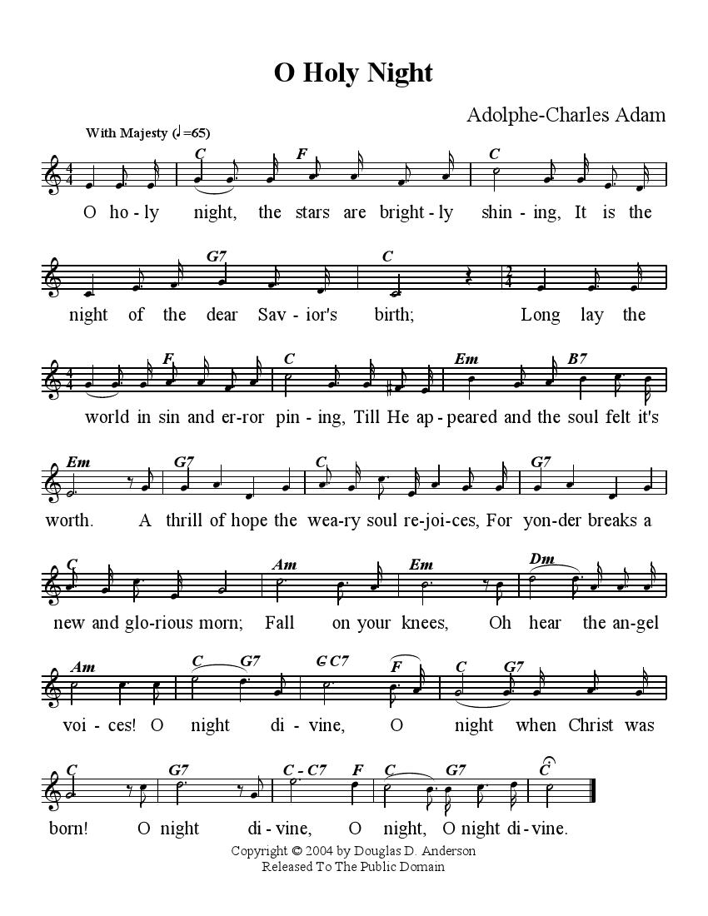

O Little Town of Bethlehem
Words: Phillips Brooks, 1868
Music: "St. Louis," Lewis Henry Redner, 1868
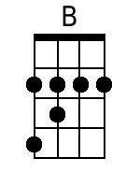 | 1. O [G] little town of [Am] Bethlehem, how [G] still we [D7] see thee [G] lie!  A- [G] bove thy deep and [Am] dreamless sleep the [G] silent [D7] stars go [G] by.  Yet [G] in thy dark streets [B] shineth the [C] everlasting [G] Light;  The [G] hopes and fears of [Am] all the years are [G] met in [D7] thee to- [G] night.  2. For Christ is born of Mary, and gathered all above,  While mortals sleep, the angels keep their watch of wondering love.  O morning stars together, proclaim the holy birth,  And praises sing to God the King, and peace to men on earth!  3. How silently, how silently, the wondrous Gift is given;  So God imparts to human hearts the blessings of His heaven.  No ear may hear His coming, but in this world of sin,  Where meek souls will receive Him still, the dear Christ enters in.  4. Where children pure and happy pray to the blessed Child,  Where misery cries out to Thee, Son of the mother mild;  Where charity stands watching and faith holds wide the door,  The dark night wakes, the glory breaks, and Christmas comes once more.  5. O holy Child of Bethlehem, descend to us, we pray;  Cast out our sin, and enter in, be born in us today.  We hear the Christmas angels, the great glad tidings tell;  O come to us, abide with us, our Lord Emmanuel!

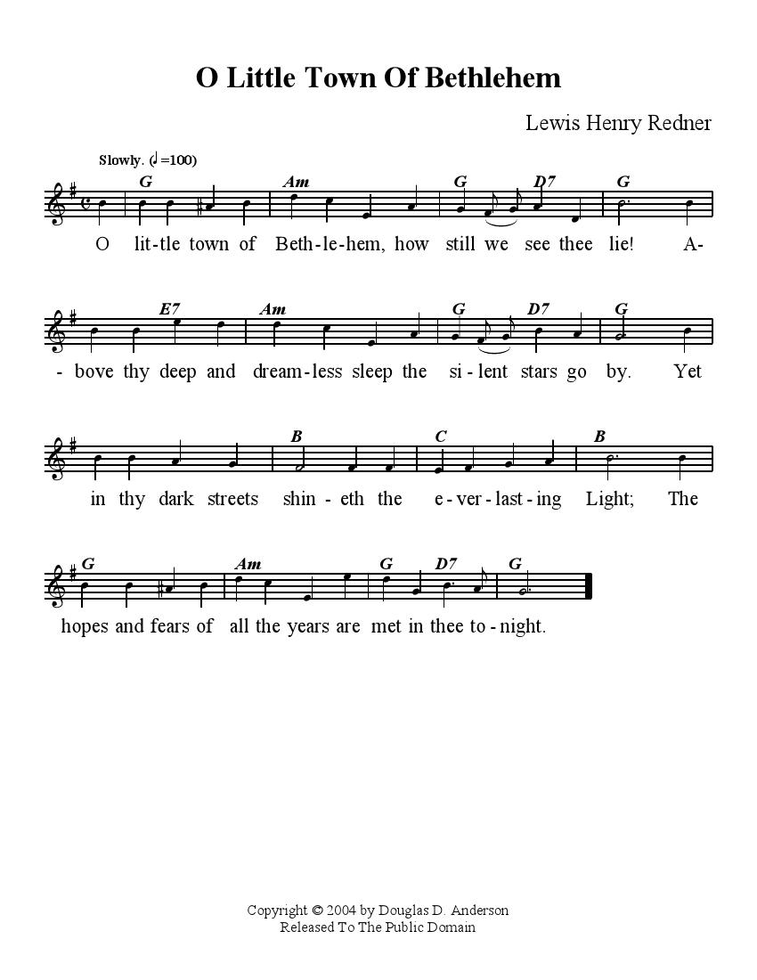

Once In Royal David's City
Words: Cecil Frances Humphreys Alexander, Hymns for Little Children, 1848.
Music: "Irby," Henry John Gauntlett (1805-1876), 1849
1. [G] Once in royal David's city, Stood a [Bm] lowly cattle [G] shed,
Where a [G] mother laid her Baby, In a [Bm] manger for His [G] bed:
[C] Mary [G] was that mo- [D] ther [G] mild, [C] Jesus [G] Christ her [C] lit- [D] tle [G] Child.
2. He came down to earth from heaven, Who is God and Lord of all,
And His shelter was a stable, And His cradle was a stall;
With the poor, and mean, and lowly, Lived on earth our Savior holy.
3. And through all His wondrous childhood, He would honor and obey,
Love and watch the lowly maiden, In whose gentle arms He lay:
Christian children all must be, Mild, obedient, good as He.
4. For he is our childhood's pattern; Day by day, like us He grew;
He was little, weak and helpless, Tears and smiles like us He knew;
And He feeleth for our sadness, And He shareth in our gladness.
5. And our eyes at last shall see Him, Through His own redeeming love;
For that Child so dear and gentle, Is our Lord in heaven above,
And He leads His children on, To the place where He is gone.
6. Not in that poor lowly stable, With the oxen standing by,
We shall see Him; but in heaven, Set at God's right hand on high;
Where like stars His children crowned, All in white shall wait around.

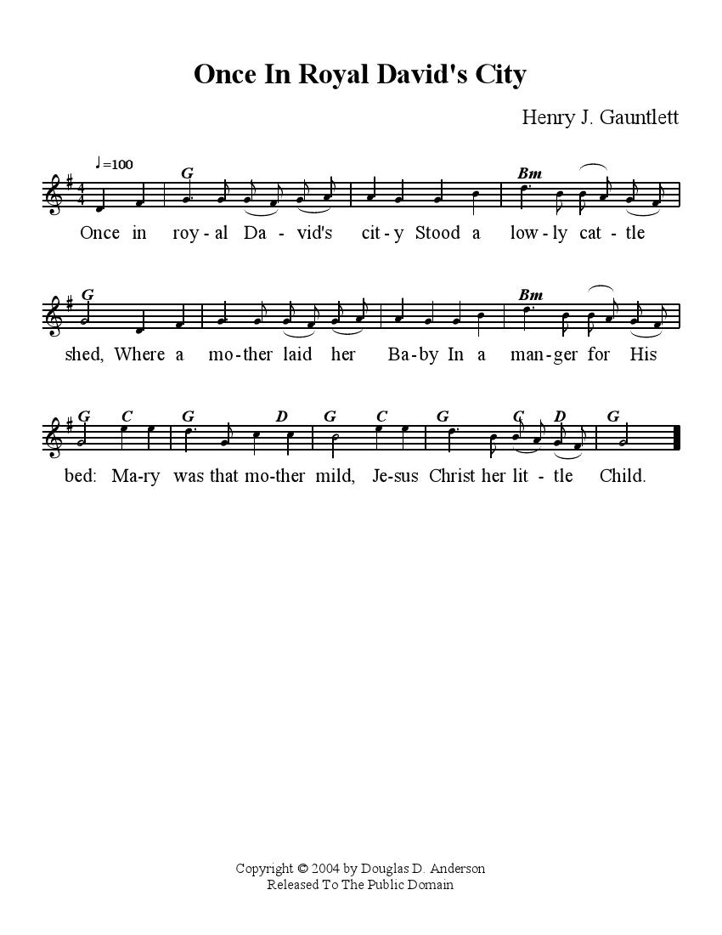

Silent Night, Holy Night
Words: Stille Nacht! Heilige Nacht!, Rev. Joseph Mohr, 1816
Music "Stille Nacht," by Franz Gruber, 1818
Translated by Rev. John Freeman Young (1820-1885) from
J. Freeman Young, Carols For Christmas Tide. (New York: Daniel Dana, Jr., 1859)
1. [C] Silent night! Holy night!
[G7] All is calm, [C] all is bright.
[F] Round yon Virgin [C] Mother and Child.
[F] Holy Infant, so [C] tender and mild.
[G7] Sleep in heavenly [C] peace,
Sleep in [G7] heavenly [C] peace.
2. Silent night! Holy night!
Shepherds quake at the sight!
Glories stream from heaven afar;
Heavenly hosts sing Alleluia!
Christ, the Savior, is born!
Christ, the Savior, is born!
3. Silent night! Holy night!
Son of God, love’s pure light
Radiant beams from Thy Holy Face.
With the dawn of redeeming grace.
Jesus, Lord, at Thy birth!
Jesus, Lord, at Thy birth!

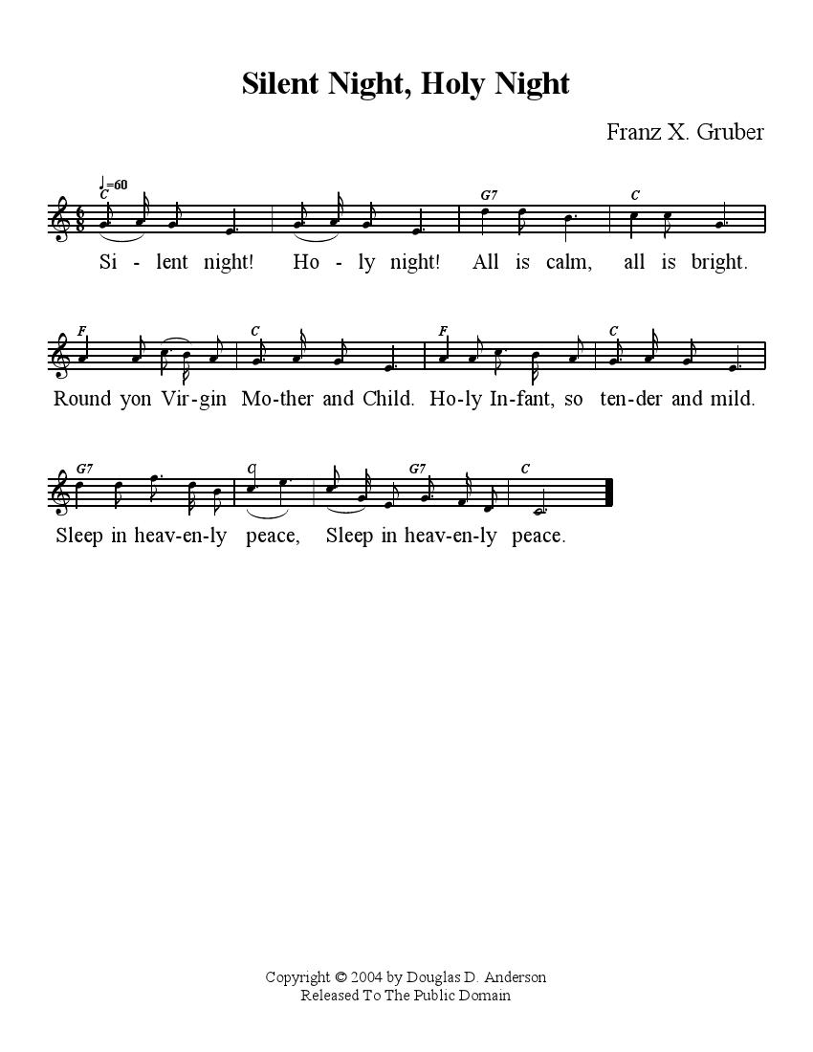

The Coventry Carol - Work
Words Attributed to Robert Croo, 1534
English Melody, 1591
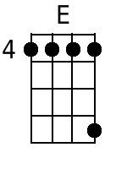  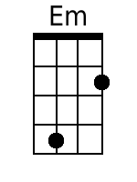  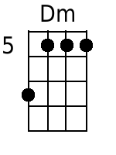  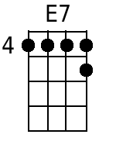 | 1. [Am] Lullay, [E or Em?] Thou [Am] little [Dm] tiny [E] Child,  [Am] By, by, lul- [Dm] ly, [E7] lul- [Am] lay.  [C] Lul- [G] lay, [Am] Thou [E] lit- [Am] tle [Dm] tiny [E] Child.  [Am] By, by, lul- [Dm] ly, [E] lul- [A] lay.  2. O sisters, too, how may we do,  For to preserve this day;  This poor Youngling for whom we sing,  By, by, lully, lullay.  3. Herod the King, in his raging,  Charged he hath this day;  His men of might, in his own sight,  All children young, to slay.  4. Then woe is me, poor Child, for Thee,  And ever mourn and say;  For Thy parting, nor say nor sing,  By, by, lully, lullay.
E chord is impossible. Go for another key. Elsewhere, the last E in the first line is an E7.
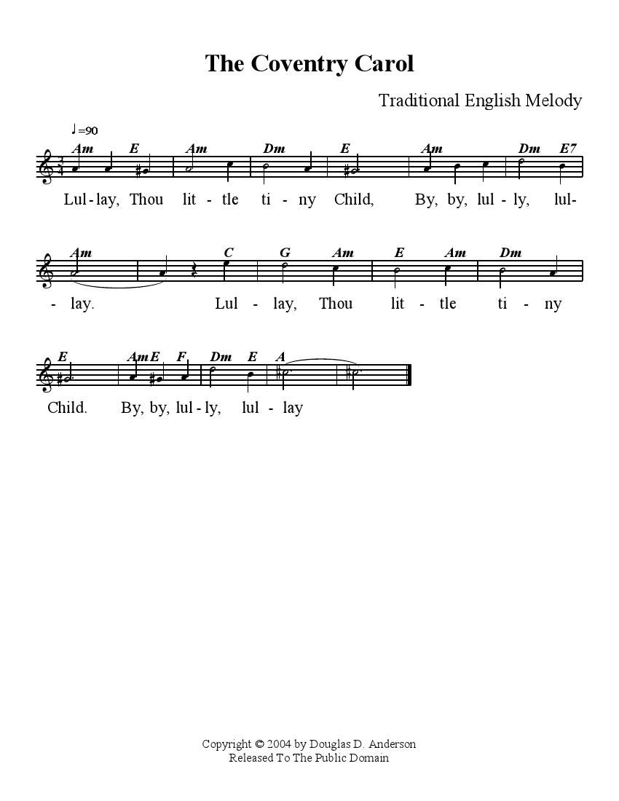

The First Nowell
For Christmas Day In The Morning
Words & Music: Traditional English carol of the 16th or 17th century, but possibly dating from as early as the 13th Century. First publication in Davies Gilbert (1823) but Broadsides may have appeared earlier.
1. The [C] first nowell the Angel did say
Was to [C] certain poor shepherds in fields as they lay.
In [C] fields where they lay keeping their sheep,
In a [C] cold winter’s night that was so deep.
Chorus
[C] Nowell, nowell, no- [F] well, no- [C] well.
[Am] Born is the [C] King of Is- [G7] ra- [C] el.
2. They looked up and saw a Star
Shining in the East beyond them far,
And to the earth it gave great light,
And so it continued both day and night. Chorus.
3. And by the lightning of that Star
There came three Wise Men from countries far,
To seek a King was their intent,
And to follow the Star wheresoever it went. Chorus.
4. This Star drew nigh to the North West,
And at Bethlehem Jury she took up her rest,
And there she did both stop and stay,
Right over the house where the King did lay. Chorus.
5. Between an ox-stall and an ass
This Child truly there born was;
For want of clothing there did him lay
All in an ox-manger amongst the hay. Chorus.
6. Now let us all with one accord
Sing praises to our Heavenly Lord,
The which hath made Heaven and Earth of nought,
And by his blood Mankind hath bought. Chorus.

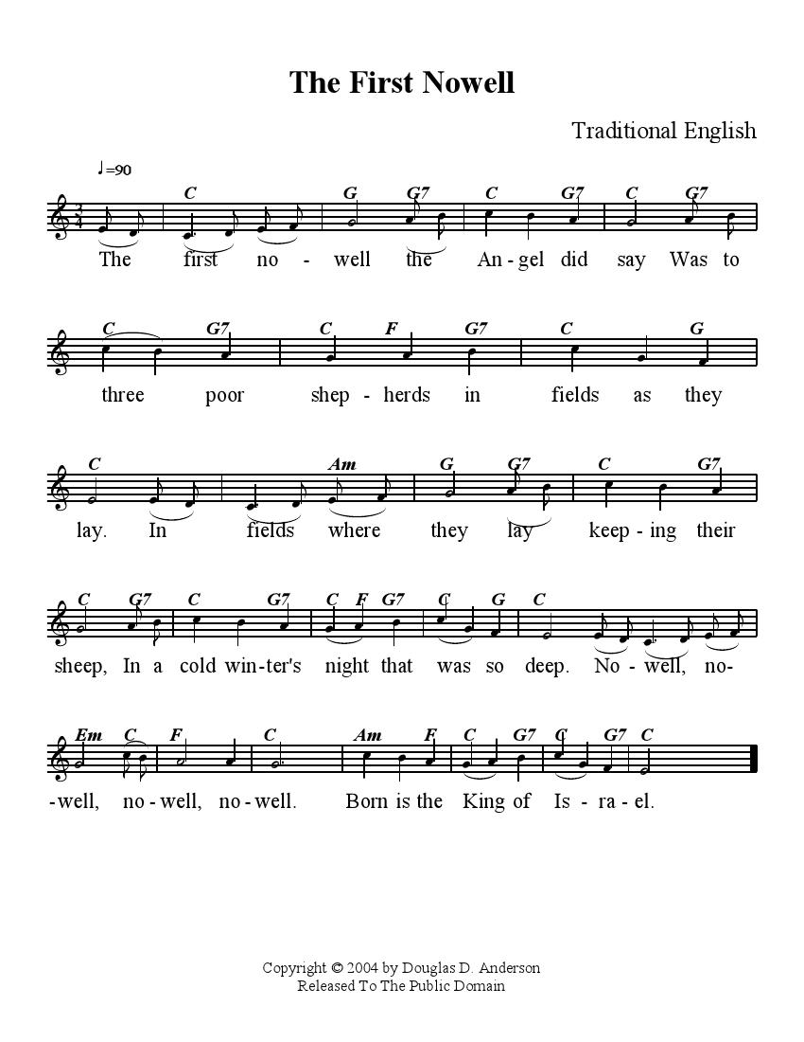

The Holly And The Ivy - Work
Words: Traditional
Music: Old French Carol; Arranged by Sir John Stainer
[D7] | 1. [G] The holly and [C] the [G] ivy,  Now [G] both are full [C] well [D] grown.  Of [G] all the trees that are [C] in the wood,  [Em] The [C] holly bears [D] the [G] crown.  Chorus  [C] Oh, the [G] rising of [C] the [G] sun,  The [G] running of [C] the [D] deer.  The [G] playing of the [C] merry  [G] or- [Em] gan,  Sweet [C] singing in [D] the [G] quire.  2. The holly bears a blossom  As white as lily flower;  And Mary bore sweet Jesus Christ  To be our sweet Savior. Chorus  3. The holly bears a berry  As red as any blood;  And Mary bore sweet Jesus Christ  To do poor sinners good. Chorus  4. The holly bears a prickle  As sharp as any thorn;  And Mary bore sweet Jesus Christ  On Christmas day in the morn. Chorus  5. The holly bears a bark  As bitter as any gall;  And Mary bore sweet Jesus Christ  For to redeem us all. Chorus  6. The holly and the ivy,  When they are both full grown,  Of all the trees that are in the wood,  The holly bears the crown. Chorus

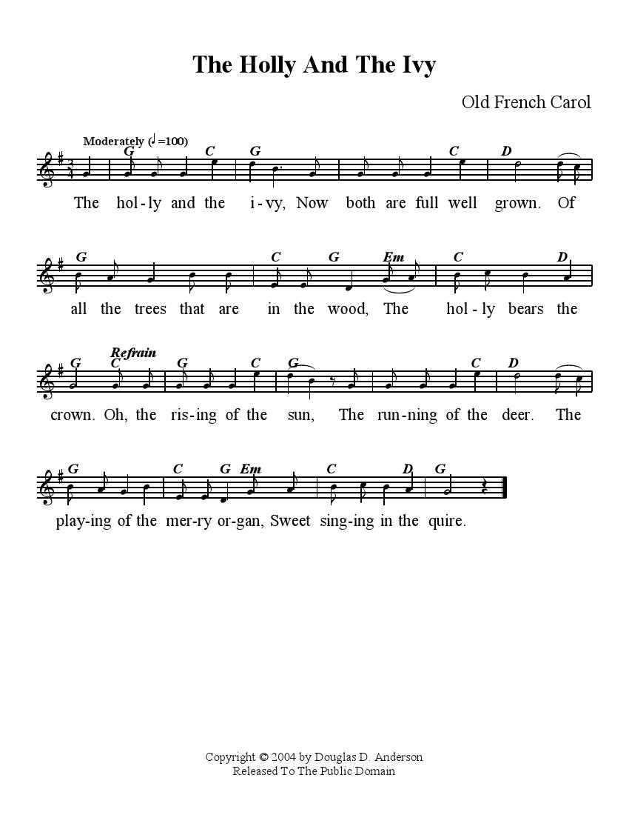

The Wassail Song - Work
Alternate Title: "Here We Come A Wassailing"
Words: English Traditional, 17th century
Music: Traditional English Wassail Song, 17th century
1. [C] Here we come a wassailing
Among the [G7] leaves so [C] green,
[F] Here we [C] come a [G7] wandering
So [Dm] fair to be [G7] seen.
Chorus
Love and [C] joy [F] come to [C] you,
And [G7] to [C] you your [F] wassail [C] too,
And [G7] God [C] bless [A7] you and
[Dm] Send you a [C] happy New [G7] Year.
And God [C] send you a
[Dm] Happy [G7] New [C] Year.
2. Our wassail cup is made
Of the rosemary tree,
And so is your beer
Of the best barley. Chorus
3. We are not daily beggars
That beg from door to door,
But we are neighbours' children
Whom you have seen before. Chorus
4. Good Master and good Mistress,
As you sit by the fire,
Pray think of us poor children
Are wandering in the mire. Chorus
5. We have a little purse
Made of ratching leather skin;
We want some of your small change
To line it well within. Chorus
6. Call up the Butler of this house,
Put on his golden ring;
Let him bring us a glass of beer,
And the better we shall sing. Chorus
7. Bring us out a table,
And spread it with a cloth;
Bring us out a mouldy cheese,
And some of your Christmas loaf. Chorus
8. God bless the Master of this house,
Likewise the Mistress too;
And all the little children
That round the table go. Chorus

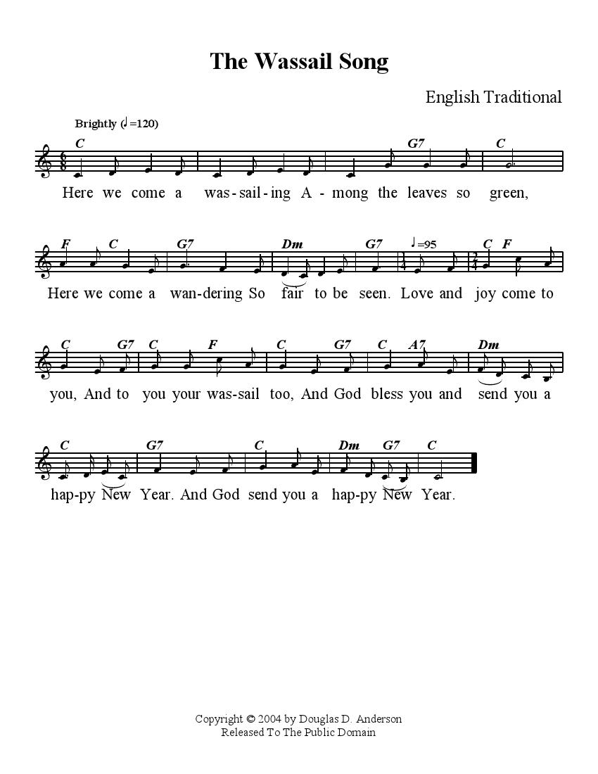

Up On The Housetop - Work
Words and Music by Benjamin R. Hamby, circa 1860
1.[C] Up on the housetop reindeer pause,
[F] Out jumps [C] good old [G7] Santa Claus.
[C] Down thru the chimney with lots of toys,
[F] All for the [C] little ones, [G7] Christmas [C] joys.
Chorus
[F] Ho, ho, ho! [C] Who wouldn’t go.
[G7] Ho, ho, ho! [C] Who wouldn’t go!
Up on the house- [C7] top, [F] click, click, click.
[C] Down thru the chimney with [G7] good Saint [C] Nick.
2. First comes the stocking of little Nell;
Oh, dear Santa, fill it well;
Give her a dolly that laughs and cries,
One that will open and shut her eyes. Chorus
3. Next comes the stocking of little Will
Oh, just see what a glorious fill
Here is a hammer, And lots of tacks
Also a ball, And a whip that cracks. Chorus

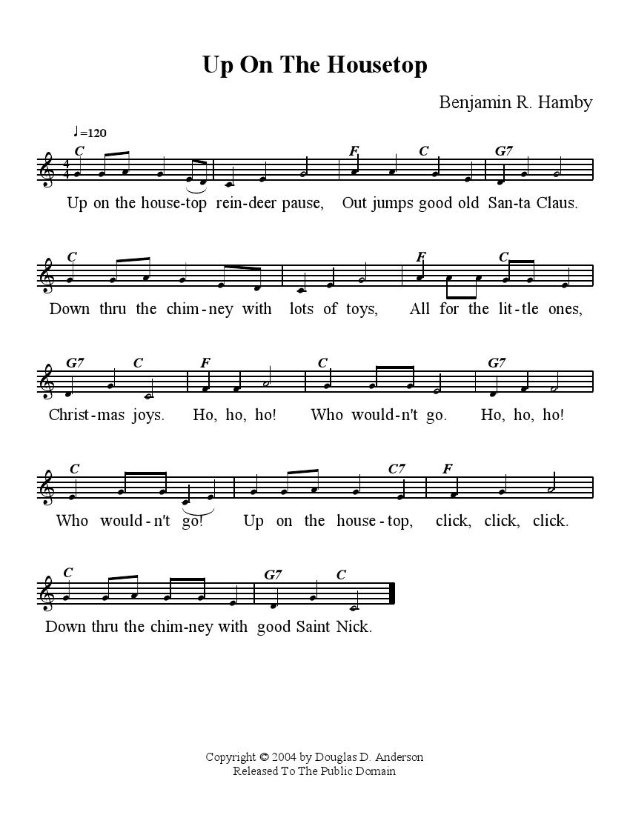

We Three Kings Of Orient Are - Work
Words: John Henry Hopkins, Jr., 1857.
Music: “Kings of Orient,” John Henry Hopkins, Jr.
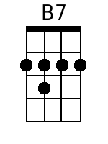 | 3 Kings:  [Em] We three kings of [B7] Orient [Em] are  Bearing gifts, we [B7] traverse a- [Em] far.  Field and [D] fountain, [G] moor and mountain,  [Am] Following [B7] yonder [Em] star.  Chorus  [D7] Oh, [G] star of wonder,  [C] star of [G] night,  Star with royal [C]beauty [G] bright,  [Em] Westward leading,  [D] still proceeding,  [G] Guide us to thy  [C] perfect [G] Light.  Gaspard:  [Am] Born a king on [G7] Bethlehem's [Am] plain,  Gold I bring to [G7] crown Him a- [Am] gain,  King for- [G] ever, [C] ceasing never,  [Em] Over us [G7] all to [Am] reign. Chorus  Melchior:  Frankincense to offer have I;  Incense owns a Deity nigh.  Prayer and praising, all men raising,  Worship Him God on high. Chorus  Balthazar:  Myrrh is mine; It’s bitter perfume;  Breathes a life of gathering gloom.  Sorrowing, sighing, bleeding, dying,  Sealed in the stone-cold tomb. Chorus  3 Kings:  Glorious now behold Him arise,  King and God and sacrifice.  Alleluia, Alleluia;  Earth to the heavens replies. Chorus

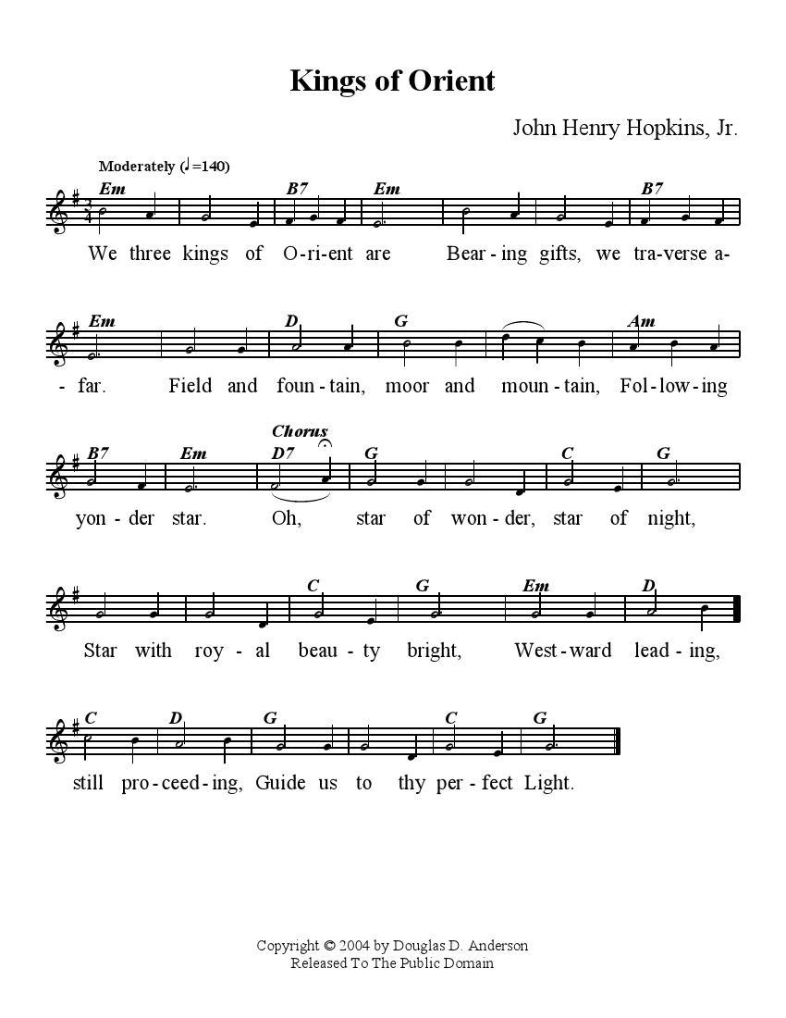

What Child Is This? - Work
Words: William Chatterton Dix, 1865.
Music: "Greensleeves," 16th Century English melody
Arranged by Sir John Stainer
[C]  [D7]  [Bm] | 1. What [Em] Child is [G] this who, [D] laid to rest  On [Em] Mary's [Am] lap is [B or Bm?] sleeping?  Whom [Em] Angels [G] greet with [D] anthems sweet,  While [Em] shepherds watch are keeping?  [Bm] This, [G] this is [D] Christ the King,  Whom [Em] shepherds [Am] guard and [B or Bm?] Angels sing;  [G] Haste, haste, to [D] lbring Him laud,  The [Em] Babe, the [B or Bm?] Son of [Em] Mary.  2. Why lies He in such mean estate,  Where ox and ass are feeding?  Good Christians, fear, for sinners here  The silent Word is pleading.  Nails, spear shall pierce Him through,  The cross be borne for me, for you.  Hail, hail the Word made flesh,  The Babe, the Son of Mary.  3. So bring Him incense, gold and myrrh,  Come peasant, king to own Him;  The King of kings salvation brings,  Let loving hearts enthrone Him.  Raise, raise a song on high,  The virgin sings her lullaby.  Joy, joy for Christ is born,  The Babe, the Son of Mary.

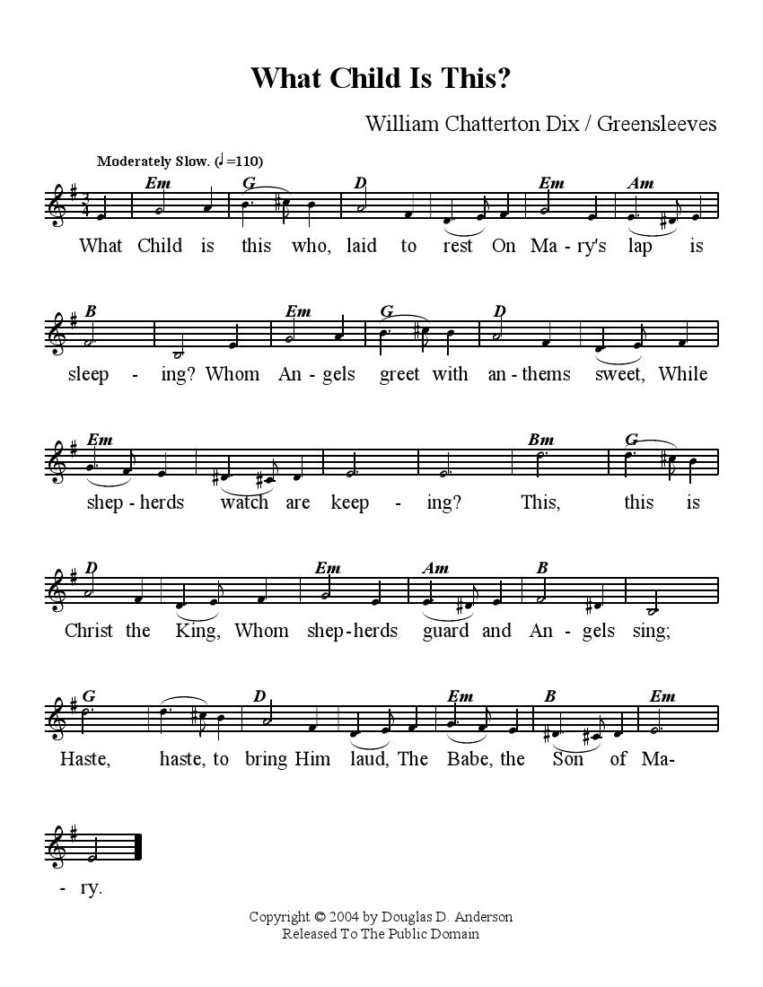

Merry Christmas

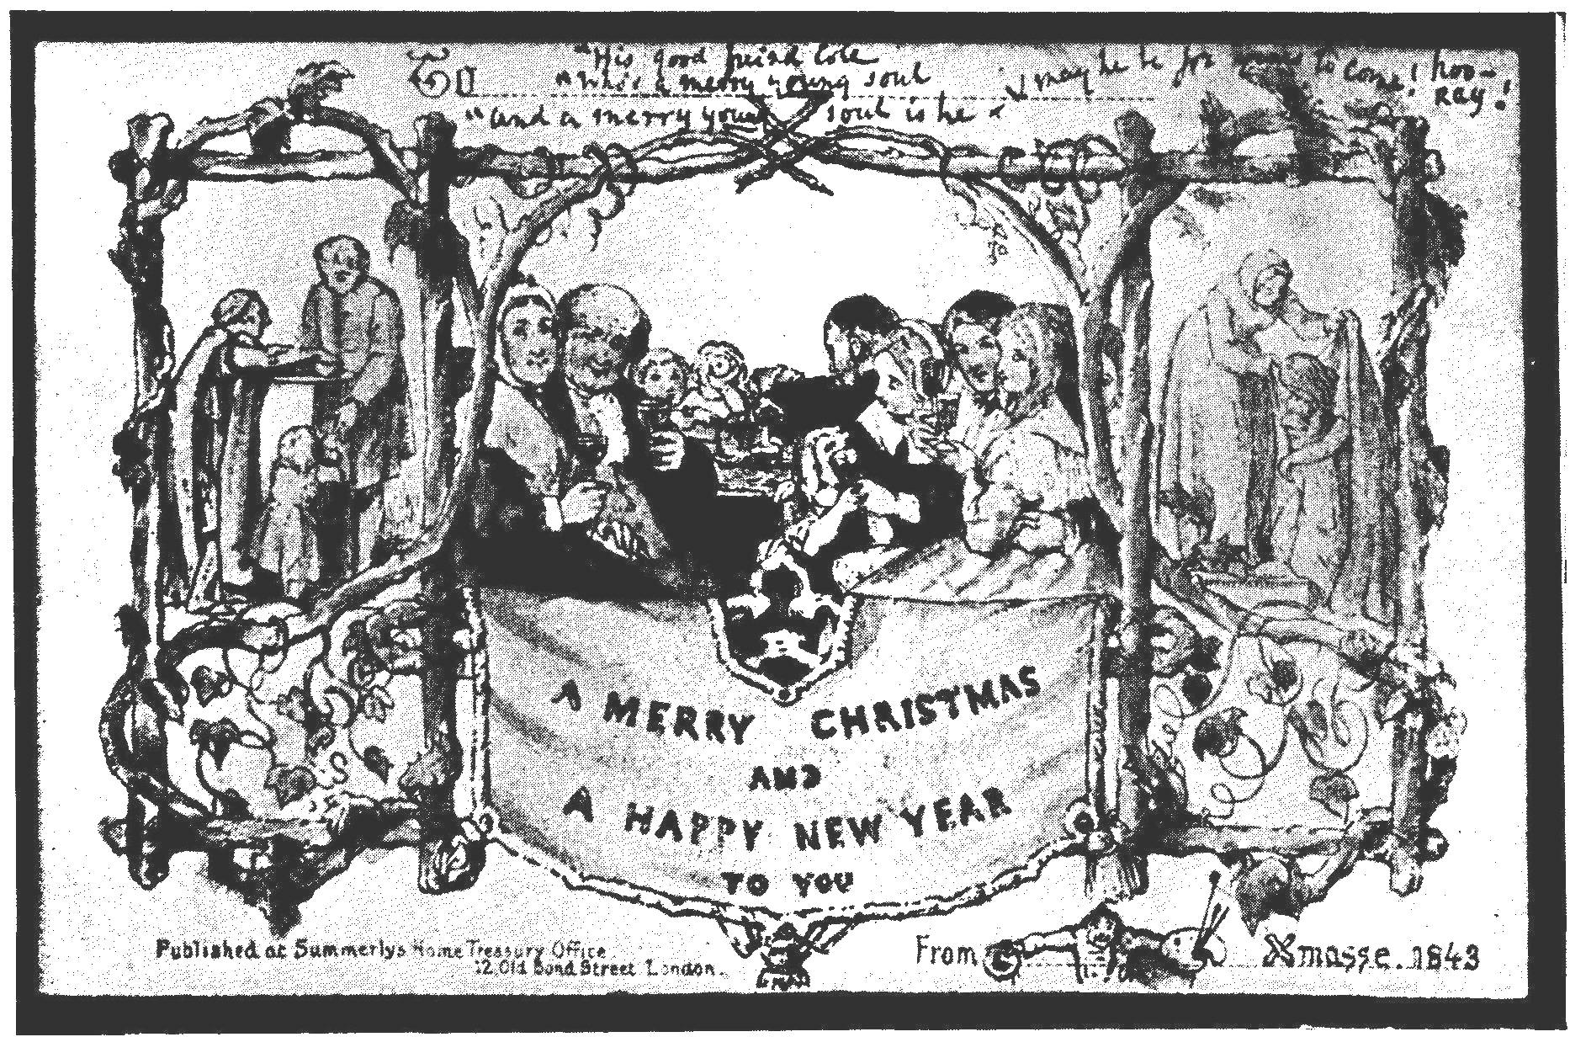
The first Christmas card, designed by J. C. Horsley for Henry Cole, 1843.

