Christmas Don’t Be Late (Alvin & the Chipmunks)
C 24

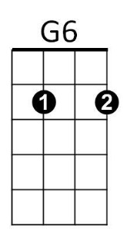
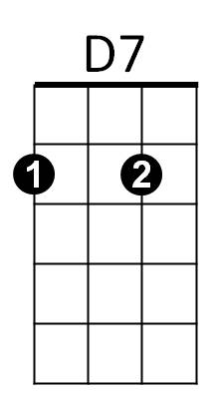

Intro: G D7 (2x)
G

G G6 D7
Christmas, Christmas time is near,
G6
Time for toys and time for cheer.



Am D7 Am D7
C
G7
Am
We've been good, but we can't last,
Am D7 G G6
Hurry Christmas, hurry fast.
G G6 G G6
Want a plane that loops the loop,
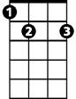
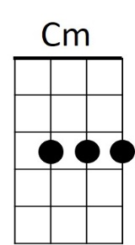
G7 C
E7
Me, I want a Hula-Hoop.
C Cm G E7
We can hardly stand the wait,
Am D7 G D7 G D7 (Rollover)
Please Christmas, don't be late.
G D7 (To Outro)

REPEAT Song, replace line 6 with:
BARITONE
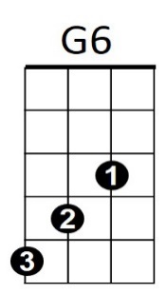
G7 C
I STILL want a Hula-Hoop!
G
D7

Outro:

C Cm G E7
We can hardly stand the wait,



Am D7 G D7 G D7 G D7 G
Am
G7
C
Please Christmas, don't be late
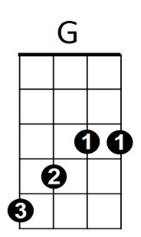
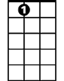
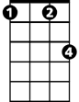
E7
Cm

