Christmas Is the Time to Say 'I Love You' (Billy Squier)

Chorus:

C F C
Christmas is the time to say "I love you",
A7 Dm
Share the joys of laughter and good cheer
F D7 C Am
Christmas is the time to say "I love you" –
Dm G7 C
And a feeling that will last all through the year

C F C
On the corner carolers are singing,
A7 Dm
There’s a touch of magic in the air
F G C Am
From grownup to minor no-one could be finer
Dm G
Times are hard but no one seems to care

C F C
Christmas Eve and all the world is watching,
A7 Dm
Santa guides his reindeer through the dark
F G C Am
From rooftop to chimney, from Harlem to Bimini
Dm G C G7
They will find a way into your heart

(Chorus)

C F C
Just outside the window snow is falling,
A7 Dm
But here beside the fire we share the glow
F G C Am
Of moonlight and brandy, sweet talk and candy
Dm G
Sentiments that everyone should know

C F C
Memories of the year that lays behind us,
A7 Dm
Wishes for the year that's yet to come
F D
And it stands to reason
C Am
That good friends in season
Dm G C G7
Make you feel that life has just begun
(Chorus)

F G
So when spirits grow lighter
C Am
And hopes are shining brighter
Dm G F C
Then you know that Christmas time is he - re.

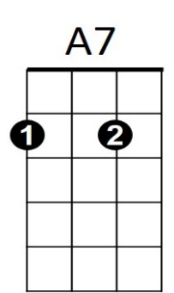
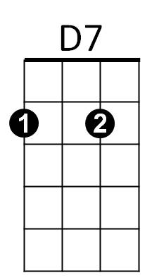
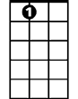
G
C
Am
D
BARITONE

F
G7
Dm
G7
Am
A7

