Christmas Time (Bryan Adams / James Vallance)

C G Am
We waited all through the year,
F C G
For the day to ap - pear
C E7 Am Am7 G
When we could be to-gether - in harmony,
C G Am
You know the time will come,
F C G
Peace on earth for every - one
C E7 Am Am7
And we can live forever,
Dm
In a world where we are free,
Dm7 G
Let it shine for you and me

Chorus:
C
There's something about Christmas time,
F
Something about Christmas time
C Am G
That makes you wish it was Christmas every day
C
To see the joy in the children's eyes
F
The way that the old folks smile
C G C
Says that Christmas will never go a - way

C G Am
We're all as one to - night,
F C G
Makes no difference if you're black or white
C E7 Am G
‘Cause we can sing to - gether in harmony.
C G Am
I know it's not too late;
F C G
The world would be a better place
C E7 Am Am7
If we can keep the spirit,
Dm
More than one day in the year
Dm7 G
Send a message loud and clear

(Chorus)

G C
It's the time of year when everyone's to - gether
G C
We'll celebrate here on Christmas day
Am
When the ones you love are there
D7 G
You can fe - el the magic in the air,
G7
You know it's everywhere

C
There's something about Christmas time
F A7
Something about Christmas time KEY CHANGE
(2X) D
There's something about Christmas time
G
Something about Christmas time
D Bm A
That makes you wish it was Christmas every day
D
To see the joy in the children's eyes
G
The way that the old folks smile
D A D
Says that Christmas will never go a - way

End:
D A D



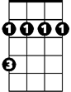



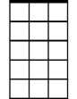

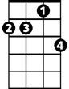
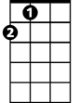
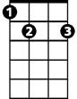
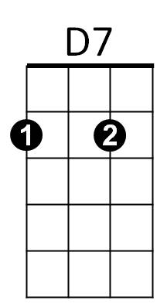
Says that Christmas will never go a - way
F
C
D
Bm
Am
G
G7
Am7
Dm
Dm7
A
E7

