Christmas in Dixie (Jeff Cook, Teddy Gentry, Mark Herndon & Randy Owen)
C36
Intro: Chords for chorus

C Dm G7
By now in New York City,
Cmaj7 C
There’s snow on the ground
Dm G7
And out in California,
Cmaj7 C
The sunshine’s falling down
C7 F G7
And maybe in Memphis,
C Am
Graceland’s in lights,
Dm G7
And in Atlanta, Georgia,
C
There’s peace on earth tonight

Chorus:

C↓ C↓ C↓ F G7
Christ-mas in Dixie
C Am
It’s snowing in the pines
Dm G7
Merry Christmas from Dixie
C
To everyone tonight




C
Dm
G7



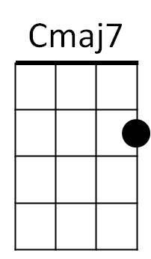
F
Am

C Dm G7
It’s windy in Chicago
Cmaj7 C
The kids are out of school
Dm G7
There’s magic in Motown
Cmaj7 C
The city’s on the move
C7 F G7
In Jackson, Mississippi,
C Am
To Charlotte, Caroline
Dm G7
And all across the nation
C
It’s a peaceful Christmas time

Repeat from Chorus

(Chorus)

Dm
And from Huntsville, Alabama …
G7 C
Merry Christmas tonight.
BARITONE



G7
Dm
C


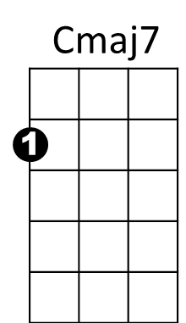
Am
F

