Christmas in the Trenches (John McCutcheon)

G Em C Am
My name is Francis Toliver, I come from Liverpool.
D7 C G
Two years ago the war was waiting for me after school.
G Em C Am
To Belgium and to Flanders, Germany to here.
D7 G
I fought for King and country I love dear.
D7 C G
‘Twas Christmas in the trenches, where the frost so bitter hung.
Em
The frozen fields of France were still,
C D7
No Christmas song was sung.
G Em C Am
Our families back in England were toasting us that day,
D7 G
Their brave and glorious lads so fa r away.

G Em C Am
I was lying with my mess mates on the cold and rocky ground.
D7 C G
When across the lines of battle came a most peculiar sound.
G Em C Am
Says I, "now listen up me boys." Each soldier strained to hear
D7 G
As one young German voice sang out so clear.
D7 C G
"He's singing bloody well y'know," my partner says to me.
Em C D7
Soon one by one each German voice joined in in harmony.
G Em C Am
The cannons rested silent, and the gas clouds rolled no more.
D7 G
As Christmas brought us respite from the war.

G Em C Am
As soon as they were finished, and a reverent pause was spent,
D7 C G
"God Rest Ye Merry Gentlemen" struck up some lads from Kent.
G Em C Am
Oh the next they sang was "Stille Nacht", 'tis Silent Night says I.
D7 G
And in two tongues one song filled up that sky.

D7 C G
G
"There's someone coming towards us", the front line sentry cried.
Em C D7
All sights were fixed on one lone figure trudging from their side.
G Em C Am
His truce flag like a Christmas star shone on that plain so bright
D7 G
As he bravely strolled unarmed into the night.
G Em C Am
Then one by one on either side walked into No-Man's Land.
D7 C G
With neither gun nor bayonet we met there hand to hand.
G Em C Am
We shared some secret brandy and we wished each other well.





D7 G
G
BARITONE
C
Em
D7
Am
And in a flare-lit soccer game we gave 'em hell.

D7 C G
We traded chocolates, cigarettes and photographs from home.
Em C D7
These sons and fathers far away from families of their own.
G Em C Am
Young Sanders played the squeezebox and they had a violin.
D7 G
This curious and unlikely band of men.
G Em C Am
Soon daylight stole upon us and France was France once more.
D7 C G
With sad farewells we each began to settle back to war.
G Em C
But the question haunted every heart that lived that wondrous
Am
night.
D7 G
"Whose family have I fixed within my sights?"
D7 C G
’Twas Christmas in the trenches, where the frost so bitter hung.
Em
The frozen fields of France were warmed
C D7
As songs of peace were sung.
G Em C Am
For the walls they kept between us to exact the work of war
D7 G
Had been crumbled and were gone forever more.

G Em C Am
My name is Francis Toliver, in Liverpool I dwell.
D7
Each Christmas comes since World War I,
C G
I've learned its lessons well.
G Em C
For the ones who call the shots won't be among the dead and
Am
lame,
D7 G
And on each end of the rifle we're the same.
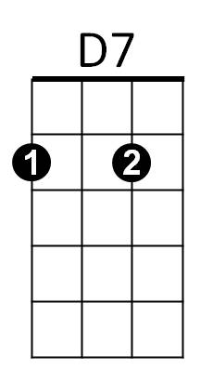
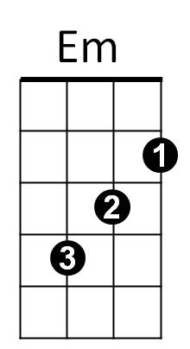
Am
C

