Chug-a-lug (Roger Miller)

Intro: G C D7 C (3x) G

CHORUS:

TACET
Chug-a-lug Chug-a-lug
G D7
Make you wanna holler hid-e-ho
G
Burns your tummy don't you know
D7 G
Chug-a-lug Chug-a-lug

TACET G
Grape wine in a mason jar
D7
Homemade and brought to school
G
By a friend of mine after class
D7
Me and him and this other fool decide
G
That we'll drink up what’s left

D7
G
Chug-a-lug so I helped ourselves
G
First time for everything
TACET
Mmmm my ears still ring

(CHORUS)

G
4-H and FFA
D7

On a field trip to the farm
BARITONE
D7


G
C
G
Me and a friend sneak off behind
D7
This big old barn
G
Where we uncovered this covered up moonshine still
D7
How we thought we’d drink our fill
G
I swallered it with a smile
TACET
Ughhh I run ten miles

(CHORUS)

G
Jukebox and a sawdust floor
D7
Something like I ain't never seen
G
Heck I'm just going on fifteen
D7
But with the help of my fan-egleing uncle
G D7
I get snuck in for my first taste of sin
G
I said let me have a big old sip
TACET
I done a double back flip

(CHORUS)
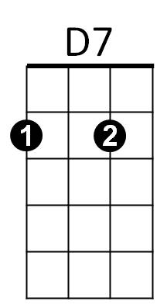
C

