Cold as Ice (Lou Gramm / Mick Jones)
Intro: Em C

Em
You're as cold as ice
C Em C
You're willing to sacrifice our love
Em
You never take advice
C Am
Someday you'll pay the price, I know

Chorus:
G Gmaj7
I've seen it before - It happens all the time
Am
Closing the door
C
You leave the world behind
G
You're digging for gold
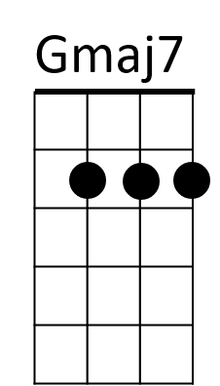
Gmaj7
Yet throwing away
Am
A fortune in feelings
B7
But som eday you'll pay

Em C




Em
C
Am
G
BARITONE

You're as cold as ice
Em
C Em C
You're willing to sacrifice our love
Em
You want paradise
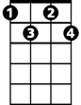
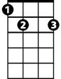
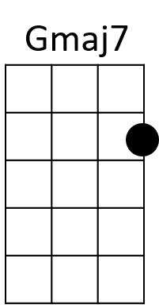
C Am
Adim
B7
But someday you'll pay the price, I know

(Chorus)

C Em / C Am G B

Bridge:

Em B7 Adim
Cold – as - ice - You know that you are
Em B7 Adim
Cold – as - ice - As cold as ice to me
Em B7 Adim
Cold – as - ice -
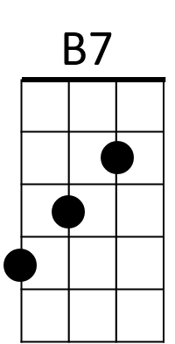
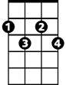

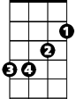
Em C (Fade out) end with Em
Adim
G
Am
Em
C

