Come Back, St. Pat (Marion Rose Horgan, March 2021)

Intro on A (DD uudu du D/D/ – DD uudu du D/D/ ) repeats between verses  A D A E7  Hail glorious, St. Patrick, our hero there’s no doubt  A D A E7  Our patron, our protector, you’ve always helped us out  A D A E7  Now we’ve a situation that’s way beyond our ken,  A D A E7 A  I wonder, could you visit us and lend a hand again?  A D A E7  You drove the snakes from Ireland, well, -- most of them are gone  A D A E7  We know that you are someone we can depend upon  A D A E7  We seek your intervention, there is no other way  A D A E7 A  I know the vaccine’s coming, but so’s Christmas, as they say  Chorus: A D A E7  Come back, St. Pat,we’re in an awful stew  A D A E7  Come back, St. Pat, we’re counting on you  A D A E7  Come back, St. Pat, we’d really be delira pronounced dee lie’ rah  A D A E7 A  If you’d agree to heed our plea and chase away the virus  A D A E7  We’re weary of these lockdowns, Fan sa bhaile le do thoil * fawn so wall le yet do hall  A D A E7  We’re crawling up the walls now, life has gotten very dull  A D A E7  ‘Tis getting mighty serious when Paddy’s lost the craic pronounced “crack”  A D A E7 A  And we’re losing all our marbles; we may never get them back!  Chorus |  |  |  |  |  |  | 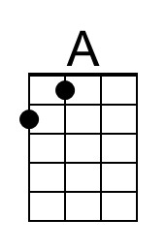
 |  |  |  |  |  |  | 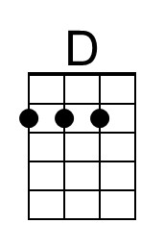
 |  |  |  |  |  |  | 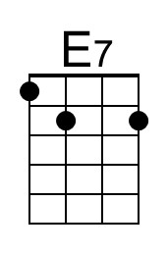
 |  |  |  |  |  |  | 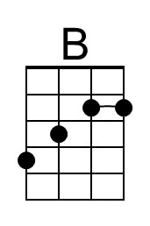
 |  |  |  |  |  |  | 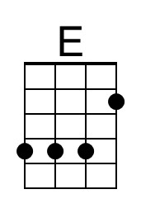
 |  |  |  |  |  |  | 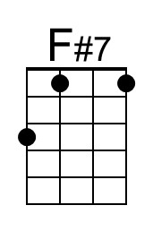
 | Bari | 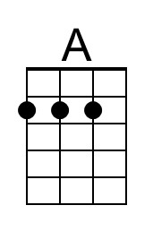 | 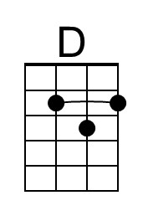 | 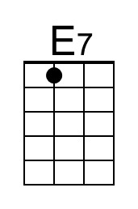 | 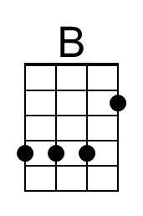 | 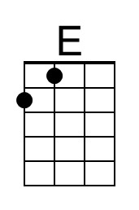 | 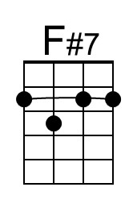
Come Back St Pat – Page 2

B E B F#
Dochas linn Naomh Padraig**, please save us from our fate Doe cas ling nave Paw’dreeg
B E B F#7
We’re full of hope that you’ll oblige, you’ll step up to the plate
B E B F#7
There’s no escaping Covid, ‘tis global, ‘tis a curse!
B E B F#7 B
And you’ll need all your tips and tricks to sort the uni-verse!

Chorus: A D A E7
Come back, St. Pat,we’re in an awful stew
A D A E7
Come back, St. Pat, we’re counting on you
A D A E7
Come back, St. Pat, we’d really be delira
A D A E7 A
If you’d agree to heed our plea and chase away the virus

Key change to B

Chorus 2: B E B F#7
Come back, St. Pat, we’re in an awful stew
B E B F#7
Come back, St. Pat, we’re counting on you
B E B F#7
Come back, St. Pat, we’d really be delira
B E B F#7 B
If you’d agree to heed our plea and chaaaase away the virus

Notes
- Paddy’s lost the craic – means Ireland has lost its sense of fun, sense of humor, or it’s been taken away from them.
- Delira - from the root word for delirious, delight
- From Urban Dictionary, 2011: delira and excira - Irish exclamation of happiness, popularised by chat show host Gay Byrne. Probable abbreviation of delirious and excited. “I was delira and excira when I heard Gay Byrne is retiring from the Late Late show”.
- ‘Fan sa bhaile le do thoil’ means ‘stay at home please!’
- ‘Dochas linn Naomh Padraig’ means ‘give us hope St Patrick’

Songwriter says she played it in G with a capo on the second fret (G, C, D7). This might be good for those who have a hard time playing B, E, and F#7

See and hear the original on YouTube:
Come Back, St. Pat by Marion Rose Horgan

