Come Saturday Morning (Dory Previn / Fred Karlin)


(Theme song for “The Sterile Cuckoo” 1970)
F
C
C F Fm
Come Saturday morning,
C Bb
I'm goin' away with my friend.
F Bb Asus4 A Asus4 A
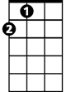
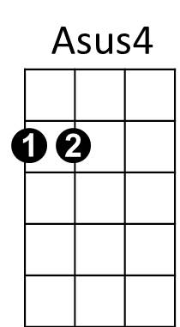
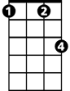

We'll Saturday spend till the end of the day.
A
Fm
Bb
Dm G7
Just I and my friend.
Dm G7 C
We'll travel for miles in our Saturday smiles.
F Em7


And then we'll move on.
G7
Dm
F C Am Dm G7 C F C
But we will remember, long after Saturday's gone.

C F G7 (x3)
Come Saturday morning

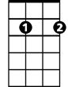
Am
Em7
C F Fm
Come Saturday morning,
C Bb
I'm goin' away with my friend.
F Bb Asus4 A Asus4 A
We'll Saturday laugh more than half of the day.
BARITONE


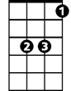
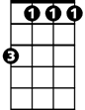
Dm G7
Dm
Am
G7
Bb
Fm
F
C
Just I and my friend.
Dm G7 C
Dressed up in our rings and our Saturday things.
F Em7
And then we'll move on.
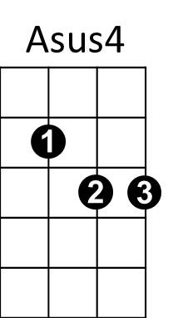

F C Am Dm G7 C
A
But we will remember, long after Saturday's gone.

C F G7 (x3)
Come Saturday morning

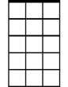
(REPEAT FIRST VERSE)
Em7

C F G7 (x2)
Come Saturday morning
C F G7 C)
Come Saturday morning

