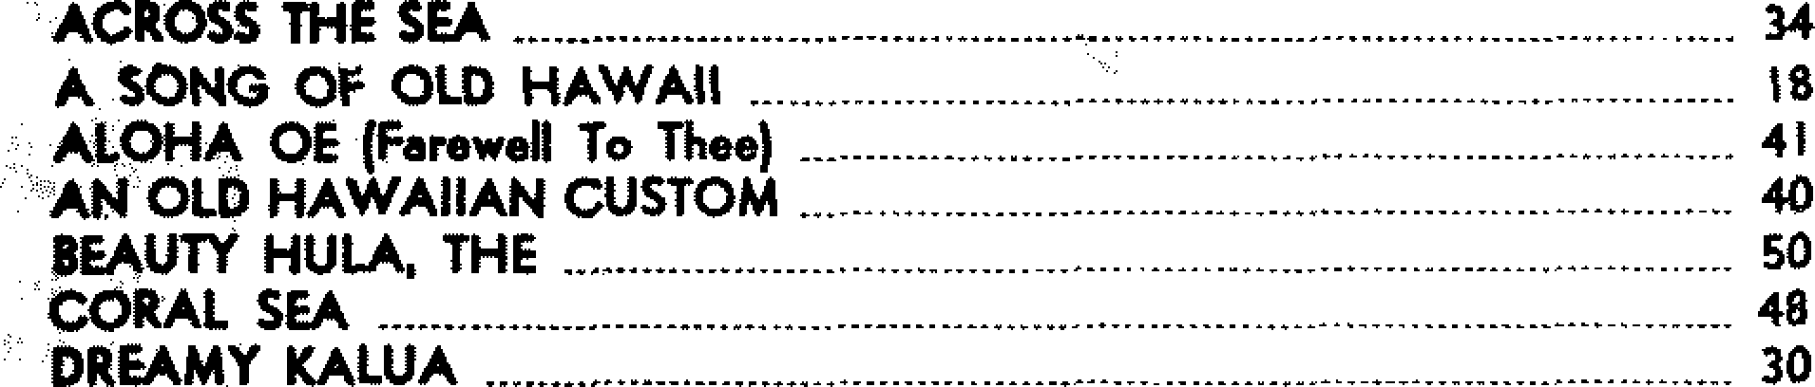
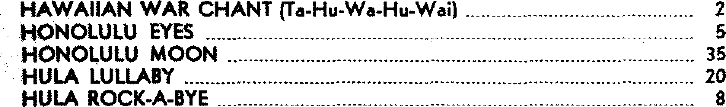
DROWSY WATERS (Waflane) 24

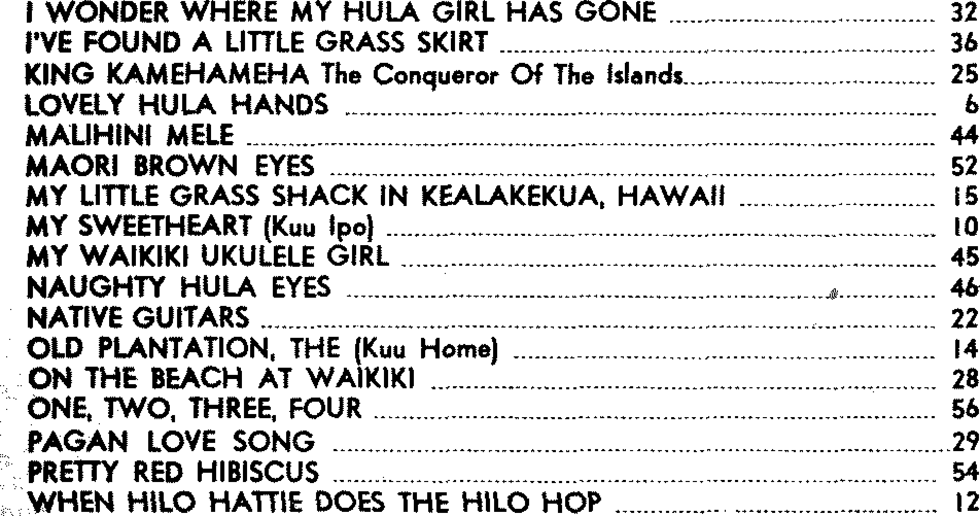
I WAHT TO LEARH TO SPEAK HAWAIIAH 42

