Count Your Blessings (Instead of Sheep) (Irving Berlin, 1954)
Performed by Bing Crosby in “White Christmas” - * Ray Conniff Singers adaptation second verse

G7 Am Em F7 C F Em Dm7 E7  When I'm worried, and I can't sleep, I count my blessings instead of sheep,  Am D7 G G7  And I fall a-sleep, counting my blessings.  G7 Am Em F7 C F Em G7 E7  When my bankroll, is gettin' small, I think of when I had none at all.  Am D7 G7 C  And I fall a-sleep, counting my bless-ings.  Ab Cm Bbm7 Fm  I think about a nursery, and I picture curly heads,  Ab Eb G7 C Dm7 C C7  And one by one I count them, as they slumber in their beds  Am Em F7 C  If you’re worried, and you can't sleep,  F Em Dm7 E7  Just count your blessings instead of sheep,  Am D7 G G7  And you’llI fall a-sleep, counting your blessings.  Am Em F7 C  So, if we’re worried, and we can't sleep,  F Em Dm7 E7  We’ll count our blessings in-stead of sheep,*  Am D7 G G7  And we’ll fall a-sleep, counting our bless-ings.  Ab Cm Bbm7 Fm  We’ll think about a Christmas Eve, and picture curly heads,  Ab Eb G7 C Dm7 C C7  With presents waiting ‘neath the tree, as they slumber in their beds.  Am Em F7 C  If you’re worried, and you can't sleep,  F Em Dm7 E7  Just count your blessings in-stead of sheep,  Am D7 G G7  And you’llI fall a-sleep, counting your bless-ings. |  |  |  |  |  |  | 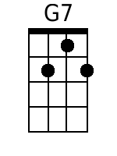 | 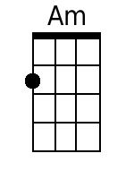
 |  |  |  |  |  |  | 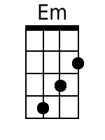 | 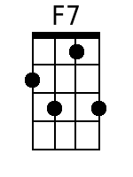
 |  |  |  |  |  |  | 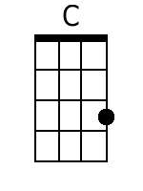 | 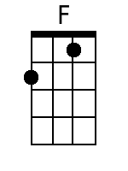
 |  |  |  |  |  |  | 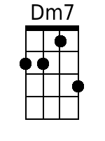 | 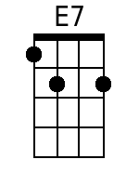
 |  |  |  |  |  |  | 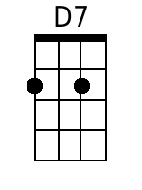 | 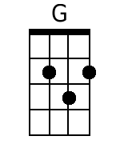
 |  |  |  |  |  |  | 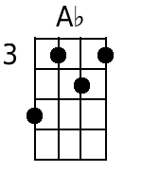 | 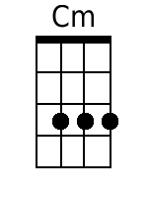
 |  |  |  |  |  |  | 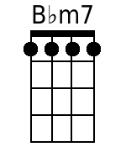 | 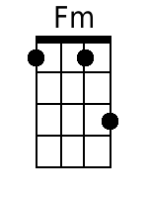
 |  |  |  |  |  |  | 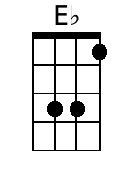 | 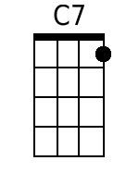
Baritone
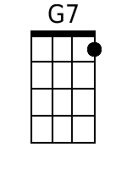 | 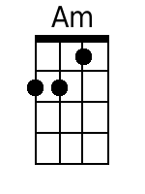 | 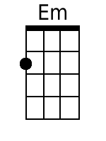 | 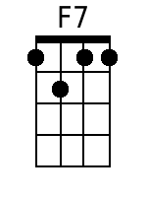 | 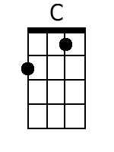 | 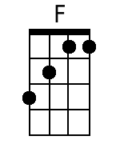 | 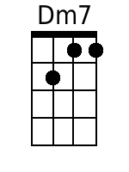 | 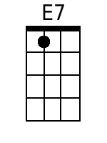
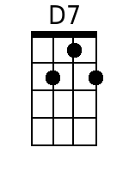 | 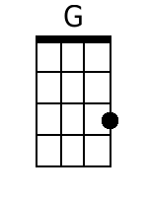 | 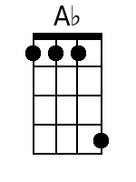 | 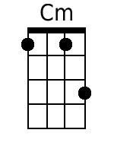 | 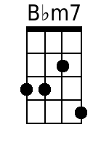 | 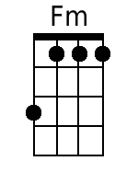 | 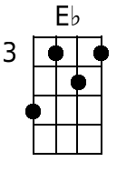 | 