Crazy (Willie Nelson, 1961)
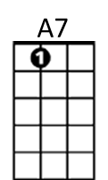
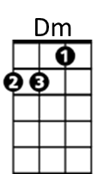
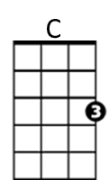
Key: C

Intro: Chords for last two lines

C A7 Dm A7 Dm
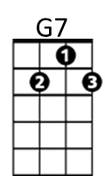
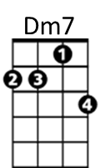
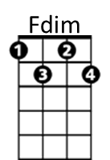
Crazy, crazy for feeling' so lonely
G7 C Fdim Dm7 G7
I'm crazy, crazy for feelin' so blue,

C A7 Dm A7 Dm
I knew, you'd love me as long as you wanted,
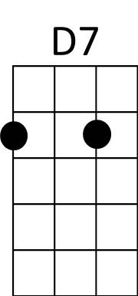
G7 C F C C7
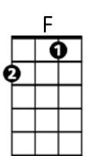
And then someday, you'd leave me for somebody new

Refrain:
F C F C C7
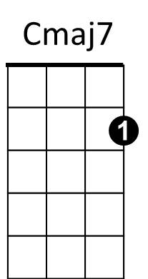
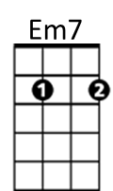
Worry, why do I let myself worry
D7 G7 Dm7 G7
Wond'rin’, what in the world did I do

C A7 Dm A7 Dm
Crazy, for thinking that my love could hold you
F Em7 Dm7 Cmaj7
I'm crazy for tryin', crazy for cryin'
Dm7 G7 C F C
And I'm crazy for lovin' you.
BARITONE

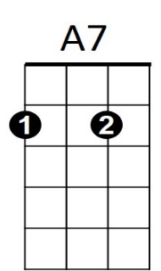


(Repeat from Refrain)
C
Dm
G7

F Em7 Dm7 Cmaj7
I'm crazy for tryin', crazy for cryin'
Dm7 G7 C F C
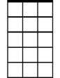
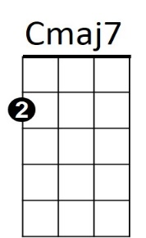


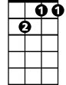
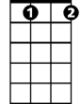
And I'm crazy for lovin' you.
Em7
F
D7
Dm7
Fdim

