Crazy Love (Van Morrison) Key C
Intro: C Em F C 2x
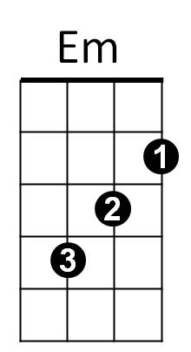


F
C
C Em F C
I can feel her heartbeat, from a thousand miles
Em F C
And the heavens open, every time she smiles
Em F C
And when I come to her, that's where I belong



Em F C
Am
Dm
G
Yeah, I'm running to her, like a river's song

Chorus:
G Am G F G
She gives me love love, love, love, crazy love
C G Am G F C
She gives me love love, love, love, crazy love

Em F C
She's got a fine sense of humor when I'm feeling low down
Em F C
And when I come to her when the sun goes down
Em F C
She takes away my trouble take away my grief
Em F C
BARITONE

Take away my heartache, in the night like a thief
F
Em
C

(Chorus)

Reprise:
G F C
Yes, I need her in the daytime,

G F C
Dm
Am
G
Yes, I need her in the night
G F C
And I want to throw my arms around her,
Am Dm G
Kiss and hug her, kiss and hug her tight

C Em F C
And when I'm returning from so far away
Em F C
She gives me some sweet lovin, brightens up my day
Em F C
Yeh, it makes me righteous, yes it makes me whole
Em F C
Yeh, it makes me mellow down into my soul

(Chorus) 2x repeat to fade

Crazy Love (Van Morrison) Key F
Intro: F Am Bb F 2x
F
Am
Bb
F Am Bb F
I can feel her heartbeat, from a thousand miles
Am Bb F
And the heavens open, every time she smiles
Am Bb F
And when I come to her, that's where I be-long
Am Bb F
Gm
Dm
C
Yeah, I'm running to her, like a river's song

Chorus:
C Dm C Bb C
She gives me love love, love, love, crazy love
F C Dm C Bb F
She gives me love love, love, love, crazy love

F Am Bb F
She's got a fine sense of humor when I'm feeling low down
Am Bb F
And when I come to her when the sun goes down
Am Bb F
BARITONE
She takes away my trouble take away my grief
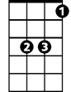
Am Bb F
Bb
Am
F
Take away my heartache, in the night like a thief

(Chorus)

Reprise:
C Bb F
Dm
C
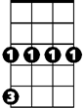
Yes, I need her in the daytime,
Gm
C Bb F
Yes, I need her in the night
C Bb F
And I want to throw my arms around her,
Dm Gm C
Kiss and hug her, kiss and hug her tight

F Am Bb F
And when I'm returning from so far a-way
Am Bb F
She gives me some sweet lovin, brightens up my day
Am Bb F
Yeh, it makes me righteous, yes it makes me whole
Am Bb F
Yeh, it makes me mellow down into my soul

(Chorus) 2x repeat to fade

Crazy Love (Van Morrison) Key G
Intro: G Bm C G 2x
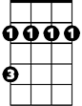
C
Bm
G
G Bm C G
I can feel her heartbeat, from a thousand miles
Bm C G
And the heavens open, every time she smiles
Bm C G
And when I come to her, that's where I belong

Bm C G
Am
D
Yeah, I'm running to her, like a river's song

Chorus:
D Em D C D
She gives me love love, love, love, crazy love
G D Em D C G
She gives me love love, love, love, crazy love

Bm C G
She's got a fine sense of humor when I'm feeling low down
Bm C G
And when I come to her when the sun goes down
Bm C G
She takes away my trouble take away my grief
Bm C G
BARITONE
Take away my heartache, in the night like a thief
C
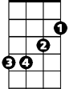
Bm
G
(Chorus)

Reprise:

D C G
Yes, I need her in the daytime,
D C G
Em
Am
D
Yes, I need her in the night
D C G
And I want to throw my arms around her,
Em Am D
Kiss and hug her, kiss and hug her tight

G Bm C G
And when I'm returning from so far away
Bm C G
She gives me some sweet lovin, brightens up my day
Bm C G
Yeh, it makes me righteous, yes it makes me whole
Bm C G
Yeh, it makes me mellow down into my soul

(Chorus) 2x repeat to fade

