Crazy Love (Rusty Young, 1978) (recorded by Poco) Key G
Cmaj7 G

G Cmaj7
Tonight I'm gonna break away
D Cmaj7 G
Just you wait and see.
Cmaj7
I'll never be imprisoned by
D Cmaj7 G
A faded mem - ory.

Cmaj7
Just when I think I'm over her,
D Cmaj7 G
this broken heart will mend.
Cmaj7
I hear her name and I have to cry,
D Cmaj7 G
The tears come down again.

Chorus:
Cmaj7
It happens all the time.
D G
This crazy love of mine,
Cmaj7
Wraps around my heart
D G
Refusing to unwind.
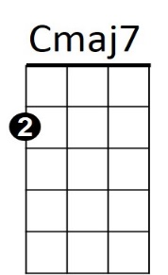

Cmaj7 D Cmaj7 G
BARITONE
D
Ooo Ooo Crazy Love
Cmaj7 D Cmaj7 G
Ahh ha

G Cmaj7
Count the stars in a summer sky,
D Cmaj7 G
That fall without a sound.
G Cmaj7
And then pretend that you can't hear
D Cmaj7 G
These tear drops coming down.

(Chorus)

REPEAT 1st verse

(Chorus)
G Cmaj7

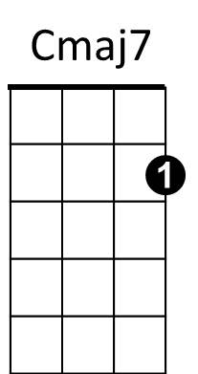
Tonight I'm gonna break away.
D
G


G

