Crying (Roy Orbison / Joe Melson) Key C

C
I was all right for a while,
I could smile for a while
But I saw you last night,
Csus2
You held my hand so tight,
F Fm
As you stopped to say hello
C G
Oh, you wished me well, you couldn't tell,
G7
That I'd been . .

C
C Em
Crying over you
C Em
Crying over you
F G

Then you said so long,
G
F G
Left me standing all alo ne
C Csus2 F Fm
Alone and crying, crying, crying, crying
C
It's hard to understa nd,
G G7
But the tou ch of your hand,
C
BARITONE

Can start me crying
C

C
I thought that I, was over you,
But it's true, so true
I love you even more,
Csus2
G
Than I did before
F Fm
But darling, what can I do?
C
Cause you don't love me,
G G7
And I'll always be

C Em
Crying over you
C Em
Crying over you
F G
Yes, now you're gone
F G
And from this moment on
C Csus2 F Fm
I'll be crying, crying, crying, crying
C Am
I'm crying, crying
F G7 C G7 C F C
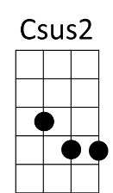
Oh-oh-oh-over you
F
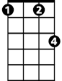
Fm


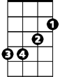

Am
Em
G7

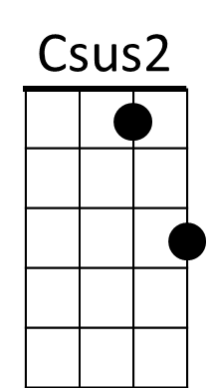

F
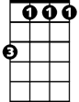
Fm



Am
Em
G7

Crying (Roy Orbison / Joe Melson) Key D

D
I was all right for a while,
I could smile for a while
But I saw you last night,
Dsus2
You held my hand so tight,
G Gm
As you stopped to say hello
D A
Oh, you wished me well, you couldn't tell,
A7
That I'd been . .


D F#m
D
Crying over you
D F#m
Crying over you
G A
Then you said so long,
G A
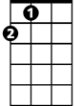
Left me standing all alone
A
D Dsus2 G Gm
Alone and crying, crying, crying, crying
D
It's hard to understand,
A A7
But the touch of your hand,
D
Can start me crying
BARITONE
D
D
I thought that I, was over you,
But it's true, so true
I love you even more,
Dsus2
Than I did before
A
G Gm
But darling, what can I do?
D
Cause you don't love me,
A A7
And I'll always be

D F#m
Crying over you
D F#m
Crying over you
G A
Yes, now you're gone
G A
And from this moment on
D Dsus2 G Gm
I'll be crying, crying, crying, crying
D Bm
I'm crying, crying
G A7 D A7 D G D
Oh-oh-oh-over you

Gm
G
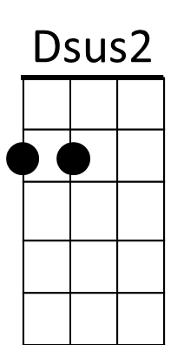

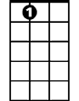
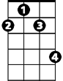
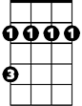
A7
F#m
Bm

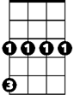
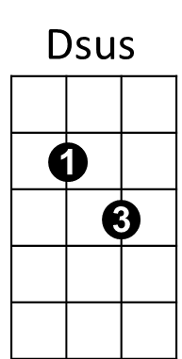
Gm
G

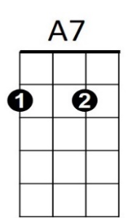
Bm
F#m

Crying (Roy Orbison / Joe Melson) Key G

G
I was all right for a while,
I could smile for a while
But I saw you last night,
Gsus2
You held my hand so tight,
C Cm
As you stopped to say hello
G D
Oh, you wished me well, you couldn't tell,
D7
That I'd been . .

G Bm
Crying over you
G Bm
Crying over you
C D
Then you said so long,
C D
Left me standing all alone
G Gsus2 C Cm
Alone and crying, crying, crying, crying
G
It's hard to understand,
D D7
But the touch of your hand,
G
BARITONE
Can start me crying

G
I thought that I, was over you,
But it's true, so true
I love you even more,
Gsus2
Than I did before
C Cm
But darling, what can I do?
G
Cause you don't love me,
D D7
And I'll always be

G Bm
Crying over you
G Bm
Crying over you
C D
Yes, now you're gone
C D
And from this moment on
G Gsus2 C Cm
I'll be crying, crying, crying, crying
G Em
I'm crying, crying
C D7 G D7 G C G
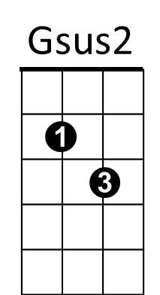
Oh-oh-oh-over you
C
G
Cm

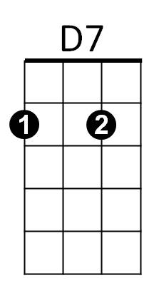
Em
Bm
D

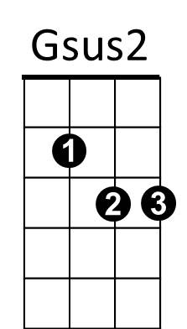
Cm
C
G

Bm
Em
D7
D

