Cuando Calienta el Sol (Love Me With All of Your Heart) Key C
(Rafael Gaston Perez / Carlos Albert Martinoli / Carlos and Mario Rigual) (English lyrics by Maurice Vaughn / Sonny Skylar)
C Am Em
When the sun is hot here on the beach,
I feel your body tremble close to me;
It's your heartbeat, it's your face, it's your hair;
It's your kisses, I'm trembling, oh, oh, oh!
When the sun is hot here on the beach,
Cuando calienta el sol aqui en la playa
F G7 C A7
Siento tu cuerpo vibrar cerca de mi
Dm G7 C Am
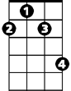
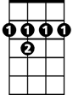






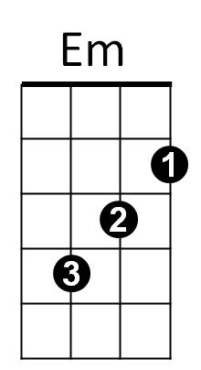

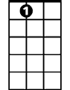
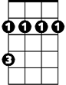
Es tu palpitar, es tu cara, es tu pelo,
F#m
B7
G
Dm
D
F
G7
Am
C
A7
Bm
Em F G7
Son tus besos, me ester-mezco, oh, oh, oh
C Am Dm
Cuando calienta el sol,
G7 C A7
Cu ando cailenta el sol

D Bm F#m
Love me with all of your heart, that’s all I want, love
G A7 D B7
Love me with all of your heart, or not at all
Em A7 D Bm
Just promise me this, that you’ll give me all your kisses,
F#m G A7
Every winter, every summer, every fall

D Bm F#m
When we are far apart, or when you’re near me
G A7 D B7
Love me with all of your heart, as I love you
Em A7 D Bm
Don’t give me your love for a moment or an hour
F#m G A7
Love me always as you’ve loved me from the start
BARITONE

D Bm Em
F
Em
Am
C
With every beat of your heart
A7 D Bm Em
With every beat of your heart
A7 D
With every beat of your heart
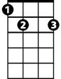
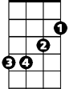

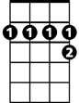

B7
G
F#m
Bm
G7
A7
Dm
D

