Daisy Bell (On a Bicycle Built for Two) - Harry Dacre (1892)

C G7
There is a flower within my heart
C
Daisy, Dai-sy
C G7
Planted one day by a glancing dart
D7 C G7
Planted by Dai-sy Bell

Am Em7 Am
Whether she loves me or loves me not
Dm A7 Dm
Sometimes it's hard to tell
Am Em7 Am
Yet I am longing to share the lot
D7 G G7
Of beautiful Daisy Bell

Chorus:

C F C
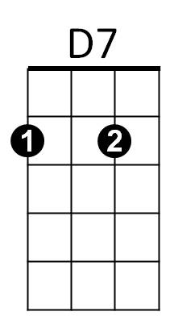

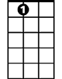


Daisy, Daisy, give me your answer do
Dm
A7
C
G7
G7 C Am D7 G7
I'm half cra - zy all for the love of you
C
It won't be a stylish marriage
F C
I can't afford a carriage
G7 C G7
But you'll look sweet upon the seat
C G7 C
Of a bicycle built for two

C G7
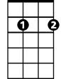
We will go tandem as man and wife
Em7
C
Daisy, Dai-sy
C G7
Pedalling away down the road of life
D7 C G7
I and my Daisy Bell
G

G
Am Em7 Am
When the road's dark, we can both despise
Dm A7 Dm
Policemen and lamps as well
Am Em7 Am
There are bright lights in the dazzling eyes
D7 G G7
Of beautiful Daisy Bell
(Chorus)

C G7
I will stand by you in “wheel” or woe,
C
Daisy, Dai-sy
C G7
You’ll be the belle which I will ring, you know
D7 C G7
Sweet little Daisy Bell

Am Em7 Am
You’ll take the lead in each trip we’ll take
Dm A7 Dm
Then if I don’t do well
Am Em7 Am
I will permit you to use the brake
D7 G G7
My beautiful Daisy Bell

(Chorus)
BARITONE
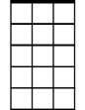

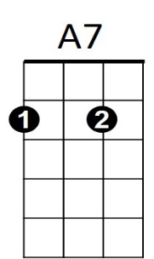

D7
Em7
C
G7



Dm
Am
Am

