Dance, Dance, Dance (Brenda Cooper, Joseph Cooper & Steve Miller)
Dance, Dance, Dance, Steve Miller Band, from the album "Fly Like An Eagle" (1976)
Key of C

G C G D7
My grandpa, he's ninety-five, he keeps on dancing; he's still alive.
G C G D7
My grandma, she's ninety-two; she loves to dance and sing some, too.
G C
I don't know, but I've been told
G D7
If you keep on dancing you'll never grow old.
G C G D7 G
Come on darlin', put a pretty dress on; we're gonna go out to-night.

Chorus:
C Cmaj7 Am7 D7 G
Dance, Dance, Dance [x3] All night long.

G C
I'm a hard workin man, I'm a son of a gun;
G D7
I been workin all week in the noonday sun.
G C
The wood's in the kitchen and the cow's in the barn;
G D7
I'm all cleaned up and my chores are all done.
G C G D7
Take my hand come along, let's go out and have some fun.
G C G D7 G
Come on darlin', put a pretty dress on; we're gonna go out to-night.
Chorus

G C
Come on, darlin', don't look that way;
G D7
Don't you know when you smile I've got to say:
G C
You're my honey-pumpkin lover, you're my heart's delight;
G D7
Don't you want to go out tonight?
G C
You're such a pretty lady, you're such a sweet girl;
G D7
When you dance, it brightens up my world.
G C G D7 G
Come on darlin', put a pretty dress on; we're gonna go out to-night.
Chorus
Notes:
Strum Pattern: DDUUD. On the split measures I just do DD for each chord. The split measures are G D7 on the last line of the verses and C C/B in the chorus.

Dance, Dance, Dance (Brenda Cooper, Joseph Cooper & Steve Miller)
Dance, Dance, Dance, Steve Miller Band, from the album "Fly Like An Eagle" (1976)
Key of G

D G D A7
My grandpa, he's ninety-five, he keeps on dancing; he's still alive.
D G D A7
My grandma, she's ninety-two; she loves to dance and sing some, too.
D G
I don't know, but I've been told
D A7
If you keep on dancing you'll never grow old.
D G D A7 D
Come on darlin', put a pretty dress on; we're gonna go out to-night.

Chorus:
G Gmaj7 Em7 A7 D
Dance, Dance, Dance [x3] All night long.

D G
I'm a hard workin man, I'm a son of a gun;
D A7
I been workin all week in the noonday sun.
D G
The wood's in the kitchen and the cow's in the barn;
D A7
I'm all cleaned up and my chores are all done.
D G D A7
Take my hand come along, let's go out and have some fun.
D G D A7 D
Come on darlin', put a pretty dress on; we're gonna go out to-night.
Chorus

D G
Come on, darlin', don't look that way;
D A7
Don't you know when you smile I've got to say:
D G
You're my honey-pumpkin lover, you're my heart's delight;
D A7
Don't you want to go out tonight?
D G
You're such a pretty lady, you're such a sweet girl;
D A7
When you dance, it brightens up my world.
D G D A7 D
Come on darlin', put a pretty dress on; we're gonna go out to-night.
Chorus

Dance, Dance, Dance (Brenda Cooper, Joseph Cooper & Steve Miller)
Dance, Dance, Dance, Steve Miller Band, from the album "Fly Like An Eagle" (1976)
Key of C

G↓ C↓ G↓ D7↓  My grandpa, he's ninety-five, he keeps on dancing; he's still alive.  G↓ C↓ G↓ D7↓  My grandma, she's ninety-two; she loves to dance and sing some, too.  G C  I don't know, but I've been told  G D7  If you keep on dancing you'll never grow old.  G C G D7 G  Come on darlin', put a pretty dress on; we're gonna go out to-night.  Chorus:  C Cmaj7 Am7 D7 G  Dance, Dance, Dance [x3] All night long.  G C  I'm a hard workin man, I'm a son of a gun;  G D7  I been workin all week in the noonday sun.  G C  The wood's in the kitchen and the cow's in the barn;  G D7  I'm all cleaned up and my chores are all done.  G C G D7  Take my hand come along, let's go out and have some fun.  G C G D7 G  Come on darlin', put a pretty dress on; we're gonna go out to-night.  Chorus  G C  Come on, darlin', don't look that way;  G D7  Don't you know when you smile I've got to say:  G C  You're my honey-pumpkin lover, you're my heart's delight;  G D7  Don't you want to go out tonight?  G C  You're such a pretty lady, you're such a sweet girl;  G D7  When you dance, it brightens up my world.  G C G D7 G  Come on darlin', put a pretty dress on; we're gonna go out to-night.  Chorus | 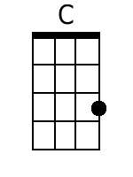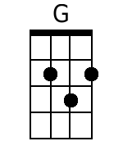  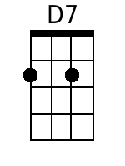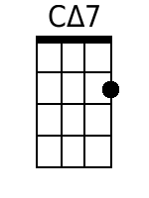  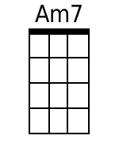
Bari

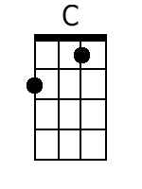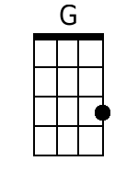
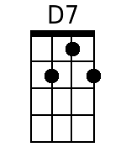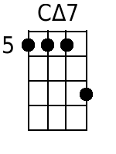
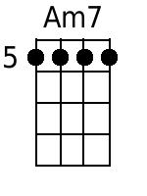

Dance, Dance, Dance (Brenda Cooper, Joseph Cooper & Steve Miller)
Dance, Dance, Dance, Steve Miller Band, from the album "Fly Like An Eagle" (1976)
Key of C

D↓ G↓ D↓ A7↓  My grandpa, he's ninety-five, he keeps on dancing; he's still alive.  D↓ G↓ D↓ A7↓  My grandma, she's ninety-two; she loves to dance and sing some, too.  D G  I don't know, but I've been told  D A7  If you keep on dancing you'll never grow old.  D G D A7 D  Come on darlin', put a pretty dress on; we're gonna go out to-night.  Chorus:  G Gmaj7 Em7 A7 D  Dance, Dance, Dance [x3] All night long.  D G  I'm a hard workin man, I'm a son of a gun;  D A7  I been workin all week in the noonday sun.  D ? G  The wood's in the kitchen and the cow's in the barn;  D A7  I'm all cleaned up and my chores are all done.  D G D A7  Take my hand come along, let's go out and have some fun.  D G D A7 D  Come on darlin', put a pretty dress on; we're gonna go out to-night  Chorus  D G  Come on, darlin', don't look that way;  D A7  Don't you know when you smile, I've got to say:  D G  You're my honey-pumpkin lover, you're my heart's delight;  D A7  Don't you want to go out tonight?  D G  You're such a pretty lady, you're such a sweet girl;  D A7  When you dance, it brightens up my world.  D G D A7 D  Come on darlin', put a pretty dress on; we're gonna go out to-night.  Chorus | 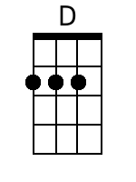  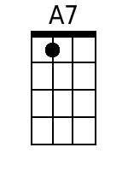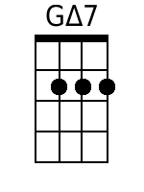  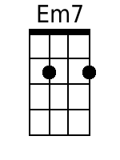
Bari

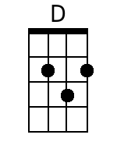
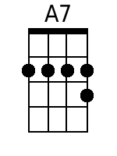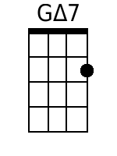
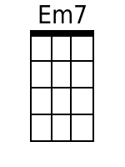

Dance, Dance, Dance (Brenda Cooper, Joseph Cooper & Steve Miller)
Dance, Dance, Dance, Steve Miller Band, from the album "Fly Like An Eagle" (1976)
Key of C

G↓ C↓ G↓ D7↓
My grandpa, he's ninety-five, he keeps on dancing; he's still alive.
G↓ C↓ G↓ D7↓
My grandma, she's ninety-two; she loves to dance and sing some, too.
G C
I don't know, but I've been told
G D7
If you keep on dancing you'll never grow old.
G C G D7 G
Come on darlin', put a pretty dress on; we're gonna go out to-night.

Chorus:
C Cmaj7 Am7 D7 G
Dance, Dance, Dance [x3] All night long.

G C
I'm a hard workin man, I'm a son of a gun;
G D7
I been workin all week in the noonday sun.
G C
The wood's in the kitchen and the cow's in the barn;
G D7
I'm all cleaned up and my chores are all done.
G C G D7
Take my hand, come along, let's go out and have some fun.
G C G D7 G
Come on darlin', put a pretty dress on; we're gonna go out to-night. Chorus

G C
Come on, darlin', don't look that way;
G D7
Don't you know when you smile, I've got to say:
G C
You're my honey-pumpkin lover, you're my heart's delight;
G D7
Don't you want to go out tonight?
G C
You're such a pretty lady, you're such a sweet girl;
G D7
When you dance, it brightens up my world.
G C G D7 G
Come on darlin', put a pretty dress on; we're gonna go out to-night. Chorus

Dance, Dance, Dance (Brenda Cooper, Joseph Cooper & Steve Miller)
Dance, Dance, Dance, Steve Miller Band, from the album "Fly Like An Eagle" (1976)
Key of G

D↓ G↓ D↓ A7↓
My grandpa, he's ninety-five, he keeps on dancing; he's still alive.
D↓ G↓ D↓ A7↓
My grandma, she's ninety-two; she loves to dance and sing some, too.
D G
I don't know, but I've been told
D A7
If you keep on dancing you'll never grow old.
D G D A7 D
Come on darlin', put a pretty dress on; we're gonna go out to-night.

Chorus:
G Gmaj7 Em7 A7 D
Dance, Dance, Dance [x3] All night long.

D G
I'm a hard workin man, I'm a son of a gun;
D A7
I been workin all week in the noonday sun.
D ? G
The wood's in the kitchen and the cow's in the barn;
D A7
I'm all cleaned up and my chores are all done.
D G D A7
Take my hand come along, let's go out and have some fun.
D G D A7 D
Come on darlin', put a pretty dress on; we're gonna go out to-night. Chorus

D G
Come on, darlin', don't look that way;
D A7
Don't you know when you smile, I've got to say:
D G
You're my honey-pumpkin lover, you're my heart's delight;
D A7
Don't you want to go out tonight?
D G
You're such a pretty lady, you're such a sweet girl;
D A7
When you dance, it brightens up my world.
D G D A7 D
Come on darlin', put a pretty dress on; we're gonna go out to-night. Chorus

Dance, Dance, Dance (Brenda Cooper, Joseph Cooper & Steve Miller)
Dance, Dance, Dance, Steve Miller Band, from the album "Fly Like An Eagle" (1976)
Key of F

C F C G7
My grandpa, he's ninty-five, he keeps on dancing; he's still alive.
C F C G7
My grandma, she's ninty-two; she loves to dance and sing some, too.
C F
I don't know, but I've been told
C G7
If you keep on dancing you'll never grow old.
C F C G7 C
Come on darlin', put a pretty dress on; we're gonna go out to-night.

Chorus:
F Fmaj7 Dm7 G7 C
Dance, Dance, Dance [x3] All night long.

C F
I'm a hard workin man, I'm a son of a gun;
C G7
I been workin all week in the noonday sun.
C F
The wood's in the kitchen and the cow's in the barn;
C G7
I'm all cleaned up and my chores are all done.
C F C G7
Take my hand come along, let's go out and have some fun.
C F C G7 C
Come on darlin', put a pretty dress on; we're gonna go out to-night.
Chorus

C F
Come on, darlin', don't look that way;
C G7
Don't you know when you smile I've got to say:
C F
You're my honey-pumpkin lover, you're my heart's delight;
C G7
Don't you want to go out tonight?
C F
You're such a pretty lady, you're such a sweet girl;
C G7
When you dance, it brightens up my world.
C F C G7 C
Come on darlin', put a pretty dress on; we're gonna go out to-night.
Chorus

