Daydream (Lovin’ Spoonful)

C A7
What a day for a daydream
Dm G7
What a day for a daydreamin' boy
C A7
And I'm lost in a daydream
Dm G7
Dreamin' bout my bundle of joy

F D7 C A7
And even if time ain't really on my side
F D7 C A7
It's one of those days for takin' a walk outside
F D7 C A7
I'm blowin' the day to take a walk in the sun
D7
And fall on my face on somebody's
G7
new-mowed lawn

C A7
I been havin' a sweet dream
Dm G7
I been dreamin' since I woke up today
C A7
It's starring me and my sweet dream
Dm G7
'Cause she's the one that makes me feel this way

F D7 C A7
And even if time is passin' me by a lot
F D7 C A7
I couldn't care less about the dues you say I've got
F D7 C A7
Tomorrow I'll pay the dues for dropping my load
7 G7
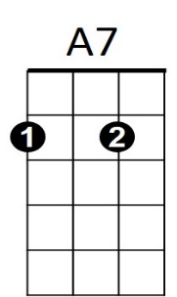
A pie in the face for bein' a sleepy bull toad

C
Verse melody (whistled)

F D7 C A7
And you can be sure that if you're feelin' right
F D7 C A7
A daydream will last 'til long into the night
F D7
Tomorrow at breakfast you may
C A7
Prick up your ears
D7
Or you may be daydreamin'
G7
For a thousand years

C A7
What a day for a daydream
Dm G7
Custom-made for a daydreamin' boy
C A7
And I'm lost in a daydream
Dm G7
Dreamin' bout my bundle of joy


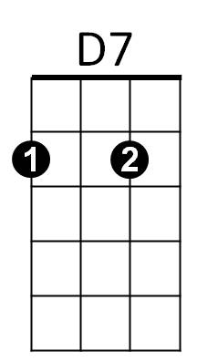


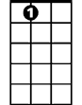
Chorus melody to fade
Dm
G7
F
C
A7

BARITONE




D7
G7
F
Dm

Daydream (John Sebastian) (Key G)
Intro: G

G E7
What a day for a daydream
Am D7
What a day for a daydreamin' boy
G E7
And I'm lost in a daydream
Am D7
Dreamin' bout my bundle of joy

C A7 G E7
And even if time ain't really on my side
C A7 G E7
It's one of those days for takin' a walk outside
C A7 G E7
I'm blowin' the day to take a walk in the sun
A7 D7
And fall on my face on somebody's new-mowed lawn

G E7
I been havin' a sweet dream
Am D7
I been dreamin' since I woke up today
G E7
It's starring me and my sweet dream
Am D7
'Cause she's the one that makes me feel this way

C A7 G E7
And even if time is passin' me by a lot
C A7 G E7
I couldn't care less about the dues you say I've got
D7
C
C A7 G E7
Tomorrow I'll pay the dues for dropping my load
A7 D7
A pie in the face for bein' a sleepy bull toad

Verse melody (whistled)
BARITONE
G
E7
Am

C A7 G E7
And you can be sure that if you're feelin' right
C A7 G E7
A daydream will last along into the night
C A7 G E7
Tomorrow at breakfast you may prick up your ears
A7 D7
Or you may be daydreamin' for a thousand years

G E7
What a day for a daydream
Am D7
Custom-made for a daydreamin' boy
G E7
And I'm lost in a daydream
Am D7
Dreamin' ‘bout my bundle of joy

Chorus melody to fade
(optional whistle)
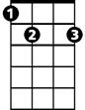


A7
E7
G
Am

C

