Daydream (Lovin’ Spoonful)
Intro: C

C A7
What a day for a daydream
Dm G7
What a day for a daydreamin' boy
C A7
And I'm lost in a daydream
Dm G7
Dreamin' bout my bundle of joy

Chorus:
F D7 C A7
And even if time ain't really on my side
F D7 C A7
It's one of those days for takin' a walk outside
F D7 C A7
I'm blowin' the day to take a walk in the sun
D7
And fall on my face on somebody's
G7
New-mowed lawn

C A7
I been havin' a sweet dream
Dm G7
I been dreamin' since I woke up today
C A7
It's starring me and my sweet dream
Dm G7
'Cause she's the one that makes me feel this way

F D7 C A7
And even if time is passin' me by a lot
F D7 C
I couldn't care less about the dues
. A7
You say I've got
F D7 C A7
Tomorrow I'll pay the dues for dropping my load
D7 G7
A pie in the face for bein' a sleepy bull toad

Verse melody (whistled)

F D7 C A7
And you can be sure that if you're feelin' right
F D7 C A7
A daydream will last 'til long into the night
F D7
Tomorrow at breakfast you may
C A7
Prick up your ears
D7 G7
Or you may be daydreamin' for a thousand years

C A7
What a day for a daydream
Dm G7
Custom-made for a daydreamin' boy
C A7
And I'm lost in a daydream
Dm G7
Dreamin' bout my bundle of joy

Chorus melody to fade





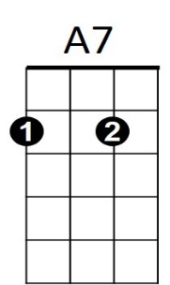
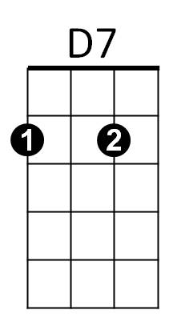


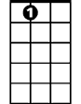
G7
D7
F
Dm
C
BARITONE
F
Dm
C
A7

G7

Daydream (Lovin’ Spoonful) Key F
Intro: F

F D7
What a day for a daydream
Gm C7
What a day for a daydreamin' boy
F D7
And I'm lost in a daydream
Gm C7
Dreamin' bout my bundle of joy

Chorus:
Bb G7 F D7
And even if time ain't really on my side
Bb G7 F D7
It's one of those days for takin' a walk outside
Bb G7 F D7
I'm blowin' the day to take a walk in the sun
G7
And fall on my face on somebody's
C7
New-mowed lawn

F D7
I been havin' a sweet dream
Gm C7
I been dreamin' since I woke up today
F D7
It's starring me and my sweet dream
Gm C7
'Cause she's the one that makes me feel this way

Bb G7 F D7
And even if time is passin' me by a lot
Bb G7 F
I couldn't care less about the dues
. D7
You say I've got
Bb G7 F D7
Tomorrow I'll pay the dues for dropping my load
G7 C7
A pie in the face for bein' a sleepy bull toad

Verse melody (whistled)

Bb G7 F D7
And you can be sure that if you're feelin' right
Bb G7 F D7
A daydream will last 'til long into the night
Bb G7
Tomorrow at breakfast you may
F D7
Prick up your ears
G7 C7
Or you may be daydreamin' for a thousand years

F D7
What a day for a daydream
Gm C7
Custom-made for a daydreamin' boy
F D7
And I'm lost in a daydream
Gm C7
Dreamin' bout my bundle of joy

Chorus melody to fade
BARITONE
F
D7
F

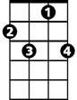
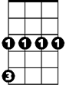
Gm
C7
C7
Gm

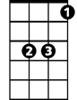
Bb
Bb
G7
G7

Daydream (Lovin’ Spoonful) Key G
Intro: G

G E7
What a day for a daydream
Am D7
What a day for a daydreamin' boy
G E7
And I'm lost in a daydream
Am D7
Dreamin' bout my bundle of joy

Chorus:
C A7 G E7
And even if time ain't really on my side
C A7 G E7
It's one of those days for takin' a walk outside
C A7 G E7
I'm blowin' the day to take a walk in the sun
A7
And fall on my face on somebody's
D7
New-mowed lawn

G E7
I been havin' a sweet dream
Am D7
I been dreamin' since I woke up today
G E7
It's starring me and my sweet dream
Am D7
'Cause she's the one that makes me feel this way

C A7 G E7
And even if time is passin' me by a lot
C A7 G
I couldn't care less about the dues
. E7
You say I've got
C A7 G E7
Tomorrow I'll pay the dues for dropping my load
A7 D7
A pie in the face for bein' a sleepy bull toad

Verse melody (whistled)

C A7 G E7
And you can be sure that if you're feelin' right
C A7 G E7
A daydream will last 'til long into the night
C A7
Tomorrow at breakfast you may
G E7
Prick up your ears
A7 D7
Or you may be daydreamin' for a thousand years

G E7
What a day for a daydream
Am D7
Custom-made for a daydreamin' boy
G E7
And I'm lost in a daydream
Am D7
Dreamin' bout my bundle of joy

Chorus melody to fade
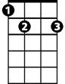

E7
G
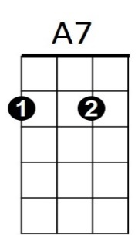
C
Am
D7
G
E7
BARITONE


Am

A7
C

