Deep Purple (Peter DeRose / Mitchell Parish)
D7 G E7 Am D7
When the deep p urple falls, over sleepy garden walls.
G Dm E7
And the stars begin to twinkle in the sky-eye-eye-eye.

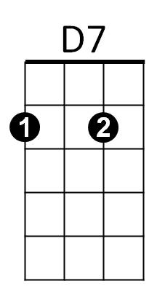
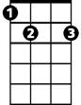
E7 Am Cm G Bbdim
G
E7
Through the mist of a memory, you wander back to me,
Am D7 G D7
Breathe..ing my name with a sigh- eye-eye-eye.

D7 G Ddim Am D7


In the still of the night, once a..gain I hold you tight.
Dm
Am
G Dm E7
Though you're gone, your love lives on when moonlight beams.
E7 Am Cm G Bbdim
And as long as my heart will beat, sweet lover, we'll always meet,
Am D7 G D7
Here in my deep pur..ple dreams.
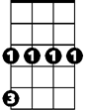
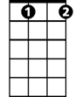
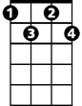
Cm
Bbdim
Ddim
D7 G E7 Am D7
When the deep purple falls, over sleepy garden walls.
G Dm E7
And the stars begin to twinkle in the sky-eye-eye-eye.
E7 Am Cm G Bbdim
Through the mist of a memory, you wander back to me,
Am D7 G D7
Breathe..ing my name with a sigh-eye-eye-eye.

D7 G Ddim Am D7
In the still of the night, once a..gain I hold you tight.
G Dm E7
Though you're gone, your love lives on when moonlight beams
E7 Am Cm G Bbdim
And as long as my heart will beat, sweet lover, we'll always meet,
Am D7 G E7
Here in my deep pur..ple dreams.

E7 Am Cm G Bbdim
And as long as my heart will beat, sweet lover, we'll always meet,
Am D7 Cm G
Here in my deep pur..ple dreams.
BARITONE
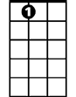
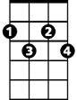
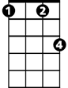



E7
Am
Bbdim
Ddim
Cm
Dm
G
D7

