Desperado (Glen Frey / Don Henley) Key C



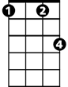

C C7 F Fm
F
C7
Fm
C
Desperado, why don't you come to your senses ?
C Am7 D7 G7
You been out ridin' fences for so long now
C C7 F Fm
Oh, you're a hard one, I know that you got your reasons,
C E7 Am7 D7 G7 C G
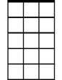

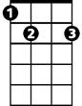
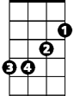

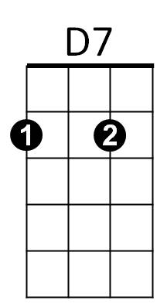

These things that are pleasin' you can hurt you somehow
Am7
G
E7
Em
Am
G7

Am Em
Don't you draw the queen of diamonds boy,
F C
She'll beat you if she's able,
Am7 F C G
You know the queen of hearts is always your best bet
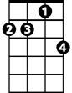
Am Em
Dm7
Now it seems to me some fine things
F C
Have been laid upon your table
Am D7 Dm7 G
But you only want the ones you can't get

G G7 C C7 F Fm
Des – per - ado, oh you ain't gettin' no younger,
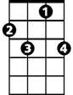
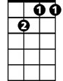
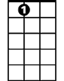

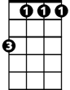

C Am7 D7 G7
C7
Dm7
D7
E7
Em
F
Fm
G
G7
Am7
Am
BARITONE
C
Your pain and your hunger, they're drivin' you home
C C7 F Fm
And freedom, well, that's just some people talkin'
C E7 Am7 D7 G7 C G
Your prison is walkin' through this world all a - lone

Am Em
Don't your feet get cold in the winter time?
F C
The sky won't snow and the sun won't shine
Am7 F C G
It's hard to tell the night time from the day
Am Em
You're losin' all your highs and lows
F C Dm7 G
Ain't it funny how the feelin' goes away

G7 C C7 F Fm
Des - perado, why don't you come to your senses
C Am D7 G7
Come down from your fences, open the gate
C C7 F Fm
It may be rainin', but there's a rainbow above you
C E7 Am F C Dm7
You better let somebody love you,
C E7 Am Dm7 G7 C C C7 F Fm C
You better let somebody love you before it's too-oo late

Desperado (Glen Frey / Don Henley) Key G
C
Fm
F
C7

G G7 C Cm
Desperado, why don't you come to your senses ?
G Em7 A7 D7
You been out ridin' fences for so long now
G G7 C Cm
Oh, you're a hard one, I know that you got your reasons,
G B7 Em7 A7 D7 G D
G7
E7
Am7
These things that are pleasin' you can hurt you somehow

Em Bm
Don't you draw the queen of diamonds boy,
C G
She'll beat you if she's able,
Em7 C G D
You know the queen of hearts is always your best bet
Dm7
G
Am
Em
Em Bm
Now it seems to me some fine things
C G
Have been laid upon your table
Em A7 Am7 D
But you only want the ones you can't get

D7 G G7 C Cm
Des - perado, oh you ain't gettin' no younger,
G Em7 A7 D7
Am
Em
Dm7
D7
G7
E7
Fm
F
C7
C
BARITONE
Your pain and your hunger, they're drivin' you home
G G7 C Cm
And freedom, well, that's just some people talkin'
G B7 Em7 A7 D7 G D
Your prison is walkin' through this world all a- lone

Em Bm
Don't your feet get cold in the winter time ?
Am7
C G
The sky won't snow and the sun won't shine
Em7 C G D
It's hard to tell the night time from the day
Em Bm
You're losin' all your highs and lows
C G Am7 D
Ain't it funny how the feelin' goes away
G

D7 G G7 C Cm
Des - perado, why don't you come to your senses
G Em A7 D7
Come down from your fences, open the gate
G G7 C Cm
It may be rainin', but there's a rainbow above you
G B7 Em C G Am7
You better let somebody love you,
G B7 Em Am7 D7 G G G7 C Cm G
You better let somebody love you before it's too-oo late

