
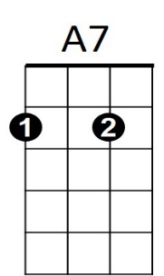


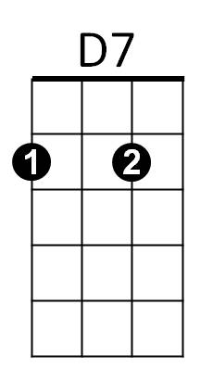
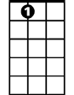

D
G
D7
BARITONE
G
A7
D
Devil Woman (Marty Robbins)
G D7
G
G7
I told Mary about it, I told her about a great sin
G
Mary cried and forgave me, then Mary took me back again
G7 C
Said if I wanted my freedom, I could be free ever more
G D7 G
But I don't want to be, and I don't want to see, Mary cry anymore
Chorus:
C
D7 G
Oh Devil woman, Devil woman let go of me
D7 G
Devil woman let me be, and leave me alone, I wanna go home
G D7
Mary is waiting and weeping, down in our shack by the sea
G
Even after I hurt her, Mary's still in love with me
G7 C
Devil woman it's over, trapped no more by your charm
G D7 G
‘Cause I don't want to stay, I want to get away, woman let go of my arm
(CHORUS)

BARITONE
D7
G7
G D7
G
Devil woman you’re evil, like the dark coral reef
G
Like the winds that bring high tides, you bring sorrow and grief
G7 C
You made me ashamed to face Mary, Mary had the strength to tell
G D7 G

Skies are not so black, Mary took me back, Mary has broken your spell
C

(CHORUS)

G D7
Running along by the seashore, running as fast as I can
G
Even the seagulls are happy, glad I’m coming home again
G7 C
Never again will I ever, cause another tear to fall
G D7 G
Down the beach I see, what belongs to me, the one I want most of all

(CHORUS)
D7 G
Oh Devil woman, Devil woman let go of me
D7 G D7 G
Devil woman don't follow me, and leave me alone, I wanna go home

