



Diggy Liggy Lo (Terry J. Clement, 1953) (C)
Adaption by J. D. Miller (July 1954)

Intro: Chords/melody 1st Verse  C  Diggy Liggy Li and Diggy Liggy Lo  G7  They fell in love at the fais-do-do  The pop was cold and the coffee *chaud  C  For Diggy Liggy Li and Diggy Liggy Lo  Chorus  C F  Diggy Liggy Li loved Diggy Liggy Lo  C  Everyone knew he was her beau  G7  No body else could ever show  C  So much love for Diggy Liggy Lo  C  That's the place they find romance  G7  Where they do the Cajun dance  Steal a kiss now they had a chance  C  She show's her love with ev'ry glance. Chorus  C  Finally went and uh-seen her Pa  G7  Now he's got hisself a Papa-in-law  Moved out where the Bayou's low  C  Now he's got a little Diggy Liggy Lo. Chorus (2x) | 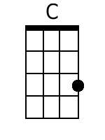
 | 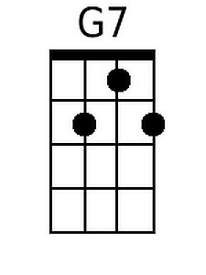
 | 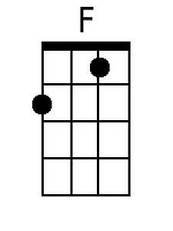
 | Bari
 | 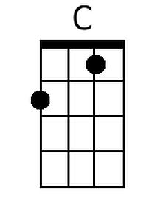
 | 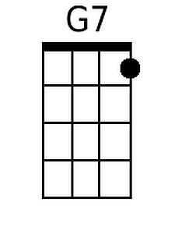
 | 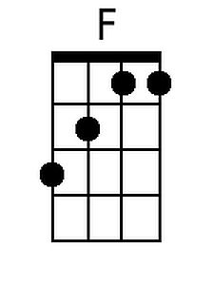

Diggy Liggy Lo (Terry J. Clement, 1953) (G)
Adaption by J. D. Miller (July 1954)

Intro: Chords/melody 1st Verse  G  Diggy Liggy Li and Diggy Liggy Lo  D7  They fell in love at the fais-do-do  The pop was cold and the coffee *chaud  G  For Diggy Liggy Li and Diggy Liggy Lo  Chorus  G C  Diggy Liggy Li loved Diggy Liggy Lo  G  Everyone knew he was her beau  D7  No body else could ever show  G  So much love for Diggy Liggy Lo  G  That's the place they find romance  D7  Where they do the Cajun dance  Steal a kiss now they had a chance  G  She show's her love with ev'ry glance. Chorus  G  Finally went and uh-seen her Pa  D7  Now he's got hisself a Papa-in-law  Moved out where the Bayou's low  G  Now he's got a little Diggy Liggy Lo. Chorus (2x) | 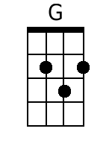
 | 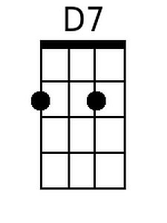
 | Bari
 | 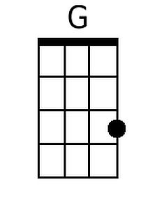
 | 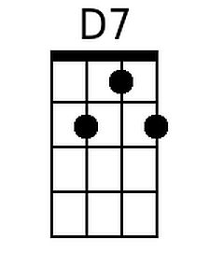

Diggy Liggy Lo (Terry J. Clement, 1953) (NN)
Adaption by J. D. Miller (July 1954)

Intro: Chords/melody 1st Verse  1  Diggy Liggy Li and Diggy Liggy Lo  5(7)  They fell in love at the fais-do-do  The pop was cold and the coffee *chaud  1  For Diggy Liggy Li and Diggy Liggy Lo |  | 1 | 4 | 5(7)
 |  | A | D | E7
 |  | C | F | G7
 |  | D | G | A7
 |  | F | Bb | C7
 |  | G | C | D7

Chorus
1 4
Diggy Liggy Li loved Diggy Liggy Lo
1
Everyone knew he was her beau
5(7)
No body else could ever show
1
So much love for Diggy Liggy Lo

1
That's the place they find romance
5(7)
Where they do the Cajun dance

Steal a kiss now they had a chance
1
She show's her love with ev'ry glance. Chorus

1
Finally went and uh-seen her Pa
5(7)
Now he's got hisself a Papa-in-law

Moved out where the Bayou's low
1
Now he's got a little Diggy Liggy Lo. Chorus (2x)

