




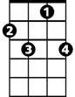

Dixie Chicken (Lowell George & Fred Martin, ca. 1973) (C)
Dixie Chicken by Little Feat (1973)

C G  I've seen the bright lights of Memphis and the Commodore Hotel  G7 G G7 C  And underneath a street lamp, I met a Southern belle  F C G  Well she took me to the river, where she cast her spell  G7 G G7 C  And in that Southern moonlight, she sang a song so well  Chorus  C G  If you'll be my Dixie chicken, I'll be your Tennessee lamb  G7 G C F C  And we can walk together down in Dix-ie-land  G7 C F C  Down in Dix-ie-land  C G  Well we made all the hot spots, my money flowed like wine  G7 G G7 C  Then that low down Southern whiskey began to fog my mind  F C G  And I don't remember church bells or the money I put down  G7 G G7 G C C7  On the white picket fence and boardwalk of the house at the edge of town  F C G  But boy do I remember the strain of her refrain  G7 G G7 G C  The nights we spent together, and the way she called my name Chorus  C G  Well it's been a year since she ran away. Yes, that guitar player sure could play  G7 G G7 G C  She always liked to sing along, she's always handy with a song.  F C G  Then one night in the lobby of the Commodore Hotel  G7 G G7 G C  I chanced to meet a bartender who said he knew her well  F C G  And as he handed me a drink he began to hum a song  G7 G G7 G C  And all the boys there, at the bar, began to sing along. Chorus |  |  |  |  |  |  |  | 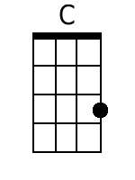
 |  |  |  |  |  |  |  | 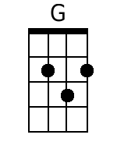
 |  |  |  |  |  |  |  | 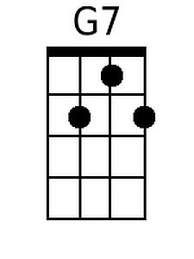
 |  |  |  |  |  |  |  | 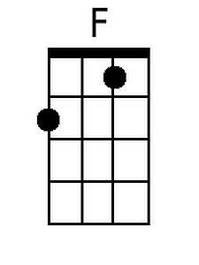
 |  |  |  |  |  |  |  | 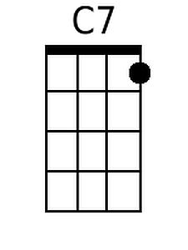
 |  |  | Bari | 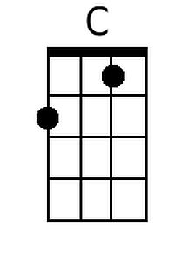 | 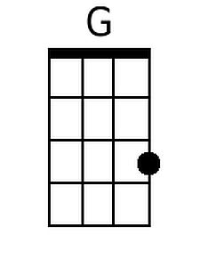 | 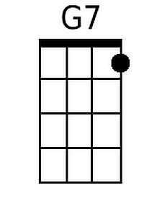 | 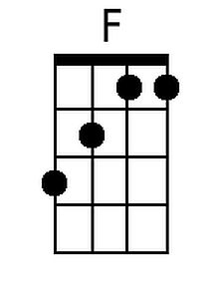 | 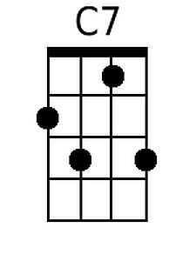

Dixie Chicken (Lowell George & Fred Martin, ca. 1973) (G)
Dixie Chicken by Little Feat (1973)

G D
I've seen the bright lights of Memphis and the Commodore Hotel
D7 D D7 G
And underneath a street lamp, I met a Southern belle
C G D
Well she took me to the river, where she cast her spell
D7 D D7 G
And in that Southern moonlight, she sang a song so well

Chorus
G D
If you'll be my Dixie chicken, I'll be your Tennessee lamb
D7 D G C G
And we can walk together down in Dix-ie-land
D7 G C G
Down in Dix-ie-land

G D
Well we made all the hot spots, my money flowed like wine
D7 D D7 G
Then that low down Southern whiskey began to fog my mind
C G D
And I don't remember church bells or the money I put down
D7 D D7 D G G7
On the white picket fence and boardwalk of the house at the edge of town
C G D
But boy do I remember the strain of her refrain
D7 D D7 D G
The nights we spent together, and the way she called my name Chorus

G D
Well it's been a year since she ran away. Yes, that guitar player sure could play
D7 D D7 D G
She always liked to sing along, she's always handy with a song.
C G D
Then one night in the lobby of the Commodore Hotel
D7 D D7 D G
I chanced to meet a bartender who said he knew her well
C G D
And as he handed me a drink he began to hum a song
D7 D D7 D G
And all the boys there, at the bar, began to sing along. Chorus

 |  |  |  |  |  |  |  | 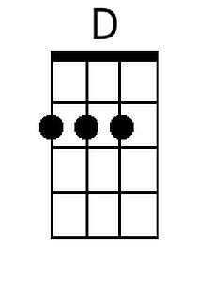
 |  |  |  |  |  |  |  | 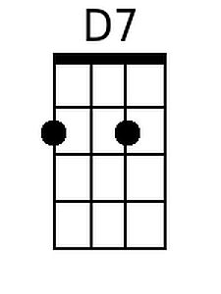
 |  |  | Bari |  | 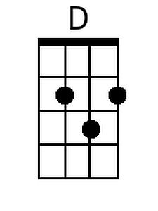 | 