Do You Hear What I Hear?
C 28
Intro (Chords for last line): F G7 C – Bb C

C Bb C
Said the night wind to the little lamb,
Am C Am C
Do you see what I see?
C Bb C
Way up in the sky, little lamb,
Am C Am C
Do you see what I see?
Am Em
A star, a star, dancing in the night
F G E7
With a tail as big as a kite
F G7 C
With a tail as big as a kite

C Bb C
Said the little lamb to the shepherd boy,
Am C Am C
Do you hear what I hear?
C Bb C
Ringing through the sky, shepherd boy,
Am C Am C
Do you hear what I hear?
Am Em
A song, a song, high above the trees
F G E7
With a voice as big as the sea
F G7 C
With a voice as big as the sea

C Bb C


Said the shepherd boy to the mighty king,
F
Am
BARITONE

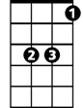
Am C Am C
C
Bb
Do you know what I know?
C Bb C
In your palace warm, mighty king,
Am C Am C
Do you know what I know?
Am Em

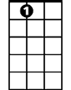


A Child, a Child shivers in the cold
Em
E7
G7
G
F G E7
Let us bring Him silver and gold
F G7 C
Let us bring Him silver and gold
C Bb C
Said the king to the people everywhere,
Am C Am C
Listen to what I say
C Bb C
Pray for peace, people everywhere!
Am C Am C
Listen to what I say
Am Em
The Child, the Child, sleeping in the night
F G E7
He will bring us goodness and light
F G7 C Bb C
He will bring us goodness and light
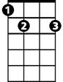

F
Am
Bb
C
E7
G7


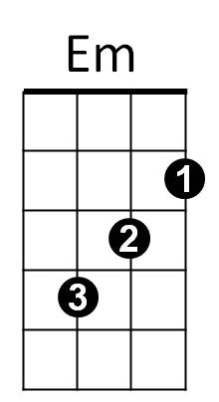
G

