Don't It Make My Brown Eyes Blue (Richard C Leigh)

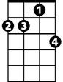


Intro: C Am Dm7 G7 / C Am Dm7 G7
G7
Dm7
Am
C
C Am Dm7 G7
Don't know when I've been so blue
C Am Dm E7
Don't know what's come over you
Am C Am D7
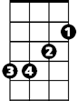

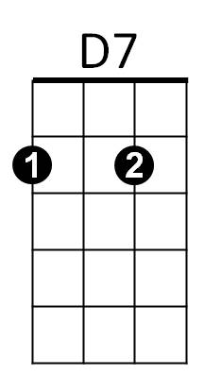
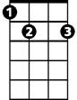
You've found someone ne - w
Em
F
E7
F Em Dm7 G
And don't it make my brown eyes blue

C Am Dm7 G7
I'll be fine when you're gone


C Am Dm E7
G
Dm
I'll just cry all night long
Am C Am D7
Say it isn't tru - e
F G C
And don't it make my brown eyes blue

Am Em F C
Tell me no secrets, tell me some lies
BARITONE

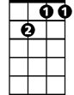
Am Em F C
G7
Dm7
Am
C
Give me no reasons, give me ali - bis
Am Em F C
Tell me you love me and don't let me cry
Dm Em F G
Say anything but don't say goodbye

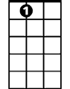
Em
F
D7
E7
C Am Dm7 G7
I didn't mean to treat you bad
C Am Dm E7
Didn't know just what I had
Am C Am D7

But honey now I do - o
G
Dm
F Em
And don't it make my brown eyes,
F Em
Don't it make my brown eyes
F G C
Don't it make my brown eyes blue.
C Am Dm7 G7 / C Am Dm7 G C

