Don't Dream It's Over (Neil Finn)
Intro: Csus4
C Am
There is freedom within, there is freedom without
F E7
Try to catch the deluge - in a paper cup
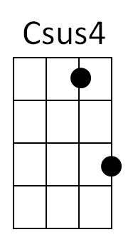


C Am
Am
C
There's a battle ahead, many battles are lost
F
But you'll never see the end of the road
E7
While you're traveling with me
Chorus:

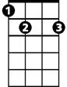

F G C Am
G
E7
F
Hey now, hey now, Don't dream it's over
F G C Am
Hey now, hey now, When the world comes in
F G C Am
They come, they come - To build a wall between us
F G
We know they won't win
C Am
Now I'm towing my car, there's a hole in the roof
F E7
My possessions are causing me suspicion but there's no proof
C Am
In the paper today - tales of war and of waste
F E7
But you turn right over to the T.V. page
(Chorus) C Am F E7 / C Am F E7 / F C F C Bb G
C Am

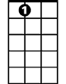
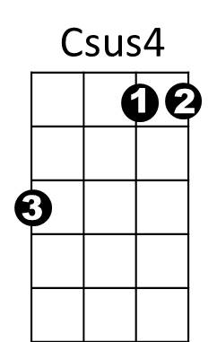

Now I'm walking again - to the beat of a drum
F
E7
G
C
Am
BARITONE
F E7
And I'm counting the steps - to the door of your heart
C Am
Only shadows ahead - barely clearing the roof
F E7
Get to know the feeling of liberation and release
(Chorus)

F G C Am F G C Am
Don't let them win - Hey now, hey now
F G C Am
Hey now, hey now - Don't let them win
F G C Am
They come, they come - Don't let them win
F G C Am / F G Am
Hey now, hey now,

Don't Dream It's Over (Neil Finn)
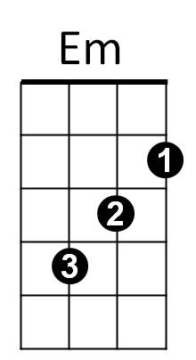
Intro: Gsus4
G

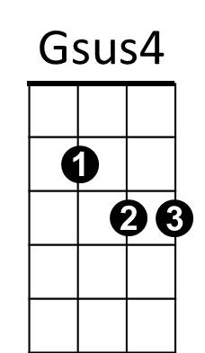
G Em
There is freedom within, there is freedom without
C B7
Try to catch the deluge - in a paper cup
G Em
There's a battle ahead, many battles are lost

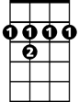
C
D
B7
C
But you'll never see the end of the road
B7
While you're traveling with me
Chorus:
C D G Em
Hey now, hey now, Don't dream it's over
C D G Em
Hey now, hey now, When the world comes in
C D G Em
They come, they come - To build a wall between us
C D
We know they won't win
G Em
Now I'm towing my car, there's a hole in the roof
C B7
My possessions are causing me suspicion but there's no proof
G Em
BARITONE
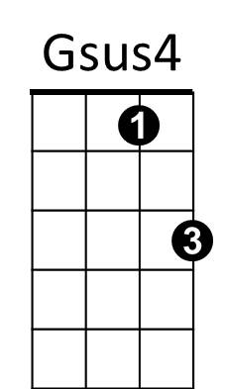
In the paper today - tales of war and of waste
G
Em
C B7
But you turn right over to the T.V. page
(Chorus)
G Em C B7 / G Em C B7 / C G C G Bb D
G Em
C
B7
D
Now I'm walking again - to the beat of a drum
C B7
And I'm counting the steps - to the door of your heart
G Em
Only shadows ahead - barely clearing the roof
C B7
Get to know the feeling of liberation and release
(Chorus)
C D G Em C D G Em
Don't let them win - Hey now, hey now
C D G Em
Hey now, hey now - Don't let them win
C D G Em
BARITONE
They come, they come - Don't let them win
C D G Em / C D Em
Hey now, hey now,

