Don’t Let the Sun Catch You Crying
Cmaj7 F

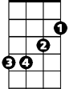



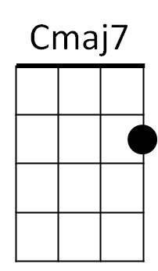
Cmaj7 F Cmaj7 F
Em
Am
G
F
Don't let the sun catch you cryin'
Cmaj7 F G
Tonight's the time for all your tears
Am Em
Your heart may be broken tonight
Am Em
But tomorrow in the mornin' light
F G Cmaj7 F
Don't let the sun catch you cryin'

Cmaj7 F Cmaj7 F
The night time shadows disappear
Cmaj7 F G
And with them go all your tears
Am Em
For sunshine will bring joy
Am Em
For every girl and boy so
F G Cmaj7 F
Don't let the sun catch you cryin'

G Am
We know that cryin's not a bad thing



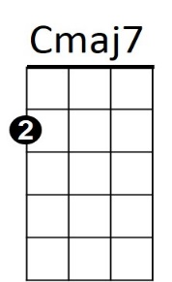
F G
Em
Am
G
F
BARITONE
But stop your cryin' when the birds sing

Cmaj7 F Cmaj7 F
It may be hard to discover
Cmaj7 F G
That you been left for another
Am Em
And don't forget that love's a game
Am Em
And it can always come again so
F G Cmaj7 F
Don't let the sun catch you cryin'
Cmaj7 F
Don't let the sun catch you cryin' oh no
Cmaj7
Oh, no, no
Don’t Let the Sun Catch You Crying
Gmaj7 Bb
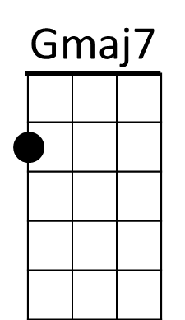
Gmaj7 Bb Gmaj7 Bb
C
Dm
Am
Bb
Don't let the sun catch you cryin'
Gmaj7 Bb C
Tonight's the time for all your tears
Dm Am
Your heart may be broken tonight
Dm Am
But tomorrow in the mornin' light
Bb C Gmaj7 Bb
Don't let the sun catch you cryin'

Gmaj7 Bb Gmaj7 Bb
The night time shadows disappear
Gmaj7 Bb C
And with them go all your tears
Dm Am
For sunshine will bring joy
Dm Am
For every girl and boy so
Bb C Gmaj7 Bb
Don't let the sun catch you cryin'

C Dm
We know that cryin's not a bad thing
Bb C
But stop your cryin' when the birds sing

Gmaj7 Bb Gmaj7 Bb
It may be hard to discover
Gmaj7 Bb C
That you been left for another
Dm Am
And don't forget that love's a game
Dm Am
And it can always come again so
Bb C Gmaj7 Bb
Don't let the sun catch you cryin'
Gmaj7 Bb Gmaj7
Don't let the sun catch you cryin' oh no - Oh, no, no

