Dream a Little Dream of Me (Fabian Andre / Gus Kahn / Wilbur Schwandt)

F E7 C#7 C7
Stars shining bright above you
F D7 Am7-5 D7
Night breezes seem to whisper "I love you"
Bb Bbm7
Birds singing in a sycamore tree
F C#7 C7
Dre am a little dream of me

F E7 C#7 C7
Sa y nighty night and kiss me
F D7 Am7-5 D7
Just hold me tight and tell me you miss me
Bb Bbm7
While I'm alone a nd blue as can be
F C#7 C7 F A7
Dream a little dream of me

Reprise:

D Bm7 Em7 A7
Stars fading but I linger on dear
D Bm7 Em7 A7
Still craving your kiss
D Bm7 Em7 A7
I'm longing to linger till dawn dear
D C#7 C7
Just saying this

F E7 C#7 C7
Sweet dreams till sunbeams find you
F D7
Sweet dreams that leave all worries
Am7-5 D7

Be-hind you
F
Bb Bbm7
But in your dreams whatever they be
F C#7 C7 F A7
Dream a little dream of me

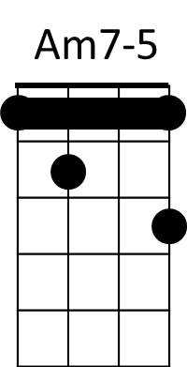
(Reprise)

F E7 C#7 C7
Sweet dreams till sunbeams find you
F D7
Sweet dreams that leave all worries
Am7-5 D7
Be-hind you
Bb Bbm7
But in your dreams whatever they be
F C#7 C7 F F7
Dream a little dream of me
Bb Bbm7
But in your dreams whatever they be
F C#7 C7 F

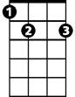
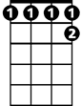

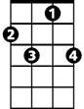

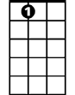
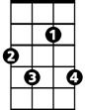
Dream a little dream of me
F
E7
C#7
C7
C7
D7
E7
C#7
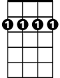
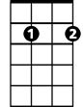

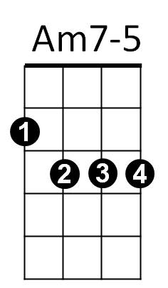
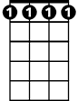
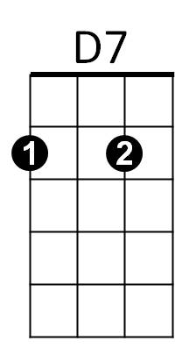
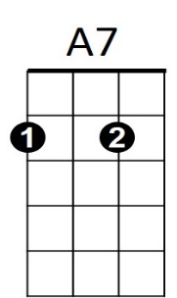
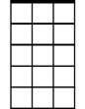
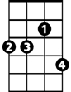
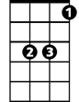

BARITONE
Bm7
A7
Em7
D
Bb
Bbm7
Em7
Bm7
Bbm7
Bb
D

