Drive My Car (Lennon / McCartney) Key C
C7 F7
Asked a girl what she wanted to be
C7 F7
She said baby, can't you see
C7 F7
I wanna be famous, a star on the screen
G7
But you can do something in between

Chorus:
Am F7
Baby you can drive my car
Am F7
Yes I'm gonna be a star
Am D7
Baby you can drive my car
G C G
And maybe I love you

C7 F7
I told that girl that my prospects were good
C7 F7
And she said baby, it's understood
C7 F7
Working for peanuts is all very fine
G7
But I can show you a better time

(Chorus)

Instrumental Verse

(Chorus)

BARITONE

Am

C7 F7
I told that girl I can start right away
C7 F7
And she said listen babe I got something to say
C7 F7
I got no car and it's breaking my heart
G7
But I've found a driver and that's a start

(Chorus)

(Repeat to fade)

G C7 F7
Beep beep'm beep beep yeah
C7 F7
Beep beep'm beep beep yeah



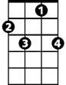

Am
G7
F7
C7



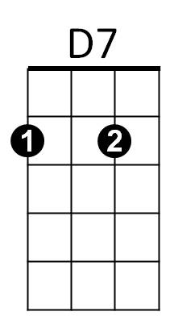
C
G

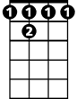

G
G7
F7
C7
C
D7

Drive My Car (Lennon / McCartney) Key D

D7 G7
Asked a girl what she wanted to be
D7 G7
She said baby, can't you see
D7 G7
I wanna be famous, a star on the screen
A7
But you can do something in between

Chorus:
Bm G7
Baby you can drive my car
Bm G7
Yes I'm gonna be a star
Bm E7
Baby you can drive my car
A D A
And maybe I love you

D7 G7
I told that girl that my prospects were good
D7 G7
And she said baby, it's understood
D7 G7
Working for peanuts is all very fine
A7
But I can show you a better time

(Chorus)

Instrumental Verse

(Chorus)

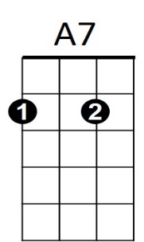
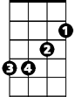
Bm
G7
D7

D7 G7
I told a girl I can start right away
D7 G7
And she said listen babe I got something to say
D7 G7
I got no car and it's breaking my heart
A7
But I've found a driver and that's a start

(Chorus)

(Repeat to fade)

A D7 G7
Beep beep'm beep beep yeah
D7 G7
Beep beep'm beep beep yeah

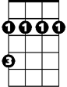
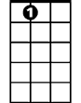
Bm
A7
G7
BARITONE

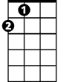

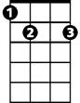
A
D
E7

D
A
E7

Drive My Car (Lennon / McCartney)

G7 C7
Asked a girl what she wanted to be
G7 C7
She said baby, can't you see
G7 C7
I wanna be famous, a star on the screen
D7
But you can do something in between

Chorus:
Em C7
Baby you can drive my car
Em C7
Yes I'm gonna be a star
Em A7
Baby you can drive my car
D G D
And maybe I love you

G7 C7
I told that girl that my prospects were good
G7 C7
And she said baby, it's understood
G7 C7
Working for peanuts is all very fine
D7
But I can show you a better time

(Chorus)

D G7
Beep beep'm beep beep yeah

Instrumental Verse

(Chorus)

Em
D7
C7
G7

G7 C7
I told a girl I can start right away
G7 C7
And she said listen babe I got something to say
G7 C7
I got no car and it's breaking my heart
D7
But I've found a driver and that's a start

(Chorus)

(Repeat to fade)

D G7 C7
Beep beep'm beep beep yeah
G7 C7
Beep beep'm beep beep yeah

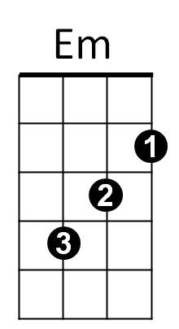
G7
C7

BARITONE

D
G
A7

D
G

