Drive (Ric Ocasek)


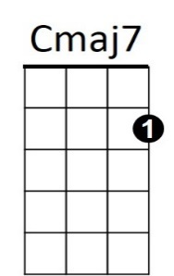
C Cmaj7 C Cmaj7
C
Who's gonna tell you when - it's too late,
C Cmaj7 C Cmaj7
Who's gonna tell you things - aren't so great.

Am D Am D

You can't go on, thinkin', nothings' wrong,
Am

C Cmaj7 C Cmaj7
D
Who's gonna drive you home, tonight.?

C Cmaj7 C Cmaj7
Who's gonna pick you up, when you fall?
C Cmaj7 C Cmaj7
W ho's gonna hang it up, when you call?

C Cmaj7 C Cmaj7
Who's gonna pay attention, to your dreams?
C Cmaj7 C Cmaj7
And who's gonna plug their ears, w hen you scream?

Am D Am D
BARITONE
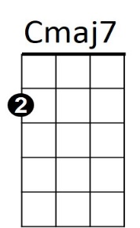

You can't go on, thinkin', nothings' wrong,
C
C Cmaj7 C Cmaj7
Who's gonna drive you home, tonight.?

C Cmaj7 C Cmaj7
Who's gonna hold you down, when you shake?
C Cmaj7 C Cmaj7


Who's gonna come around, when you break?
Am
D

Am D Am D
You can't go on, thinkin', nothings' wrong,
C Cmaj7 C Cmaj7
Who's gonna drive you home, tonight.?

Am D Am D
You can't go on, thinkin', nothings' wrong,
C Cmaj7 C Cmaj7 C
Who's gonna drive you home, tonight.?

