Duke of Earl (C)
(Gene Chandler, Earl Edwards & Bernice Williams, 1961)
Duke of Earl by Gene Chandler (1961) (F) – Duke of Earl by Sha-Na-Na (at Woodstock)
4/4 – 101 BPM
Intro  C Am F  Duke, Duke, Duke, Duke of Earl. Duke, Duke, Duke of Earl.  G C  Duke, Duke, Duke of Earl. Duke, Duke, Duke of Earl.  Am F  Duke, Duke, Duke of Earl. Duke, Duke, Duke of Earl.  G  Duke, Duke, Duke of Earl. Duke, Duke.  C Am F G  As I walk through this world, nothing can stop the Duke of Earl.  C Am F G  And you, you are my girl, and no one can hurt you, oh, no.  Chorus 1  C Am  Yes, I, oh, I'm gonna love you, oh, oh.  F G  Come on let me hold you, darlin', 'Cause I'm the Duke of Earl.  G  So, yeah, yeah, yeah, yeah.  C Am F G  And when I hold you, you'll be my duchess, the Duchess of Earl.  C Am F G  We'll walk through my dukedom, and a paradise we will share.  Chorus 2  C Am F  Yes, I, oh, I'm gonna love you, oh, oh. Nothing can stop us now,  G  'Cause I'm the Duke of Earl. So, yeah, yeah, yeah, yeah.  Repeat Intro. Chorus 2.  Outro  C Am F  Duke, Duke, Duke, Duke of Earl. Duke, Duke, Duke of Earl.  G | C  Duke, Duke, Duke of Earl. | 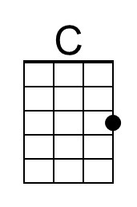
 | 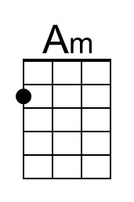
 | 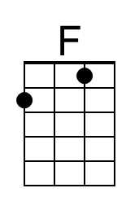
 | 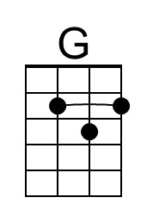
 | Bari
 | 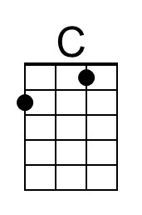
 | 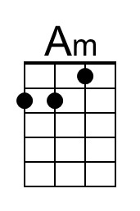
 | 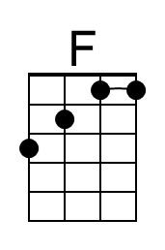
 | 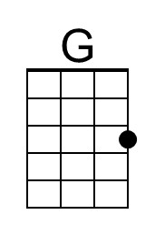

Duke of Earl (F)
(Gene Chandler, Earl Edwards & Bernice Williams, 1961)
Duke of Earl by Gene Chandler (1961) (F) – Duke of Earl by Sha-Na-Na (at Woodstock)
4/4 – 101 BPM
Intro
F Dm Bb
Duke, Duke, Duke, Duke of Earl. Duke, Duke, Duke of Earl.
C F
Duke, Duke, Duke of Earl. Duke, Duke, Duke of Earl.
Dm Bb
Duke, Duke, Duke of Earl. Duke, Duke, Duke of Earl.
C
Duke, Duke, Duke of Earl. Duke, Duke.

F Dm Bb C
As I, I walk through this world, nothing can stop the Duke of Earl.
F Dm Bb C
And you, you are my girl, and no one can hurt you, oh, no.

Chorus 1
F Dm
Yes, I, oh, I'm gonna love you, oh, oh.
Bb C
Come on let me hold you, darlin', 'Cause I'm the Duke of Earl.
C
So, yeah, yeah, yeah, yeah.

F Dm Bb C
And when I hold you, you'll be my duchess, the Duchess of Earl.
F Dm Bb C
We'll walk through my dukedom, and a paradise we will share.

Chorus 2
F Dm Bb
Yes, I, oh, I'm gonna love you, oh, oh. Nothing can stop us now,
C
'Cause I'm the Duke of Earl. So, yeah, yeah, yeah, yeah.

Repeat Intro. Chorus 2.

Outro
F Dm Bb
Duke, Duke, Duke, Duke of Earl. Duke, Duke, Duke of Earl.
C | F
Duke, Duke, Duke of Earl.
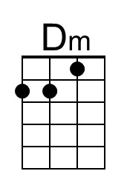
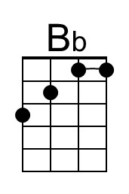
Bari
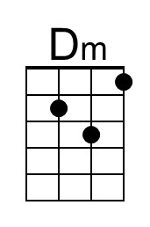
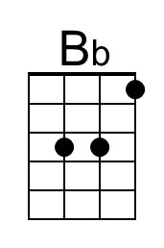

Duke of Earl (G)
(Gene Chandler, Earl Edwards & Bernice Williams, 1961)
Duke of Earl by Gene Chandler (1961) (F) – Duke of Earl by Sha-Na-Na (at Woodstock)
4/4 – 101 BPM
Intro
G Em C
Duke, Duke, Duke, Duke of Earl. Duke, Duke, Duke of Earl.
D G
Duke, Duke, Duke of Earl. Duke, Duke, Duke of Earl.
Em C
Duke, Duke, Duke of Earl. Duke, Duke, Duke of Earl.
D
Duke, Duke, Duke of Earl. Duke, Duke.

G Em C D
As I walk through this world, nothing can stop the Duke of Earl.
G Em C D
And you, you are my girl, and no one can hurt you, oh, no.

Chorus 1
G Em
Yes, I, oh, I'm gonna love you, oh, oh.
C D
Come on let me hold you, darlin', 'Cause I'm the Duke of Earl.
D
So, yeah, yeah, yeah, yeah.

G Em C D
And when I hold you, you'll be my duchess, the Duchess of Earl.
G Em C D
We'll walk through my dukedom, and a paradise we will share.

Chorus 2
G Em C
Yes, I, oh, I'm gonna love you, oh, oh. Nothing can stop us now,
D
'Cause I'm the Duke of Earl. So, yeah, yeah, yeah, yeah.

Repeat Intro. Chorus 2.

Outro
G Em C
Duke, Duke, Duke, Duke of Earl. Duke, Duke, Duke of Earl.
D | G
Duke, Duke, Duke of Earl.
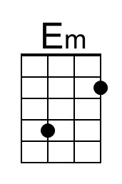
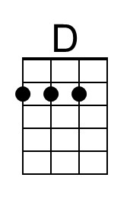
Bari
