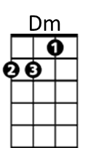
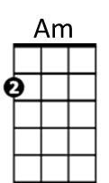
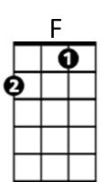
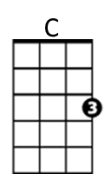
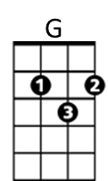
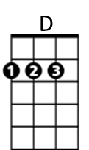
Dust in the Wind (Kansas)

Intro: C G Am F / C G Am F

C G Am G Dm Am
I close my eyes - only for a moment and a moment´s gone.
C G Am G Dm Am
All my dreams - pass before my eyes are curiosity.

D G Am D G Am Am / G /
Dust in the wind, all we are is dust in the wind.

C G Am G Dm Am
Same old song, just a drop of water in the endless sea.
C G Am G Dm Am
All we do, crumbles to the ground though we refuse to see.

D G Am D G Am G F Am
Dust in the wind, all we are is dust in the wi -- nd ohh oh ohhh

Am G Am F / Am G Am F / C Am C Am

C G Am G Dm Am
Don't hang on, nothing lasts forever but the earth and sky.
C G Am G Dm Am
It slips away and all your money won´t another minute buy.

D G Am D G Am
Dust in the wind, all we are is dust in the wind
D G Am D G Am
Dust in the wind, all we are is dust in the wind

Am G Am F / C G Am F (end on Am)







BARITONE
D
Dm
F
Am
G
C

