Easy To Be Hard (James Rado / Galt Mac Dermot) Key C
INTRO: Cmaj7 A7 (x2)

Cmaj7 A7
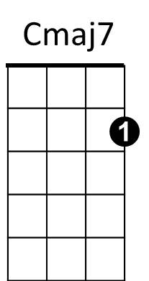
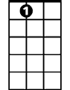

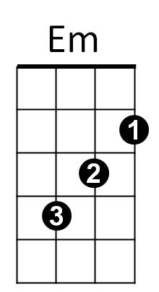
How can people be so heartless..
A7
D
Cmaj7 A7
How can people be so cruel?
D Em A D D7
Eas-y to be hard - easy to be cold.


Cmaj7 A7
G

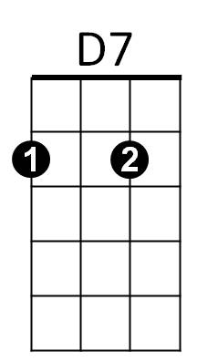
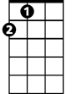
How can people have no feelings.
Dm
A
Cmaj7 A7
How can they ignore their friends?
D Em A D D7
Eas-y to be proud - easy to say no.

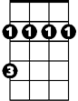
CHORUS:
Bm
G Dm G Dm
Especially people who care about strangers..
G Dm G Dm
who care about evil and social injustice.
Em A7 Em A7
Do you only care about the bleeding crowds?
Em A7 D Cmaj7 A7
BARITONE
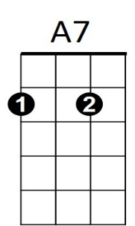
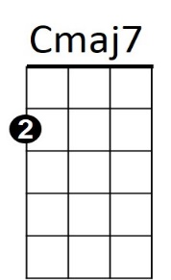



How about a needed friend..I need a friend.
D
A
D7
Dm
G

Cmaj7 A7
How can people be so heartless..
Cmaj7 A7
You know I'm hung up on you.
D Em A D D7

Eas-y to be proud - easy to say no.
Em

(CHORUS) Change end of last line – “We all need a friend”

(Repeat last Verse, Drop D7 at end play Outro)

OUTRO:
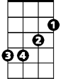
Em A D Em A D
Bm
Ea.- sy to be cold.- ea..- sy to say no.
Em A D Em A D
Come on, ea.-.sy to give in - ea.-.sy to say no.
Em A D Em A D
Ea.- sy to be cold.- ea..- sy to say no.
Em A Bm (hold)
Much too easy to say no..

