Edelweiss Key G
(Robin Spielberg / Richard Rodgers / Oscar Hammerstein)




C G C F
C
F
G
Edelweiss, edelweiss
C Am Dm G7
D7
Every morning you greet me



C G C F
Am
Dm
G7
Small and white, clean and bright
C G7 C
You look happy to meet me

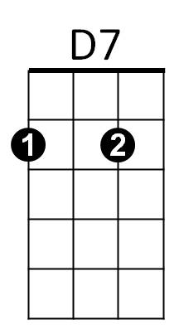
G C
Blossom of snow may you bloom and grow
F D7 G G7
Bloom and grow, forever
C G C F
Edelweiss, edelweiss
C G7 C
Bless my homeland forever

Repeat entire song, extend last line

BARITONE



C
Am
Dm
G7
D7
G
F

Edelweiss Key G
(Robin Spielberg / Richard Rodgers / Oscar Hammerstein)


G D G C
C
D
G
BARITONE
Edelweiss, edelweiss
G Em Am D7
Every morning you greet me
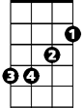
G D G C
Am
Em
Small and white, clean and bright
G D7 G
You look happy to meet me


D G
A7
Blossom of snow may you bloom and grow
C A7 D D7
Bloom and grow, forever
G D G C
Edelweiss, edelweiss
G D7 G
Bless my homeland forever

Repeat entire song, extend last line

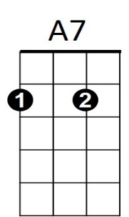
Em
D7
Am
C
D
G

