Eight Days A Week ( Lennon/McCartney) Key C

Intro: C D7 F C
C
BARITONE

C D7
Ooh I need your love babe,
F C
Guess you know it's true.
C D7
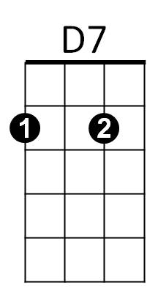
Hope you need my love babe,
F C
Just like I need you.

Chorus:
Am F Am D7

Hold me, love me, hold me, love me.
F
C D7
I ain't got nothin' but love babe,
F C
Eight days a week.


C D7
Am
Love you ev'ry day girl,
F C
Always on my mind.
C D7
One thing I can say girl,
F C

Love you all the time.
G

(Chorus)

Bridge:


G
G7
Eight days a week –
Am
I lo – o - ve you.
D7
Eight days a week
F G7
Is not enough to show I care.

C D7
Ooh I need your love babe,
F C
Guess you know it's true.
C D7
Hope you need my love babe,
F C
Just like I need you.
C

(Chorus)

(Bridge)

C D7
Love you ev'ry day girl,
D7
F C
Always on my mind.
C D7
One thing I can say girl,
F C

Love you all the time.
F

(Chorus)

(Outro)


F C
Am
Eight days a week,
F C
Eight days a week.

C D7 F C

G
G7

Eight Days A Week ( Lennon/McCartney) Key D

Intro: D E7 G D
D
BARITONE

D E7
Ooh I need your love babe,
G D
Guess you know it's true.
D E7
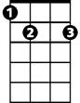
Hope you need my love babe,
E7
G D
Just like I need you.

Chorus:
Bm G Bm E7
Hold me, love me, hold me, love me.
G
D E7
I ain't got nothin' but love babe,
G D
Eight days a week.

D E7
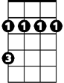
Love you ev'ry day girl,
Bm
G D
Always on my mind.
D E7
One thing I can say girl,
G D
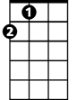
Love you all the time.
A

(Chorus)

Bridge:

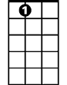
A
A7
Eight days a week –
Bm
I lo – o - ve you.
E7
Eight days a week
G A7
Is not enough to show I care.

D E7
Ooh I need your love babe,
G D
Guess you know it's true.
D E7
Hope you need my love babe,
G D
Just like I need you.
D

(Chorus)

(Bridge)

D E7
E7
Love you ev'ry day girl,
G D
Always on my mind.
D E7
One thing I can say girl,
G D
G
Love you all the time.

(Chorus)

(Outro)
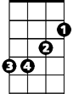
Bm
G D
Eight days a week,
G D
Eight days a week.

D E7 G D
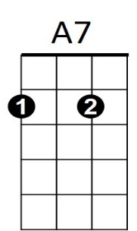
A

Eight Days A Week ( Lennon/McCartney) Key D
Intro: G A7 C G
G

G A7
Ooh I need your love babe,
C G
Guess you know it's true.
G A7
A7
Hope you need my love babe,
C G
Just like I need you.

Chorus:
Em C Em A7
Hold me, love me, hold me, love me.
G A7
C
I ain't got nothin' but love babe,
C G
Eight days a week.

G A7
Love you ev'ry day girl,
Em
C G
Always on my mind.
G A7
One thing I can say girl,
C G
Love you all the time.
D

(Chorus)

Bridge:

D
Eight days a week –
Em
I lo – o - ve you.
A7
Eight days a week
C D7
Is not enough to show I care.

G A7
Ooh I need your love babe,
C G
Guess you know it's true.
G A7
Hope you need my love babe,
C G
BARITONE
Just like I need you.
Em
C
G

(Chorus)

(Bridge)

G A7
Love you ev'ry day girl,
C G
Always on my mind.
G A7
One thing I can say girl,
C G
Love you all the time.

(Chorus)

(Outro)

C G
Eight days a week,
C G
Eight days a week.

G A7 C G
D7
D

