

Every Breath You Take (Sting)
Am
C
Intro: C Am F G Am

C Am
Every breath you take every move you make
F G Am
Every bond you break every step you take, I'll be watching you
C Am
Every single day every word you say
F G C
Every game you play every night you stay, I'll be watching you

Chorus:
F C
Oh, can' t you see, you belong to me
Am D7 G G7
How my poor heart aches, with every step you take

C Am
Every move you make, every vow you break
F G Am
Every smile you fake every claim you stake, I'll be watching you

Bridge:
G# Bb
Since you've gone, I've been lost without a trace
G#
I dream at night I can only see your face
Bb
I look around but it's you I can't replace
G#
I feel so cold and I long for your embrace
Bb Dm C G
I keep crying baby, baby pl - ea - se

(Intro) + (Chorus)
C Am
Every move you make, every vow you break
F G Am
Every smile you fake every claim you stake, I'll be watching you
F G Am
Every move you make, every step you take, I'll be watching you
(Hold 4 beats)

C


I'll be watching you (Every move you make,
G
F
Am F
Every vow you break, every step you take)
G C
I'll be watching you (Every move you make,
Am F
Every vow you break, every step you take)
G C Am
I'll be watching you, I'll be watching you,
F G C


Every move you make, every step you take, I'll be watching you
Bb
Dm
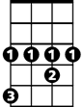

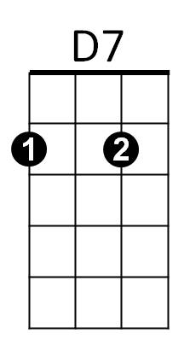
G#
G7
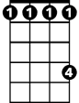
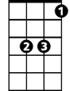


C
D7
F
G
Am
G#
Bb
Dm
G7
BARITONE

