Every Breath You Take (Sting)
Intro: C Am F G Am

C Am
Every breath you take every move you make
F G
Every bond you break every step you take,
Am
I'll be watching you
C Am
Every single day every word you say
F G
Every game you play every night you stay,
C
I'll be watching you

Chorus:
F C
Oh, can' t you see, you belong to me
Am D7 G G7
How my poor heart aches, with every step you take

C Am

Every move you make, every vow you break
G7
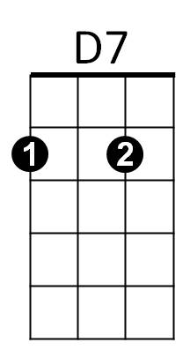
F G
Every smile you fake every claim you stake,
Am
I'll be watching you

Bridge:
Ab Bb
Since you've gone, I've been lost without a trace
Ab
I dream at night I can only see your face
Bb
I look around but it's you I can't replace



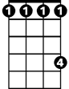
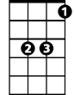


Ab
D7
G
F
BARITONE
C
Ab
Bb
Dm
G7

I feel so cold and I long for your embrace
Am
Bb Dm C G
I keep crying baby, baby pl - ea - se

(Instrumental verse) + (Chorus)
C Am
Every move you make, every vow you break
F G
Every smile you fake every claim you stake,
Am
I'll be watching you
F G
Every move you make, every step you take,
Am (Hold 4 beats)
I'll be watching you

C
I'll be watching you (Every move you make,
Am F
Every vow you break, every step you take)
G C
I'll be watching you (Every move you make,
Am F
Every vow you break, every step you take)
G C Am
I'll be watching you, I'll be watching you,
F G
Every move you make, every step you take,
C
I'll be watching you


G
F
C
Am
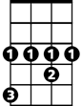
Ab
Bb
Dm

